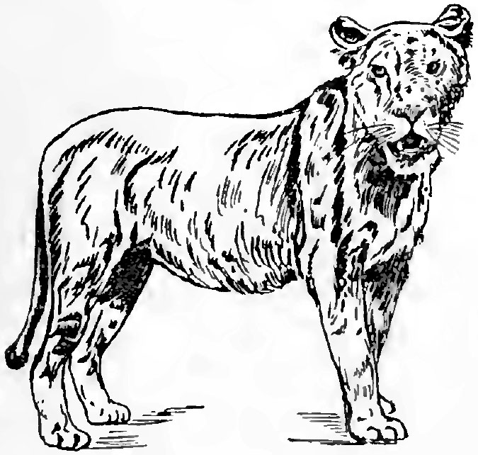LEGO WeDo – Roaring Lion – Science/Math Extensions
Lion Science
The species name of the African Lion is Panthera leo.
There other types of “big cats” that are related to African lions.
This genus name of this related group is Panthera (also Puma).
Research the following information about African lions and other Panthera and Puma species.
Type  of Lion | Species Name | Habitat/Location | Social Behavior (How do they cooperate, hunt, reproduce, etc.?)
African Lion | Panthera leo

Programming Logic
Save all of the WeDo programs that you create for this project; use the name “P5 Lion”.
- Explain each part of this program: (Put words in the boxes below.)
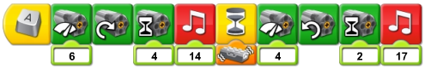
Start when press “A” key

- Create some new programs that can “remote control” the lion, using the tilt sensor.
Build the new programs underneath the original programs.
Be sure to control the time that the motor runs. (Don’t let it grind!)
Maybe try to use these program blocks (in a different order):
Draw your new program(s) on the back of this page…

Be sure to save all of your programs together, and name the project “P5 Lion”.
Be sure to get sign-off on your tracking sheet.

