Name: ____________________________ Period: ______

**Social Studies 8  
Prohibition Inquiry**

**Compelling Question: Why are some laws difficult to enforce?**

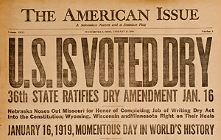

**Supporting Questions**

1. What was the goal of the 18th amendment?
2. Why did some Americans support prohibition?
3. oHoHow did Americans get around the 18th amendment?

**Supporting Question 1**

|  |  |
| --- | --- |
| Supporting Question | What was the goal of the 18th amendment? |
| Formative Performance Task | Interpret sections of the 18th amendment to determine its meaning and predict the intended impact on American society. |
| Featured Sources | Source A: 18th amendment to the U.S Constitution |
| Conceptual Understandings | 8.3e Following the end of World War I, the United States entered a period of increased economic prosperity and radical cultural change known as the Roaring Twenties. During this time, new opportunities for women were gained, and African Americans engaged in various efforts to distinguish themselves and celebrate their culture. |
| Content Specifications | Students will examine the impact of prohibition on American society. |
| Social Studies Practices | Comparison and Contextualization  Gathering, Using and Interpreting Evidence |

Supporting Question 1: Source A

**The 18th Amendment** (**Modified**)

*Source: United States Constitution*

*Context: The US Senate passed the 18th Amendment on December 18,*

*1917. It was ratified on January 16, 1919, after 36 states approved it. The*

*18th Amendment, and the enforcement laws accompanying it, established*

*Prohibition of alcohol in the United States. Several states already had*

*Prohibition laws before this amendment. It was eventually repealed by the*

*21st Amendment on December 5, 1933. It is the only amendment that has*

*ever been completely repealed.*

Section 1. After one year from the **ratification** of this **article** the

manufacture, sale, transportation, importation or exportation of

**intoxicating liquors** in the United States and all its territory is hereby

prohibited.

Section 2. The Congress and the States shall both have power to

enforce this article by appropriate legislation.

Section 3. This article shall have no power unless it shall have been

ratified as an amendment to the Constitution by the legislatures of the

States, as provided in the Constitution, within seven years from the

date of the submission to the States by the Congress.

**Vocabulary**

To ratify—to confirm or pass something, such as an amendment

Intoxicating liquors—alcohol

Article—a section or item in a written document. Until enough states ratified this

amendment, it was known as an article.

**Guiding Questions:**

1. What is your first reaction to the 18th amendment?

2. Do you think this amendment could be passed today? Why or why not?

3. Why do you think some Americans in 1918 might have wanted this amendment?

Supporting Question 2

|  |  |
| --- | --- |
| Supporting Question | Why did some Americans support Prohibition? |
| Formative Performance Task | Analyze various sources to determine the views of those who support the temperance movement and how they believed prohibition would solve America’s problems. |
| Featured Sources | Source A: Prohibition and Health. *Statement read at the Eighth Annual Meeting of the National*  *Temperance Council, Washington D.C., September 20, 1920. The National*  *Temperance Council was created in 1913 to work for Prohibition.*  Source B: “Alcoholism and Degeneracy.” *Boston, MA and Westerville, Ohio: Scientific Temperance and American*  *Issue Publishing Company, 1913.*  Source C: “Children in Misery.” *Boston, MA and Westerville, Ohio: Scientific Temperance Federation and American Issue Publishing Company, 1913.*  Source D: Those Who Laugh at the Drunken Man. Anonymous Editorial in the *New York Evening Journal* 1918. |
| Conceptual Understandings | 8.3e Following the end of World War I, the United States entered a period of increased economic prosperity and radical cultural change known as the Roaring Twenties. During this time, new opportunities for women were gained, and African Americans engaged in various efforts to distinguish themselves and celebrate their culture. |
| Content Specifications | Students will examine the impact of prohibition on American society. |
| Social Studies Practices | Comparison and Contextualization  Gathering, Using and Interpreting Evidence |

Supporting Question 2: Source A

**Prohibition and Health (Modified)**

Alcohol poisons and kills; Abstinence and Prohibition save lives and

safeguard health.

Dr. S.S. Goldwater, formerly Health Commissioner of New York City,

stated the decision of science, the final opinion of our nation after a

hundred years of education upon the subject of alcohol.

“It is believed that less consumption of alcohol by the community

would mean less tuberculosis, less poverty, less dependency, less

pressure on our hospitals, asylums and jails.”

“Alcohol hurts the tone of the muscles and lessens the product of

laborers; it worsens the skill and endurance of artists; it hurts

memory, increases industrial accidents, causes diseases of the heart,

liver, stomach and kidney, increases the death rate from pneumonia

and lessens the body’s natural immunity to disease.”

Justice Harlan speaking for the United States Supreme Court, said:

“We cannot shut out of view the fact that public health and public

safety may be harmed by the general use of alcohol.”

**Vocabulary**

Abstinence: Stopping yourself from doing something (e.g., drinking)

Consumption: eating or drinking

*Source: Statement read at the Eighth Annual Meeting of the National*

*Temperance Council, Washington D.C., September 20, 1920. The National*

*Temperance Council was created in 1913 to work for Prohibition.*

Supporting Question 2: Source B

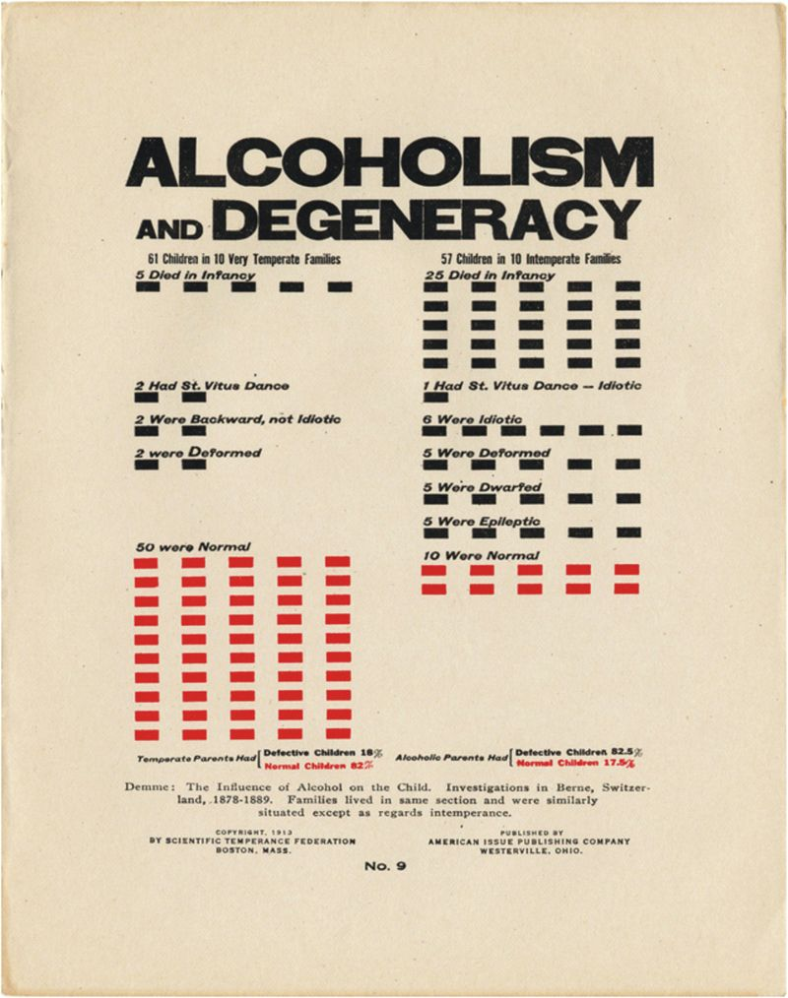

*Source: Boston, MA and Westerville, Ohio: Scientific Temperance and American*

*Issue Publishing Company, 1913.*

Supporting Question 2: Source C

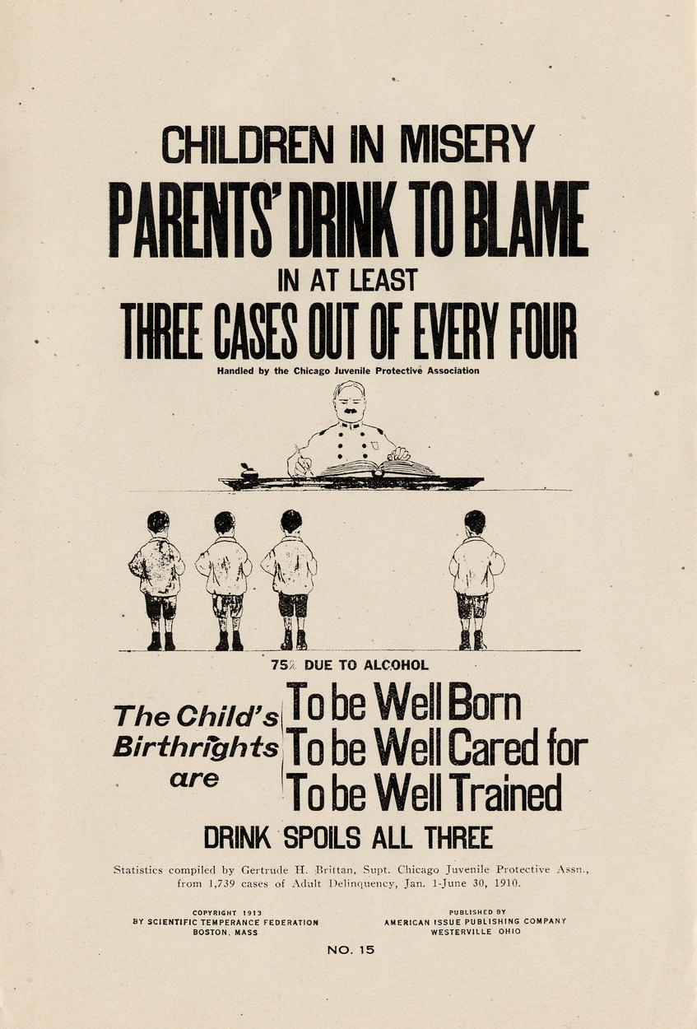

*Source: Boston, MA and Westerville, Ohio: Scientific Temperance Federation*

*and American Issue Publishing Company, 1913.*

Supporting Question 2: Source D

**Anonymous  
Editorial in the New York *Evening Journal*  
1918**

How often have you seen a drunken man stagger along the street!

His clothes are soiled from falling. His face is bruised. His eyes are dull. Sometimes he curses the boys that tease him. Sometimes he tries to smile in a drunken effort to placate pitiless, childish cruelty.

His body, worn out, can stand no more, and he mumbles that he is going home.

The children persecute him, throw things at him, laugh at him, running ahead of him.

Grown men and women, too, often laugh with the children, nudge each other, and actually find humor in the sight of a human being sunk below the lowest animal.

The sight of a drunken man going home should make every other man sad and sympathetic. And horrible as the sight is, it should be useful, by inspiring in those who see it a determination to avoid and to help others avoid that man's fate.

That reeling drunkard is going home.

He is going home to children who are afraid of him, to a wife whose life he has made miserable.

He is going home, taking with him the worst curse in the world - to suffer bitter remorse himself after having inflicted suffering on those whom he should protect.

And as he goes home men and women, knowing what the homecoming means, laugh at him and enjoy the sight.

In the old days in the arena it occasionally happened that brothers were set to fight each other. When they refused to fight, they were forced to it by red-hot irons applied to their backs.

We have progressed beyond the moral condition of human beings guilty of such brutality as that. But we cannot call ourselves civilized while our imaginations and sympathies are so dull that the reeling drunkard is thought an amusing spectacle.

Supporting Question 2: Source Analysis

1. Why might the National Temperance Council have met in 1920 (*after* the passage of the 18th Amendment)? What do you predict they will say?

2. What does the National Temperance Council claim is caused by

alcohol?

3. Do you think people at the time found these claims convincing? Explain.

4. According to these posters, what are two reasons why Prohibition is a

good idea?

5. Using these posters, explain some of the beliefs about children that were

common in the early 20th century. Do you think these beliefs are reasonable? Explain.

People who supported Prohibition thought it would solve a lot of society’s problems. Use the documents to explain what problems they saw in society and why they thought Prohibition would solve these problems.

Supporting Question 3

|  |  |
| --- | --- |
| Supporting Question | How did Americans get around the 18th amendment? |
| Formative Performance Task | Analyze primary source excerpts to determine ways in which Americans were able to break the law. |
| Featured Sources | Source A: Bootlegging and Speakeasies. The Century for Young People: 1901-1936: Becoming Modern America By Peter Jennings, Todd Brewster Source B: Quote from Al Capone 1919.  Source C: Police Corruption. The Century for Young People: 1901-1936: Becoming Modern America By Peter Jennings, Todd Brewster |
| Conceptual Understandings | 8.3e Following the end of World War I, the United States entered a period of increased economic prosperity and radical cultural change known as the Roaring Twenties. During this time, new opportunities for women were gained, and African Americans engaged in various efforts to distinguish themselves and celebrate their culture. |
| Content Specifications | Students will examine the impact of prohibition on American society. |
| Social Studies Practices | Comparison and Contextualization  Gathering, Using and Interpreting Evidence |

Supporting Question 3: Source A

**Bootlegging and Speakeasies**

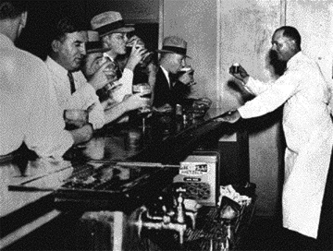*“My mother was Irish, from county Sligo, and for her making booze was a family tradition. In Ireland, everyone makes their own stuff. So when she got here to New York, she and my father bough some rooming houses and when Prohibition hit, she just started making booze in the kitchen and selling it from the ground floor. She was a real businesswoman, my mother, and I guess I took after her. As a teenager, I was already driving around in a Nash convertible making deliveries and running four speakeasies.*

*The way it worked was we’d make some of our own stuff, and the rest we’d bring in from Scotland or Canada. Our speakeasies were just like regular bars you’d see today except for door with the peephole in it. We had to be careful who we let in and we know our customers on a first name basis--they were like family. If a stranger were to come in and turned out to be a government agent and you sold him anything, you’d be arrested. The minute you asked him for the money, he’d put on the badge and pow! They would put a big lock on your door and close your joint down.”*

1. How did American’s obtain alcohol during Prohibition?

Supporting Question 3: Source B

**Rise of Organized Crime**

“*I make my money by supplying a public demand. If I break the law, my customers, who number hundreds of the best people in Chicago, are as guilty as I am. Everyone calls me a racketeer [criminal], I call myself a businessman.”*

-Al Capone, quoted in 1919

1. How did Al Capone justify his actions of distributing alcohol illegally during Prohibition?

Supporting Question 3: Source C

**Police Corruption**

“*We had to watch out for cops, too, but we knew quite a few of them. Some of the best customers were cops? Sometimes they’d pay for their drinks but mostly we’d take care of them, you know, if they were working the beat. When we’d bring in barrels of beer we’d give the beat cop a dollar a barrel if he was watching. This kind of thing was going on across every level. If the Prohibition agents were going to raid us, we would usually get a call from the police captain at the desk telling us ahead of time.”*

1. Based on this document, why was Prohibition hard to enforce?

**Summative Performance Task**

Write an argument that addresses the compelling question by using specific claims and relevant evidence from historical sources while acknowledging the reasons Americans supported the temperance movement and why it ultimately failed. Be sure to use R.A.C.E and cite specific examples from the text to support your claim.