Curriculum Area Project

**CAP SUMMER 2014**

**Computer - Grade 8**

**East Meadow School District**

Superintendent:

Mr. Louis R. DeAngelo

**Woodland Middle School**

Principal:

Mr. James Lethbridge

Project Facilitator:

Marie Garcia

Writers:

Marie Garcia and Patricia Burnside

Curriculum Area Project

**CAP SUMMER 2014**

**Computer – Grade 8**

|  |  |
| --- | --- |
| Content | Page(s) |
| Abstract | 3 |
| Rationale | 4 |
| Excel Project – Grade Book  Average/MIN/MAX/COUNT | 5-8 |
| Excel Project – Bookstore  Discount/Sales Tax | 9-15 |
| Excel Project – Shopping Spree  Budgeting | 16-21 |
| Excel Project – Gas Prices  Line Chart (Trends) | 22-23 |
| Excel Project – Candy Color Comparison  Pie Chart (Percentage of Whole) | 24-26 |
| Excel Project – Theoretical Expected Value/Experimental Expected Value  Scientific Method | 27-35 |
| Excel Project – Functions   * Linear Function * Exponential Function * Polynomial Function | 36-41 |
| Works Cited | 42 |

**Table of Contents**

Curriculum Area Project

**Summer 2014**

**Computer – Grade 8**

Abstract

This Curriculum Area Project is geared towards students in Computer - Grade 8. It was designed to streamline the Computer – Grade 8 Curriculum and to incorporate Common Core Standards and Science, Technology, Engineering, and Mathematics (STEM) into the lessons.

Lessons were designed to use the Excel application to incorporate Mathematical Operations to calculate data. Some of the topics introduced are: Setting up a Grade Book using total, average, minimum, maximum, and count formulas; calculating Bookstore discounts, sales tax, and final costs; creating a Budgeting for a Shopping Spree. Graphing lessons included pie charts, line charts, and bar charts. Scattered line charts were created to introduce Linear Functions, Polynomial Functions, and Exponential Functions to expose students to slope and intercept concepts. Each lesson includes critical thinking questions to align with the Common Core Curriculum. Students will also conduct a scientific experiment, chart the results, and summarize the scientific method.

Curriculum Area Project

**Summer 2014**

**Computer – Grade 8**

Rationale

This Curriculum Area Project was created to provide students in Computer - Grade 8 with the opportunity to solve real-world problems. Science, Technology, Engineering, and Mathematics (STEM) topics are reinforced throughout the unit.

Students are introduced to high-level computer and thinking skills using Excel to input data for analysis and interpretation. They are given the opportunity to work in a cooperative learning environment through groups work and shared ideas. Projects use hands-on activities to teach computer skills and STEM concepts. The students are responsible and accountable for their final projects. They will develop their communication and presentation skills by sharing their completed work with others.

**COMPUTER 8**

**Aim of Lesson:**

**Use Microsoft Excel to create a Grade Book to calculate SUM/AVG/MIN/MAX/COUNT**

**DO NOW: Open Up GRADE BOOK document from Teacher Name/Excel Share Folder.**

**New York State Standards**

**2.1-2.6, 3.3-3.6, 4.1-4.4 MST 3.2/3.3/3.5 CDOS 2**

**READING STANDARDS FOR LITERACY IN SCIENCE AND TECHNICAL SUBJECTS**

**3, 4, 6**

**WRITING STANDARDS – LITERACY IN HISTORY/SOCIAL STUDIES, SCIENCE, AND TECHNICAL SUBJECTS 6-12**

**1c-1e, 2a-2f, 4, 5, 6**

**Behavioral Objectives**

**•Students are to work cooperatively. Students are to listen to formula directions and participate with questions regarding mathematical calculations.**

**Procedure**

* **Students will open template from share folder**
* **Students will add column and split name list-Data/Text to Columns**
* **Students will add formulas to calculate the Student and Class Totals/AVG/MIN/MAX/COUNT**
* **Student will print formulas to the Laser printer (Ctrl ~)**
* **Students will add rows and delete columns**
* **Students will use the formatting tools including text size, bold, color fill, cell alignment, borders**
* **Students will sort data on AVERAGE Column in descending order to find student with highest average**
* **Students will print final copy to the color printer**
* **Extra Credit Level V – Synthesis Question on HOW TO Sheet**

**Instructional Materials**

* **Hand out instruction how-to-sheet**
* **LiteWare Projector for demonstrating and modeling**
* **White board to demonstrate formulas**

**Instructional Technology**

* **Computers**
* **Internet**
* **LiteWare Projector**

**Assessment Questions**

**How do you calculate averages, minimum and maximum grades, and count the total number of items in a column/row? How do you find the student with the highest average? What are you representing by the count formula for the students and for the class?**

**Summary**

* **Students are to submit their completed Excel Color Copy and attach formula calculations.**

**Supplementary Activities**

* **Students will create a Grade Book for their own grades to monitor their performance throughout Computer 8 (10-week class).**
* **Students will include a header on their spreadsheet.**
* **Students will include the following Column Headings: Application Used, Project Name, Project Grade, Resubmitted Grade**

# C:\Users\margarci\AppData\Local\Microsoft\Windows\Temporary Internet Files\Content.IE5\C5A2Y0F0\MC900150927[1].wmfComputer 8

# Excel Activity

# **GRADE BOOK (How-to-Sheet)**

1. Open Excel
2. Choose File Open
   1. Woodland/Share
   2. Teacher Name (Garcia/Burnside/Dale)
   3. Excel
   4. Grade Book
3. Save in your own DIRECTORY as Grade Book
4. Right Click on Column B and select Insert to insert a new column.
5. Select all students in Column A (do not include the Column Heading)
6. Select the Data Ribbon and select “**Text to Columns**”
7. Click on Next, Next, and Finish.
8. Change Column Heading in cell A1 to “Last Name”
9. Change Column Heading in cell B1 to “First Name”
10. Calculate the spreadsheet (use your FORMULA SHEET)
11. Click on Insert/Header and Footer - Custom header
    1. Left Section: Your Name
    2. Center Section: Computer 8/Period #
    3. Right Section: Date
12. Click on CTRL ~ to show formulas.
13. Print your spreadsheet with the formulas to the **LASER PRINTER.**
14. **Format Spreadsheet**
15. Insert 3 rows on top by clicking on the grayed “line #1” and right click Insert OR select Insert/Insert Sheet Row – Repeat 3 times.
16. Put the title GRADE BOOK (ALL CAPS) in cell C3 – Use Font Size 16, Bold, and underline
17. Change All the Words in the Column Headings and Column A and B to Font Size 12, Bold – Center All Column Headings and Words
18. Change the Numbers to Font Size 12, Bold
19. CENTER All Numbers in their cells by clicking on the center button.
20. Highlight Student Section (Include Column Headings) - Fill Color Blue
21. Highlight Class Section (Include Row Headings) – Fill Color –Yellow
22. **Additional Tasks**
    1. Delete Column “Project 2” by clicking on the grayed “G” and right click Delete **OR** select Delete/Delete Sheet Column.
    2. Sort Students by the Average Column by selecting all student information and selecting SORT/CUSTOM SORT/SORT ON Column I/Descending Order (Z-A).
    3. Draw an **arrow** pointing to the **STUDENT(s) (point to his/her name)** with the highest grade point average by selecting Insert/Shapes. Select a line color and weight for your arrow.
    4. Place a cell border around the **CELL** with the highest student average (cell goes around the average figure) by clicking on ***Borders/Line Color and then Borders/Thick Box Border. Select any color NOT BLACK.***
    5. Insert a picture relating to **SCHOOL**.
23. Printing
    1. First Click on View/Page Layout
    2. Be sure everything fits to **ONE PAGE ONLY (Double Click between columns to resize)**
    3. Select File/Print Color Printer
24. Attach Color printout with Formula printout.

**\*DON’T FORGET TO TRY THIS EXTRA CREDIT FOR 5 POINTS\*:**

**If the Student with the Homework grade “0” hands in his/her**

**Homework and gets a grade of “70”**

**Then how many points did his/her *Averag*e increase by? ANSWER: \_\_\_\_\_\_\_\_\_\_\_\_\_**.

**Formula Sheet**

**=sum(cell#:cell#)**

**bd07227_=average(cell#:cell#)**

**=min(cell#:cell#)**

**=max(cell#:cell#)**

**=count(cell#:cell#)**

**Sample Formula**

Cell #

Cell #

=**sum**(**b7:b12**)

**Mathematical**

**Operation**

**Range of Numbers**

**(Starting Cell:Ending Cell)**

All formulas begin with an equal sign.

**TO PRINT YOUR FORMULAS:**

**Click on CTRL and ~ (Everything stretches out—just select at the bottom of the Print Options “No Scaling” and change to “Fit Sheet on One Page.” Print to the LASER.**

**Click CTRL and ~ to get back to your spreadsheet with your numbers.**

**COMPUTER 8**

**Aim of Lesson:**

**Use Microsoft Excel to calculate Percentage Discount and Nassau County Sales Tax**

**DAY 1:**

**DO NOW: Open Up BOOKSTORE document from Teacher Name (Garcia/Burnside/Dale) Excel Share Folder.**

**DAY 2:**

**DO NOW: Open Up BOOKSTORE document from your files. Answer the three questions based on your BOOKSTORE spreadsheet.**

**New York State Standards**

**2.1-2.6, 3.3-3.6, 4.1-4.4 MST 3.2/3.3/3.5 CDOS 2**

**READING STANDARDS FOR LITERACY IN SCIENCE AND TECHNICAL SUBJECTS**

**3, 4, 6**

**WRITING STANDARDS – LITERACY IN HISTORY/SOCIAL STUDIES, SCIENCE, AND TECHNICAL SUBJECTS 6-12**

**1c-1e, 2a-2f, 4, 5, 6**

**Behavioral Objectives**

* **Students are to work cooperatively. Students are to listen to formula directions and participate with questions regarding mathematical calculations.**

**Procedure**

* **Students will open template from share folder**
* **Students will add formulas to calculate % Discount/Sales Price/8.625% Tax/Final Cost/Totals**
* **Student will print formulas to the Laser printer**
* **Students will use the formatting tools to format the spreadsheet**
* **Students will print final copy to the color printer**

**Instructional Materials**

* **Hand out instruction how-to-sheet and Grading Rubric**
* **LiteWare Projector for demonstrating and modeling**
* **White board to demonstrate formulas**

**Instructional Technology**

* **Computers**
* **Internet**
* **LiteWare Projector**

**Assessment Questions**

**What is a cell? What is a discount? How do you calculate a discount? How do you find the Sales Price? What is the Nassau County Sales Tax? How would you calculate the Sales Tax for each book?**

**Summary**

* **Students are to submit their completed Excel Color Copy and attach formula calculations.**

**Supplementary Activities:**

1. **Bookstore Questions – Students will open file from share folder and answer 10 questions analyzing the Bookstore spreadsheet.**
2. **Have students use the Internet to search the following website:** [**http://www.barnesandnoble.com/**](http://www.barnesandnoble.com/)

**Have students search for another book they would like to read and have them add it to their Bookstore spreadsheet. Have them find the List Price/20% Discount/Sale Price/Tax/Final Cost for this book.**

# DIRECTIONS FOR BOOKSTORE

MCj04123980000[1]

**In EXCEL, open the spreadsheet “Bookstore” from the share folder.**

**TEACHER NAME(GARCIA/BURNSIDE/DALE)/COMPUTER 8/EXCEL/BOOKSTORE**

**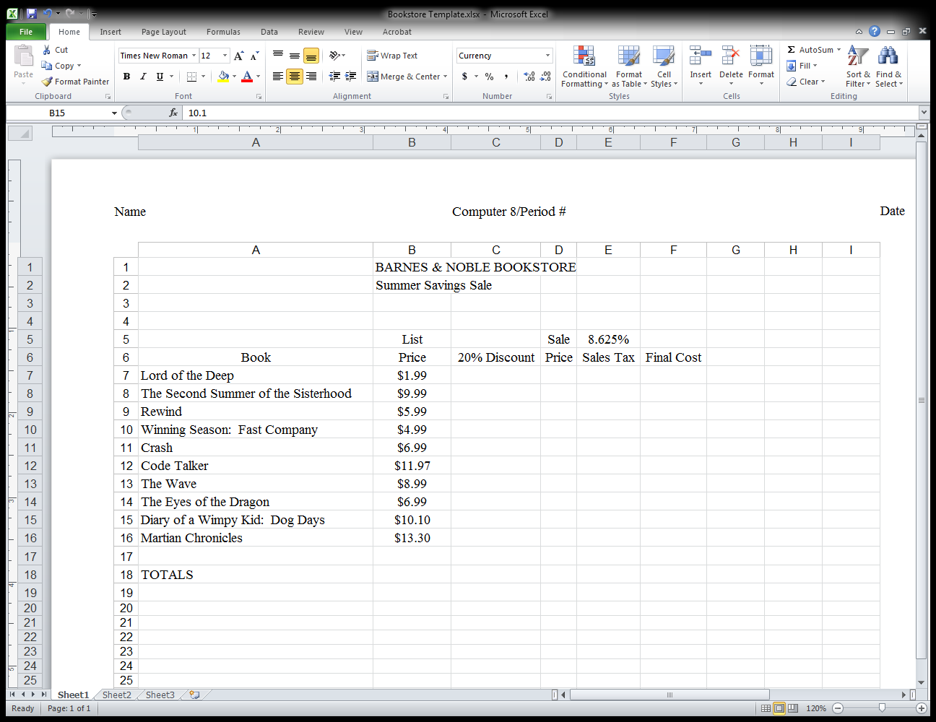**

1. **Calculate the Spreadsheet by inserting the appropriate formulas:**

* **(20% Discount = List Price\*20% OR .20)**
* **(Sale Price = List Price - 20% Discount)**
* **(Sales Tax Rate = Sale Price \* Sales Tax Total (8.625% or .08625)**

**SALES TAX BREAKDOWN**

**District Rate**

**New York State 4.00%**

**Nassau County 4.625%**

**Total 8.625%**

* **(Final Cost = Sale Price + Sales Tax)**

1. **Add header by selecting Insert/Header/Three Column Header - Type the following in each section:**
2. **Your Name Computer 8/Period # Date**
3. **Print FORMULAS to Laser Printer by selecting CTRL ~ then SAVE as “Bookstore” CTRL ~ again to get out of formulas. Remember to select print to “Fit Sheet to One Page”**

**FORMATTING:**

1. **Format Columns B, C, D, E, F for Currency by selecting number cells and on the HOME ribbon click Numbers and select Currency (Decimal Places should be 2 and $ for symbol)**
2. Choose CENTER alignment for all numbers in your spreadsheet by highlighting number cells and selecting the CENTER alignment on the formatting toolbar.
3. **Widen the columns to the longest line by placing the cursor between the lettered columns and double-click with your mouse.**
4. **Change Title in Cell B1 to BOLD, Size 16, and Underline.**
5. **Change Subtitle in Cell B2 to BOLD, Size 14**
6. **Insert 3 Rows ABOVE the Title by placing the cursor on the grayed row numbers and clicking on Home Ribbon Insert/Sheet Rows (repeat 3 times).**
7. **Change Column Headings to BOLD, Size 12. Choose any Font Style.**
8. **CENTER all Column Headings using the center button.**
9. **Change all the text in Column A to BOLD, Size 12. Choose any Font Style.**
10. **SORT all the Text in Column A using Sort Filter/Sort A to Z (on Home Ribbon)**
11. **Draw a picture relating to one of the books on the list using Insert Ribbon Shapes. Fill your drawing with the bucket.**
12. **Add a clip art or Internet picture relating to Books, Insert Ribbon/ClipArt.**
13. **Change Font Color in Column F (Total) to PURPLE by highlighting column and selecting Font color.**
14. **Change Fill Color in Row 21 to LIGHT ORANGE. (Use Paint Bucket)**
15. **Put a RED Outline Border around the TOTAL of all the books together. Click on HOME ribbon Border, Select Down Arrow and Click on More Borders – Change Color Automatic to Blue, Select Line Style and update by pressing Outline Button.**
16. **Print and preview the spreadsheet, change orientation to landscape by selecting Page Layout/Orientation/Landscape.**
17. **Print to color printer.**
18. **Attach the Laser sheet with your formulas to the color copy. (Ctrl ~)**

Name Period#

**DO NOW:**

**BOOKSTORE QUESTIONS**

What are the **formulas** to calculate the following?

1. **Sale Price** of Diary of a Wimpy Kid: Dog Days? \_\_\_\_\_\_\_\_\_\_\_\_\_\_\_\_\_\_\_\_\_\_\_
2. Total **List Price** of ALL the Books together? \_\_\_\_\_\_\_\_\_\_\_\_\_\_\_\_\_\_\_\_\_\_\_\_\_\_\_
3. The **20% Discount** for Martian Chronicles? \_\_\_\_\_\_\_\_\_\_\_\_\_\_\_\_\_\_\_\_\_\_\_\_\_\_\_\_\_\_

Name Period#

**EXIT OUTCOME:**

**BOOKSTORE**

Why would you use the Excel program instead of a calculator when calculating discounts?

\_\_\_\_\_\_\_\_\_\_\_\_\_\_\_\_\_\_\_\_\_\_\_\_\_\_\_\_\_\_\_\_\_\_\_\_\_\_\_\_\_\_\_\_\_\_\_\_\_\_\_\_\_\_\_\_\_\_\_\_\_\_\_\_\_\_\_\_\_\_\_\_\_\_\_\_\_\_\_\_\_\_\_\_\_\_\_\_\_\_\_\_\_\_\_\_\_\_\_\_\_\_\_\_\_\_\_\_\_\_\_\_\_\_\_\_\_\_\_\_\_\_\_\_\_\_\_\_\_\_\_\_\_\_\_\_\_\_\_\_\_\_\_\_\_\_\_\_\_\_\_\_\_\_\_\_\_\_\_\_\_\_\_\_\_\_\_\_\_\_\_\_\_\_\_\_\_\_\_\_\_\_\_\_\_\_\_\_\_\_\_\_\_\_\_\_\_\_\_\_\_\_\_\_\_\_\_\_\_\_\_\_\_\_\_\_\_\_\_\_\_\_\_\_\_\_\_\_\_\_\_\_\_\_\_\_\_\_\_\_\_\_\_\_\_\_\_\_\_\_\_\_\_\_\_\_\_\_\_\_\_\_\_\_\_\_\_\_\_\_\_\_\_\_\_\_\_\_\_\_\_\_\_\_\_\_\_\_\_\_\_

****

**EXCEL – BOOKSTORE**

**Supplementary Activity**

1. **Use the Internet to search the following website:** [**http://www.barnesandnoble.com/**](http://www.barnesandnoble.com/)
2. **Search for another book that you would like to read and add it to your Bookstore spreadsheet.**
3. **Type the name of your book in cell A20 and the List Price of the book in cell B20.**
4. **Watch the spreadsheet automatically calculate your book into the Totals.**
5. **Save spreadsheet as: “BarnesandNoble” and print to color printer.**

**COMPUTER 8**

**Aim of Lesson:**

**Use Microsoft Excel to create a budget for a Shopping Spree**

**DO NOW: Open Up SHOPPING SPREE document from Teacher Name (Garcia/Burnside/Dale) Excel Share Folder.**

**DAY 2:**

**DO NOW: Open Up SHOPPING SPREE document from your files. Answer the three questions based on your SHOPPING SPREE spreadsheet.**

**New York State Standards**

**2.1-2.6, 3.3-3.6, 4.1-4.4 MST 3.2/3.3/3.5 CDOS 2**

**READING STANDARDS FOR LITERACY IN SCIENCE AND TECHNICAL SUBJECTS**

**3, 4, 6**

**WRITING STANDARDS – LITERACY IN HISTORY/SOCIAL STUDIES, SCIENCE, AND TECHNICAL SUBJECTS 6-12**

**1c-1e, 2a-2f, 4, 5, 6**

**Behavioral Objectives**

**•Students are to work cooperatively. Students are to listen to formula directions and participate with questions regarding mathematical calculations.**

**Procedure**

* **Students will open Shopping Spree template from share folder**
* **Students will add formulas to calculate Price x Quantity/Cost/8.625% Sales Tax/Final Cost**
* **Students must stay within a $850 budget (amount given can be changed for each class)**
* **Students print formulas to the Laser printer**
* **Students will use the formatting tools to format the spreadsheet**
* **Students will print final copy to the color printer**

**Instructional Materials**

* **Hand out instruction how-to-sheet**
* **LiteWare Projector for demonstrating and modeling**
* **White board to demonstrate formulas**

**Instructional Technology**

* **Computers**
* **Internet**
* **LiteWare Projector**

**Assessment Questions**

**What does Quantity represent? How do you calculate the cost of an item? How do you check to make sure you are within budget?**

**Summary**

* **Students are to submit their completed Excel Color Copy and attach formula calculations.**

**Supplementary Activity**

* **Have students create a spreadsheet budget to purchase tickets from** [**http://www.stubhub.com/**](http://www.stubhub.com/)

**for an upcoming event. The budget is $200. They should include a title, name of the event, price of**

**each ticket, quantity, 8.625% sales tax, and final cost.**

* **Have students attach the StubHub ticket detail sheet to their spreadsheet.**

DIRECTIONS FOR SHOPPING SPREE

j0234419

1. Start by entering 2 for each of the items in the QUANTITY column.
2. Calculate spreadsheet by entering formulas in columns D, E, F. (Price x Quantity = Cost)
3. Calculate the total columns B, C, D, E, F (=sum(firstcell#:lastcell#)
4. Format Column C to a Number **by selecting number cells and on the HOME ribbon click Numbers and select Numbers—Click on decimal button to select 0 decimal places.**
5. **Format Columns B, D, E, F for Currency by selecting number cells and on the HOME ribbon click Numbers and Currency (Decimal Places should be 2 and $ for symbol)**
6. **CENTER** all numbers in each column by highlighting the number cells and selecting the Center button.
7. **Sort the items in column B by selecting Sort&Filter on the Home Ribbon. Be sure to select all rows across to final cost.**
8. **Put a Custom Header on your spreadsheet by selecting (View/Header/Footer/Custom Header).**

**Name Computer 8/Period # Date**

1. Insert 3 rows above the title by clicking on the Row #1 and selecting Insert/Insert Sheet Rows (do this 3 times).
2. Format Title Size 16, **Bold**, Underline, and Select a Decorative Font Style.
3. Change all **Column Headings** to **Bold, Size 12**, and select any font style.
4. **CENTER** all **Column Headings** by clicking on the Center Button.
5. Change **all the text in Column A** to **Bold, Size 12**, and select any font style.
6. Widen each column by Double-clicking between the grayed column letters (you will get a two sided, black cross).
7. Change the Font Color in Column F (FINAL COST) to DARK BLUE
8. Change the Fill Color (use the Bucket) in Row 15 (TOTALS) to YELLOW
9. Put a **PURPLE** Border around the **Final Cost Total** cell.
10. Add one graphic that relates to the items purchased (example T-Shirt, Boots, etc.)
11. Draw a “shopping bag” using Insert/Shapes. Right Click on Shape to Add Text (Add the name of the store that you shop at for clothing.)
12. **Change the Quantity numbers to represent what you will be buying with your $850.** Try to get your ***final cost total as close to $850 as possible* without going over!** (You may have “0” Quantity for some items, but type a zero in those cells.)
13. bd04896_Save as “Shopping Spree.”
14. Be sure to FIT TO ONE PAGE and print to the Color Printer.
15. Print formulas to the laser printer by selecting CTL ~ .
16. Attach laser copy of FORMULAS to COLOR COPY.

**$850**

Name Period#

**DO NOW:**

**SHOPPING SPREE QUESTIONS**

What are the **formulas** to calculate the following?

1. The **Cost** for the **Sweatshirt**?\_\_\_\_\_\_\_\_\_\_\_\_\_\_\_\_\_\_\_\_\_\_\_
2. Total **Final Cost** of **ALL** the items? \_\_\_\_\_\_\_\_\_\_\_\_\_\_\_\_\_\_\_\_\_\_\_\_
3. The **Tax** for the **Boots**? \_\_\_\_\_\_\_\_\_\_\_\_\_\_\_\_\_\_\_\_\_\_\_\_

Name:

MC900044903[1]Period:

**SHOPPING SPREE QUESTIONS**

**Directions:**

* **Open your Excel spreadsheet (BOOKSTORE) in order to make the changes to answer the questions.**
* **Type your answers below. Be sure to insert a header with the following information:**

**Name Computer 8/Period # Date**

* **Each Question is worth 1 point; you must get the whole question correct to earn the 1 point.**
* **Don’t forget to use $ with currency.**

**Questions:**

1. Using complete sentences**, *explain*** how you calculate the formulas for the cost column?
2. Would the **formulas** change in the **cost column** if the quantity is more than one? Using complete sentences,

***explain*** Why or Why Not?

1. If the sales tax changed to **9 ½%** show me what it would look like in the formula:

as a decimal AND as a percentage

1. What is the **RANGE** of cells to add up the total number of items you purchased?
2. What would the final cost be for the t-shirts if you purchased **three** t-shirts and the price is only $5.00 each?
3. What would the tax be for the socks if you purchased **five** pairs of socks and the price is $2.50 each?
4. How do you represent 15% discount as a decimal?
5. It is l “**NO TAX WEEK.”** What would the final cost be for the boots if you buy 4 pairs of BOOTS and the price is $150 each?
6. If it is **“NO TAX WEEK”,** list the **two columns** that you could delete from the spreadsheet?
7. John wants to use his whole $1000 budget on sneakers. How many pairs of sneakers could he buy?

**C:\Users\mgarcia.INST.000\AppData\Local\Microsoft\Windows\Temporary Internet Files\Content.IE5\UZK77MRA\MC900238965[1].wmf**

**EXCEL – SHOPPING SPREE**

**Supplementary Activity**

1. **Use the Internet to search the following website:** [**http://www.stubhub.com/**](http://www.stubhub.com/)
2. **Create a spreadsheet budget to purchase tickets for an upcoming event.**
3. **The budget is $200.**
4. **Be sure to include a title, name of the event, price of each ticket, quantity, 8.625% sales tax, and final cost.**
5. **Save spreadsheet as: “StubHub” and print to color printer.**
6. **Have students attach the StubHub Ticket Detail sheet to their spreadsheet.**

**COMPUTER 8**

**Aim of Lesson:**

**Use Microsoft Excel to create a line graph displaying changes in US Gas Prices**

**DO NOW: Open Gas Prices file from teacher (GARCIA/BURNSIDE/DALE) share folder.**

**New York State Standards**

**2.1-2.6, 3.3-3.6, 4.1-4.4 MST 3.2/3.3/3.5 CDOS 2**

**READING STANDARDS FOR LITERACY IN SCIENCE AND TECHNICAL SUBJECTS**

**3, 4, 6**

**WRITING STANDARDS – LITERACY IN HISTORY/SOCIAL STUDIES, SCIENCE, AND TECHNICAL SUBJECTS 6-12**

**1c-1e, 2a-2f, 4, 5, 6**

**Behavioral Objectives**

**•Students are to work cooperatively. Students are to listen to formula directions and participate with questions regarding mathematical calculations and Line Graph creation.**

**Procedure**

* **Students will follow instruction sheet for Gas Prices Graph**
* **Students will create a Line Graph from the Data**
* **Students will use the formatting tools to format the Line Graph**
* **Students will print final copy to the color printer**
* **Student will answer question(s) to analyze the Graph**

**Instructional Materials**

* **Hand out instruction how-to-sheet**
* **LiteWare Projector for demonstrating and modeling**
* **SmartBoard/Whiteboard to demonstrate formulas**

**Instructional Technology**

* **Computers**
* **Internet**
* **LiteWare Projector**
* **SmartBoard/Whiteboard**

**Assessment Questions**

**Why would we use a line graph for the Gas Prices information? What do line graphs represent?**

**Summary**

* **Students are to submit their completed Line Graph, attach formula calculations, and question**

**GAS PRICES (LINE GRAPH)**

**CREATING THE CHART**

1. **Open – “Gas Prices Line Graph” from teacher share folder**
2. **Select the information to be graphed (A3:B10)**
3. **Click on Insert /Chart/Line/Line with Markers**
4. **Click on Chart and Move Chart (right upper corner) and select New Chart/New Sheet. Press OK.**
5. **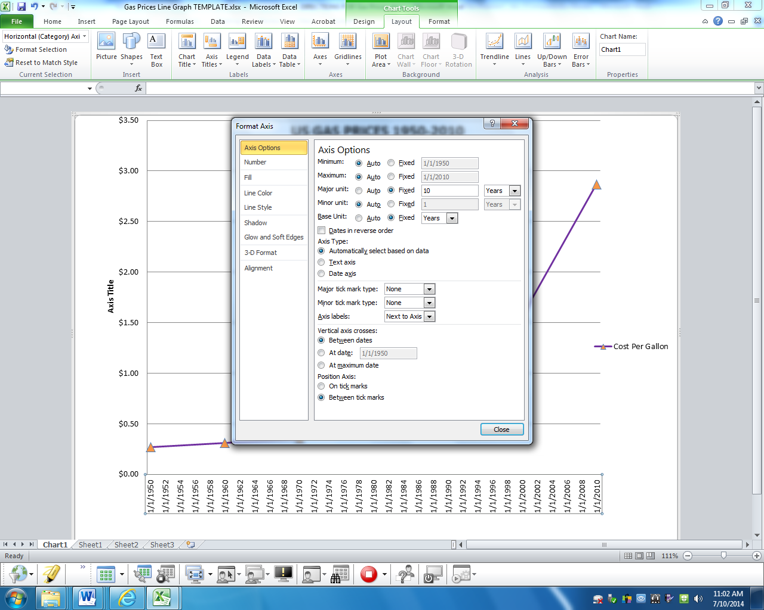Insert a Custom Header: Name Computer 8/Period # Date**

**FORMATING THE CHART**

1. **Click on X Axis and right-click Format Axis and set Major unit to 10 years.**
2. **Double-click on the line markers (be sure all are selected) and change the following:**

* **Marker Options/Select Built in/Change Size of Marker (no more than size 10)**
* **Marker Fill – Select a Solid Fill Color**
* **Line Color – Select a Solid Line Color**

1. **Click on Chart Tools/Design/and select grayed Layout #1**
2. **Right Click/Format Legend/Move Legend to the TOP of page**
3. **Insert Chart Title: US GAS PRICES 1950-2010 (ALL CAPS)**
4. **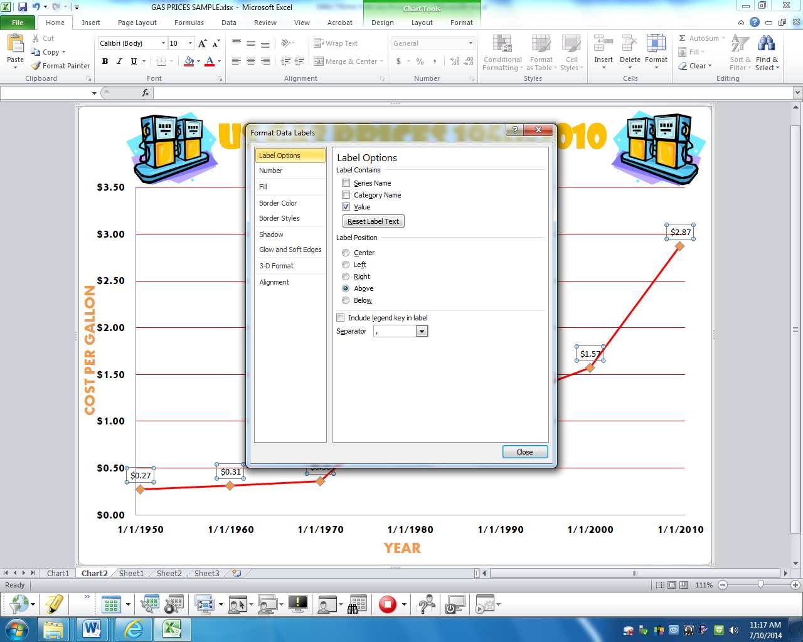Click on Chart tools/Layout/Axis Titles/Primary Horizontal Axis/Title Below Axis**

**Horizontal (x-axis) – YEAR (ALL CAPS)**

**Vertical (y-axis) – COST PER GALLON (ALL CAPS)**

1. **Right click on line and ADD DATA LABELS. Right click on line again and FORMAT DATA LABELS. Select Label Position/Above**
2. **Change font size and colors for all titles.**
3. **Add a picture that relates to gas prices.**
4. **Print preview. If ok, then print graph to the color printer.**

**Answer the following questions based on the line graph. (EXTRA CREDIT – 2 POINTS)**

**Which of the following is a true statement?**

1. **Gas prices decreased over time**
2. **The steepest rise in the price of gas occurred between 1950-1970**
3. **Gas prices remained the same between 1980 and 1990**
4. **Gas prices were lowest in 2010**

**What causes gas prices to fluctuate? \_\_\_\_\_\_\_\_\_\_\_\_\_\_\_\_\_\_\_\_\_\_\_\_\_\_\_\_\_\_\_\_\_\_\_\_\_\_\_\_\_\_\_\_\_\_\_\_\_\_\_\_\_**

\_\_\_\_\_\_\_\_\_\_\_\_\_\_\_\_\_\_\_\_\_\_\_\_\_\_\_\_\_\_\_\_\_\_\_\_\_\_\_\_\_\_\_\_\_\_\_\_\_\_\_\_\_\_\_\_\_\_\_\_\_\_\_\_\_\_\_\_\_\_\_\_\_\_\_\_\_\_\_\_\_\_\_\_\_\_\_\_\_\_\_\_

\_\_\_\_\_\_\_\_\_\_\_\_\_\_\_\_\_\_\_\_\_\_\_\_\_\_\_\_\_\_\_\_\_\_\_\_\_\_\_\_\_\_\_\_\_\_\_\_\_\_\_\_\_\_\_\_\_\_\_\_\_\_\_\_\_\_\_\_\_\_\_\_\_\_\_\_\_\_\_\_\_\_\_\_\_\_\_\_\_\_\_\_

**NAME \_\_\_\_\_\_\_\_\_\_\_\_\_\_\_\_\_\_\_\_\_\_\_\_\_\_\_\_\_\_\_\_\_\_\_\_\_\_\_\_\_\_\_\_\_\_\_\_\_\_\_\_ PERIOD \_\_\_\_\_\_\_\_\_\_\_\_**

**COMPUTER 8**

**Aim of Lesson:**

**Use Microsoft Excel to create a Pie Chart to represent the percentage of each color in a bag of candy to represent the percentage of a part to the whole**

**DO NOW: Open CANDY COLOR COMPARISON document from Teacher (GARCIA/BURNSIDE/DALE)/Excel Share Folder.**

**New York State Standards**

**2.1-2.6, 3.3-3.6, 4.1-4.4 MST 3.2/3.3/3.5 CDOS 2**

**READING STANDARDS FOR LITERACY IN SCIENCE AND TECHNICAL SUBJECTS**

**3, 4, 6**

**WRITING STANDARDS – LITERACY IN HISTORY/SOCIAL STUDIES, SCIENCE, AND TECHNICAL SUBJECTS 6-12**

**1c-1e, 2a-2f, 4, 5, 6**

**Behavioral Objectives**

**•Students are to work cooperatively. Students are to listen to formula directions and participate with questions regarding mathematical calculations.**

**Procedure**

* **Students will open template from share folder**
* **Students are given a bag of candy**
* **Students will sort the candy by color and enter the data into the spreadsheet**
* **The students will add formulas to calculate the percentages of each color and the Totals formulas**
* **Student will print formulas to the Laser printer (Ctrl ~)**
* **Students will use the formatting tools to format the spreadsheet**
* **Students will create a Pie Chart and format the chart according to directions**
* **Students will print final copy to the color printer**
* **Extra Credit Question on HOW TO Sheet**

**Instructional Materials**

* **Hand out instruction how-to-sheet and bag of Candy (M&M’s, Skittles, Starburst, Smarties, etc.)**
* **LiteWare Projector for demonstrating and modeling**
* **White board to demonstrate formulas**

**Instructional Technology**

* **Computers**
* **Internet**
* **LiteWare Projector**

**Assessment Questions**

**How do you represent a % (part) of a whole (100%)? How do you create a pie chart?**

**Summary**

* **Students are to submit their completed Excel Color Copy and attach formula calculations.**

Computer 8

# Excel Graph Activity

**CANDY COLOR COMPARISON**

# How-to-Sheet

In EXCEL, open the spreadsheet “Cady Color Comparison from the share folder.

**TEACHER NAME (GARCIA/BURSIDE/DALE)/COMPUTER8/EXCEL/CANDY COLOR COMPARISON**

1. In cell **A4**, put the type of candy you have (m&m’s Pretzel OR m&m’s Plain OR Smarties OR Skittles)
2. Enter the values for each color candy from your package in cells B4 through G4 **(If your colors are different from the colors listed--Delete or Add Columns as needed. (sit on the gray column letter and press Delete/Sheet Column ).**
3. Go to cell **H4** and under the cell that says TOTALS, enter the formula to total the number of candies in your package **=SUM(CELL#:CELL#)**
   1. Go to row 5 and enter the formula for the % of total candies by dividing **(take the candy number and divide by total candies)**  **=CELL#/TOTAL CELL# For example: B4/H4**
4. Go to cell **H6** enter the formula to total the percentage of total candies **=SUM(CELL#:CELL#)**
5. Format cells in row 5 to Percentage with no decimals (Click on Number Tab and Select Percentage Click on Decrease Decimal icon 2x)
6. Go to row 3 and highlight each individual cell **with the appropriate color fill (bucket)** to represent the **candy color** (use paint bucket).
7. **Insert 3 rows ABOVE the title by clicking on the grayed line #1 and selecting Insert/Sheet Row**
8. **Change Title to BOLD, Font Size 16, Underline**
9. **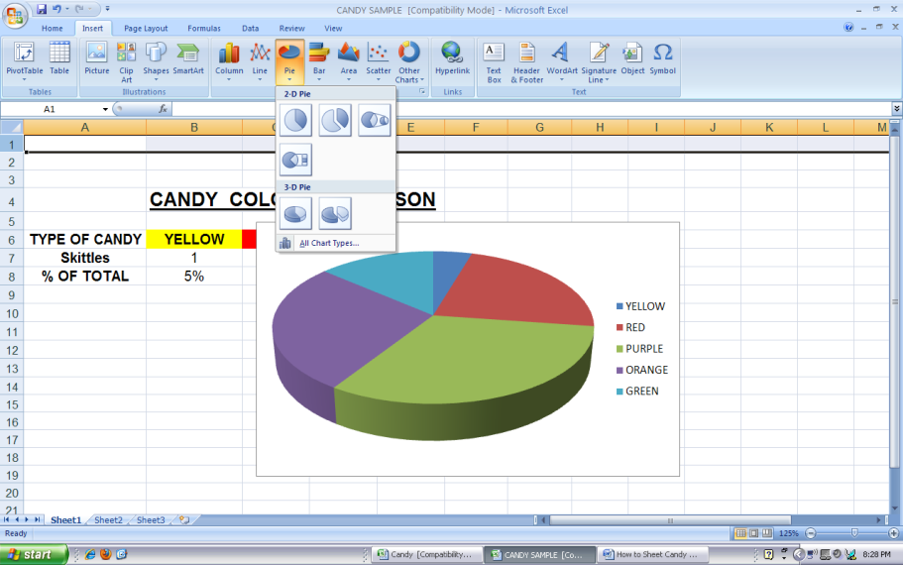Bold 12 all Column Heading.**
10. **Center all Column Headings.**
11. **Bold 12 all words in Column A.**
12. **Bold 12 all numbers and percentages.**
13. **Center all numbers and percentages.**
14. Highlight the range of cells **B6 through G7**

(Just the Colors and the Numbers listed below them—NOT the percentages)

1. Click on Insert/Pie/3D
2. Double Click Pie to
3. Get Chart Tools.
4. Select Chart Layout/Design.
5. Select the 2nd choice with

the Chart Title and %.

1. 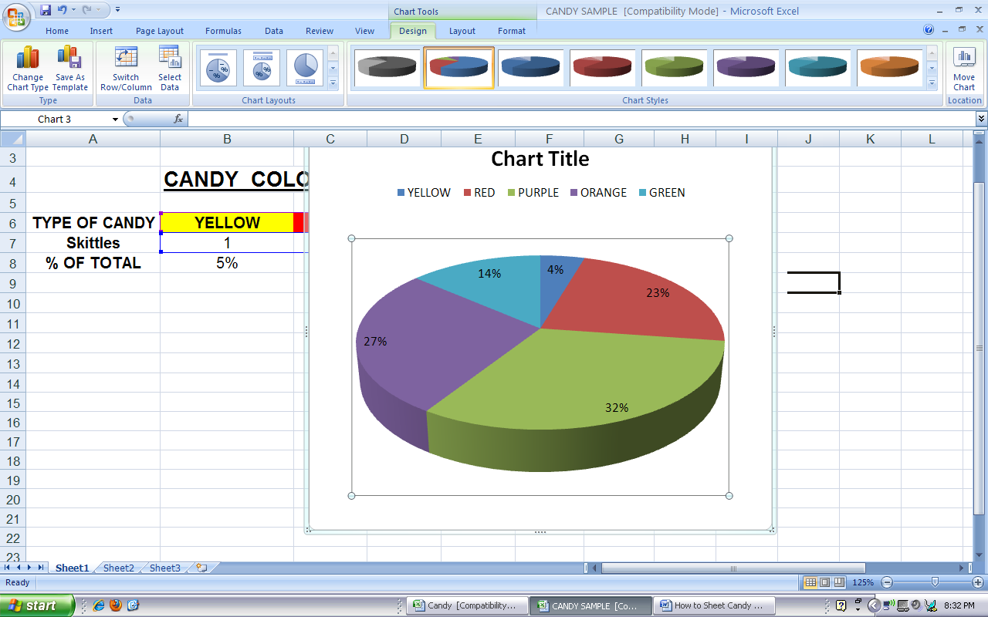Double Click Chart Title and type

chart title CANDY COLOR COMPARISON (use ALL CAPS)

1. Click on color name and Right Click Format Chart Area. Fill Color with appropriate colors.
2. Click on Insert Ribbon to Insert/Header as follows:

Name Computer 8/Period # Date

1. **Insert *at least one* clip art or picture from the Internet**

to enhance your graph. The Skittles website is: [www.skittles.com](http://www.skittles.com) and

the M&M website is: [www.m-ms.com](http://www.m-ms.com) or use your Insert Ribbon to Insert/Clip Art to insert a clip art picture into Excel which relates to CANDY.

1. Right Click to REMOVE HYPERLINK from picture.
2. Double Click Picture to Recolor with Transparent Color Pen.

24. Select View/Page Layout/Full Screen to be sure all information is within viewing range and that it **fits on ONE page.** Otherwise change orientation to “Landscape” which can be found under Page Layout Ribbon/Orientation/Landscape.

25. Print to COLOR Printer.

26. Print FORMULAS to laser printer (Ctrl ~ to display formulas.)

27. Attach Color copy and Formulas together.

28. Put in the completed work folder.

**EXTRA CREDIT QUESTION (5 POINTS)—Which of your**

**candy color(s) had the highest percentage?**

**Answer: \_\_\_\_\_\_\_\_**

**COMPUTER 8**

**Aim of Lesson:**

* **Introduce the topic of Theoretical and Expected Values with the “Cereal Box Problem”**
* **Students will perform an experiment to determine the number of cereal boxes they would need to buy to get all six different prizes**
* **Students will graph their results (using Excel) and type up their Scientific Method (using Word).**

**DO NOW:**

**Students are presented with the problem “How many boxes of cereal do you need to buy to get all six different prizes?” Students will write down their “guess” (hypothesis) on a handout. Hand in to teacher.**

**New York State Standards:**

**MST 1, 2, 3, 4, 5, 6, 7**

**ELA 3**

**2.1-2.6, 3.3-3.6, 4.1-4.4 MST 3.2/3.3/3.5 CDOS 2**

**READING STANDARDS FOR LITERACY IN SCIENCE AND TECHNICAL SUBJECTS**

**3, 4, 6**

**WRITING STANDARDS – LITERACY IN HISTORY/SOCIAL STUDIES, SCIENCE, AND TECHNICAL SUBJECTS 6-12**

**1c-1e, 2a-2f, 4, 5, 6**

**Behavioral Objectives**

* **Students are to work cooperatively in groups. Students are to listen to formula directions and participate with questions regarding mathematical calculations.**

**Instructional Materials**

* **Tally sheet**
* **Dice**
* **LiteWare Projector for demonstrating and modeling**
* **White board to demonstrate formulas**
* **Tri-fold Poster Board for Class Experiment Presentation**

**Instructional Technology**

* **Computers**
* **Internet**
* **LiteWare ProjectorProcedures**
* **Website** [**http://mste.illinois.edu/reese/cereal/model.php**](http://mste.illinois.edu/reese/cereal/model.php)

**Procedures:**

1. **Explain *The Cereal Box Problem* to the students. Ask them the question:   
   “How many boxes of cereal do you need to buy to get all six different prizes?” Have students fill out Guess handout.**
2. **Have students get into groups of 3. Then have students go to the following website:** [**http://mste.illinois.edu/reese/cereal/cereal.php**](http://mste.illinois.edu/reese/cereal/cereal.php)
3. **Type “6” under the Number of Animal Types. Then press “Run Simulation.” Have students repeat the simulation several times to see how many boxes of cereal were bought.**
4. **Explain the formula for the Theoretical Expected Value (TEV) to the students. Explain how they will each perform the experiment to see what the results will be. They will use dice to represent the 6 different prizes they can get in each of the cereal boxes.**
5. **Give the students a Blank Tally Sheet to perform the experiment. They will roll the dice and tally what number they get on the dice. Once they have at least one of each number, they will add up the total number of rolls. Students will repeat the experiment 10 times. After they finished have them give a grand total # of Rolls and then calculate the Experimental Expected Value (EEV).**
6. **Discuss the results after 10 times. Take the total number of rolls for the 10 trials and divide by 10 to get the Experimental Expected Value (EEV). Basically this is an average. Have each report their info to be inputted into an Excel spreadsheet.**
7. **Then add up all the rolls for all the groups together and see what the EEV is for the class. For example, if you have 8 groups of students who each did the experiment 10 times you would have had 80 trials total for the class. For example, (1330 rolls/80 trials = EEV 13.3). This will vary depending on how many groups you have in the class.**
8. **Have the students create an Excel Bar Graph representing the EEV for the class. Add a text box with the results for the class EEV (the combined rolls). (See attached How-To-Sheet)**
9. **Have each group write up their Scientific Method indicating the different parts of the experiment.**

**Assessment:**

**Have students hand in:**

* **Guess Sheet**
* **The Cereal Box Problem TEV/EEV Worksheet**
* **Group Tally Sheet**
* **EEV Results Bar Graph**
* **Scientific Method Report**

**Supplemental Activities:**

* **Have students perform other Science Experiments and talk about how they would set up the experiment and record their results.**
* **Probability Website:** [**http://matti.usu.edu/nlvm/nav/vlibrary.html**](http://matti.usu.edu/nlvm/nav/vlibrary.html)

**Assessment Questions**

**How did your group’s results compare to your hypothesis (guess)?**

**How did the class’s results compare to your hypothesis (guess)?**

**Summary**

* **Create a Class Poster Board for the Experiment**

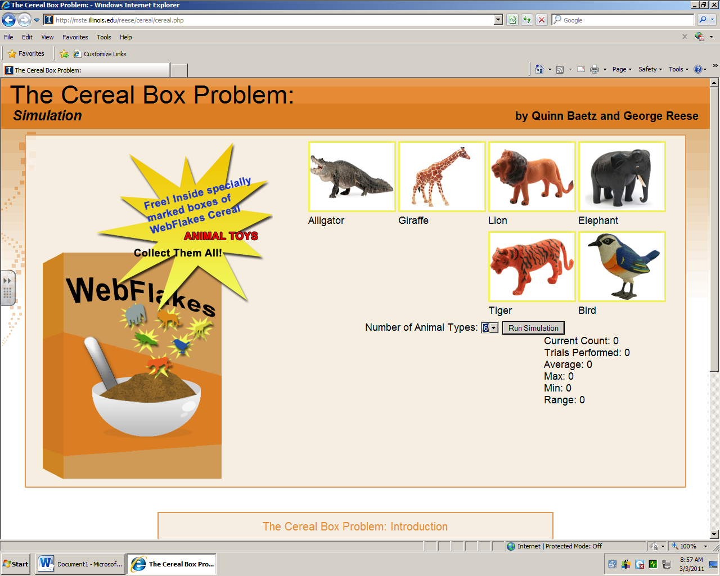

**GET ALL SIX PRIZES**



MY GUESS IS:

**How many boxes of cereal do you need to buy to get all six different prizes?**

****

Name(s)\_\_\_\_\_\_\_\_\_\_\_\_\_\_\_\_\_\_\_\_\_\_\_\_\_\_\_\_\_\_\_\_\_\_\_\_\_\_\_\_\_\_\_\_\_ Group # \_\_\_ Period #

THE CEREAL BOX PROBLEM

Experimental Expected Value

**TALLY SHEET**

|  |  |  |  |  |  |  |  |
| --- | --- | --- | --- | --- | --- | --- | --- |
|  | Prize #1 . . . | Prize #2 . . . | Prize #3 . . . | Prize #4 . . . | Prize #5 . . . | Prize #6 . . . | Total Number of Rolls |
| Trial #1 |  |  |  |  |  |  |  |
| Trial #2 |  |  |  |  |  |  |  |
| Trial #3 |  |  |  |  |  |  |  |
| Trial #4 |  |  |  |  |  |  |  |
| Trial #5 |  |  |  |  |  |  |  |

|  |  |  |  |  |  |  |  |
| --- | --- | --- | --- | --- | --- | --- | --- |
|  | Prize #1 . . . | Prize #2 . . . | Prize #3 . . . | Prize #4 . . . | Prize #5 . . . | Prize #6 . . . | Total Number of Rolls |
| Trial #6 |  |  |  |  |  |  |  |
| Trial #7 |  |  |  |  |  |  |  |
| Trial #8 |  |  |  |  |  |  |  |
| Trial #9 |  |  |  |  |  |  |  |
| Trial #10 |  |  |  |  |  |  |  |

GRAND TOTAL # of Rolls = \_\_\_\_\_\_\_\_\_\_\_

EEV = \_\_\_\_\_\_\_\_\_\_\_

**Name\_\_\_\_\_\_\_\_\_\_\_\_\_\_\_\_\_\_\_\_\_\_\_\_\_\_\_\_\_\_\_\_\_\_\_\_\_\_\_\_\_\_\_\_\_\_\_\_\_\_\_ Period\_\_\_\_\_\_\_\_\_**

**MC900233681[1]**

**THE CEREAL BOX PROBLEM**

[**http://mste.illinois.edu/reese/cereal/cereal.php**](http://mste.illinois.edu/reese/cereal/cereal.php)

**The Theoretical Expected Value (TEV)**

**As you do more and more trials, you will find that the number approaches 14.7.**

**This number is given by:**

**6/1 + 6/2 + 6/3 + 6/4 + 6/5 + 6/6 = 14.7**

* **What is the Theoretical Expected Value if you had 2 prizes? \_\_\_\_\_\_\_\_\_\_\_**

**FORMULA = \_\_\_\_\_\_\_\_\_\_\_\_\_\_\_\_\_\_\_\_\_\_\_\_\_\_\_\_\_\_\_\_\_\_\_\_\_\_\_\_\_\_\_\_\_\_\_\_\_\_\_**

* **What is the Theoretical Expected Value if you had 10 prizes? \_\_\_\_\_\_\_\_\_\_\_**

**FORMULA = \_\_\_\_\_\_\_\_\_\_\_\_\_\_\_\_\_\_\_\_\_\_\_\_\_\_\_\_\_\_\_\_\_\_\_\_\_\_\_\_\_\_\_\_\_\_\_\_\_\_\_**

**The Experimental Expected Value (EEV)**

**Find the average of all the trials done by you by dividing the total number of rolls by the total number of trials (For example: 150/10 = 15.0)**

**GROUP # of trials = 10**

* **What was your total number of rolls? \_\_\_\_\_\_\_\_\_\_**
* **What was your EEV? \_\_\_\_\_\_\_\_\_\_\_\_**
* **How does the TEV (14.7) compare to your experimental expected value? \_\_\_\_\_\_\_\_\_\_\_\_\_\_\_\_\_\_\_\_\_\_\_\_\_\_\_\_\_\_\_\_\_\_\_\_\_\_\_\_\_\_\_\_\_\_\_\_\_\_\_\_\_\_\_\_\_\_\_\_\_\_\_**



**CLASS # of trials = \_\_\_\_\_\_\_**

* **What was the class total number of rolls? \_\_\_\_\_\_\_\_\_\_**
* **What was the class EEV? \_\_\_\_\_\_\_\_**
* **How does the TEV (14.7) compare to the class experimental expected value? \_\_\_\_\_\_\_\_\_\_\_\_\_\_\_\_\_\_\_\_\_\_\_\_\_\_\_\_\_\_\_\_\_\_\_\_\_\_\_\_\_\_\_\_\_\_\_\_\_\_\_\_\_\_\_\_\_\_\_\_\_\_\_\_\_**



Double-Click on Microsoft Excel.

1. Open Group EEV Info Chart from Teacher (GARCIA/BURNSIDE/DALE) Share Folder.

**Making the Chart:**

1. Highlight the range: A1 through B9 (Cells may vary depending on # of groups)

(This tells the computer which data you want to use to create the chart.)

1. Click on Insert/Columns/2D Column/Clustered Column
2. Click on Move Chart Location/Click on New Sheet
3. **Select Chart Tools/Layout Ribbon**
4. Add Chart Title/Above Chart - THE CEREAL BOX PROBLEM. (ALL CAPS) Select larger font size and color.
5. Add Subtitle below Experimental Expected Value (EEV)
6. **IMPORTANT--Click on each individual bar of your chart and fill with color. (Click then double-click to select just one bar at a time.)**
7. Right Click on Legend and Format Legend/Position/Top. Select larger font size.
8. Click on Chart Tools/Layout/Axis Titles/Primary Horizontal Axis/Title Below Axis. Type GROUP (ALL CAPS)
9. Click on Chart Tools/Layout/Axis Titles/Primary Vertical Axis/Rotated Title. Type EEV (After 10 Trials) (ALL CAPS)
10. Click on X axis (GROUP) – Select Font/Bold/Larger Size
11. Click on Y axis (EEV) – Select Font/Bold/Larger Size (SAME AS X AXIS)
12. Insert Text Box with following information:

**After \_\_\_\_ Trials**

**EEV = \_\_\_\_**

1. Insert clipart or pictures from the Internet to enhance your graph. Right Click/Paste to insert pictures.
2. Insert/Header/Click on Custom Header. Type the following:
3. Name Computer 8/Period # Date
4. Click OK/OK.
5. Click on File/Print. Select Color Printer. **IMPORTANT—**Check your preview **BEFORE** you print to color printer.

**PROBABILITY**

[**http://matti.usu.edu/nlvm/nav/vlibrary.html**](http://matti.usu.edu/nlvm/nav/vlibrary.html)



**:**

**Scientific Method**

Cereal Box Problem

What was the original problem? What were we trying to find out by doing the experiment?

**Hypothesis:**

This is the number of boxes you “guessed.”

**Materials:**

List all the materials used for this experiment.

**Procedures:**

Explain how you conducted the experiment. Be specific with your steps.

**Results:**

As per the chart, my group’s experimental expected value was \_\_\_\_ after 10 trials.

The class’s experimental expected value was \_\_\_\_ after \_\_\_\_\_\_\_ trials.

**Conclusion:**  
This is a summary of how your group’s results compared to your guess, and how

your group’s results compared to the Theoretical Expected Value (14.7).

**COMPUTER 8**

**Aim of Lesson:**

**Use Microsoft Excel to create Scattered Line Graphs to represent linear functions, polynomial functions, and exponential functions**

**DO NOW: Videos**

1. **How Do You Graph a Linear Equation by Making a Table?**

[**http://www.virtualnerd.com/pre-algebra/algebra-tools/relations-ordered-pairs-coordinate-plane/ordered-pairs-coordinate-plane/linear-equation-graphing-method**](http://www.virtualnerd.com/pre-algebra/algebra-tools/relations-ordered-pairs-coordinate-plane/ordered-pairs-coordinate-plane/linear-equation-graphing-method)

1. **Graphing Linear Equations**

[**http://www.brainpop.com/technology/computerscience/graphinglinearequations/**](http://www.brainpop.com/technology/computerscience/graphinglinearequations/)

**Common Core Standards**

**Math.Content.8.F.A.1, F.A.2, F.A. 3, F.B. 4, F.B. 5**

**New York State Standards**

**2.1-2.6, 3.3-3.6, 4.1-4.4 MST 3.2/3.3/3.5 CDOS 2**

**READING STANDARDS FOR LITERACY IN SCIENCE AND TECHNICAL SUBJECTS**

**3, 4, 6**

**WRITING STANDARDS – LITERACY IN HISTORY/SOCIAL STUDIES, SCIENCE, AND TECHNICAL SUBJECTS 6-12**

**1c-1e, 2a-2f, 4, 5, 6**

**Behavioral Objectives**

**•Students are to work cooperatively. Students are to listen to formula directions and participate with questions regarding mathematical calculations.**

**Procedure**

* **Define, evaluate, and compare functions and understand that the graph of a function is the set of ordered pairs consisting of an input and the corresponding output.**
* **Students will create Scattered Line Charts to graph functions: Linear, Polynomial, Exponential**
* **Students will enter the data into the spreadsheet per instruction sheets**
* **The students will add formulas to calculate the f(x)**
* **Student will print formulas to the Laser printer (Ctrl ~)**
* **Students will use the formatting tools to format the spreadsheets**
* **Students will insert text box to write a description of what they did and what the charts represent**
* **Students will print final copies to the color printer**
* **Students will answer questions to analyze charts**

**Instructional Materials**

* **Hand out instruction how-to-sheets**
* **LiteWare Projector for demonstrating and modeling**
* **White board to demonstrate formulas**

**Instructional Technology**

* **Computers**
* **Internet**
* **LiteWare Projector**

**Assessment Questions**

* **What is f(x)? Where did your line intersect with the y-axis? What is the slope of the linear equation?**
* **Exit Outcome - Handout Chart for Linear Function to write equations for f(x).**

**Have students complete Slope & Intercept Quiz from BrainPop:**

* [**http://www.brainpop.com/math/algebra/slopeandintercept/**](http://www.brainpop.com/math/algebra/slopeandintercept/)

**Summary**

* **Students are to submit their completed Excel Color Copy and attach formula calculations.**

C:\Users\mgarcia.INST.000\AppData\Local\Microsoft\Windows\Temporary Internet Files\Content.IE5\MTG3G64U\MC900055040[1].wmf

# GRAPHING LINEAR FUNCTIONS

**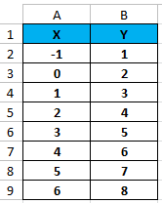Recording the Data:**

1. Double-Click on Microsoft Excel.
2. Type X in cell A1. (USE ALL CAPS)
3. Type Y in cell B1. (USE ALL CAPS)
4. Type the following numbers in columns A:

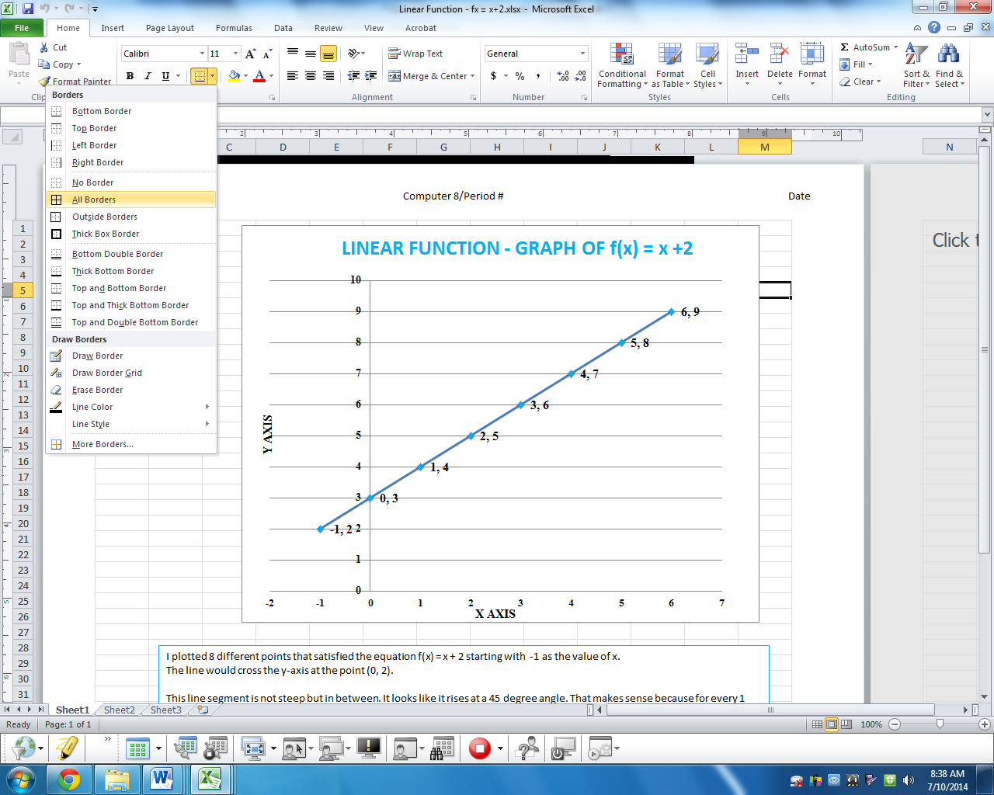

1. 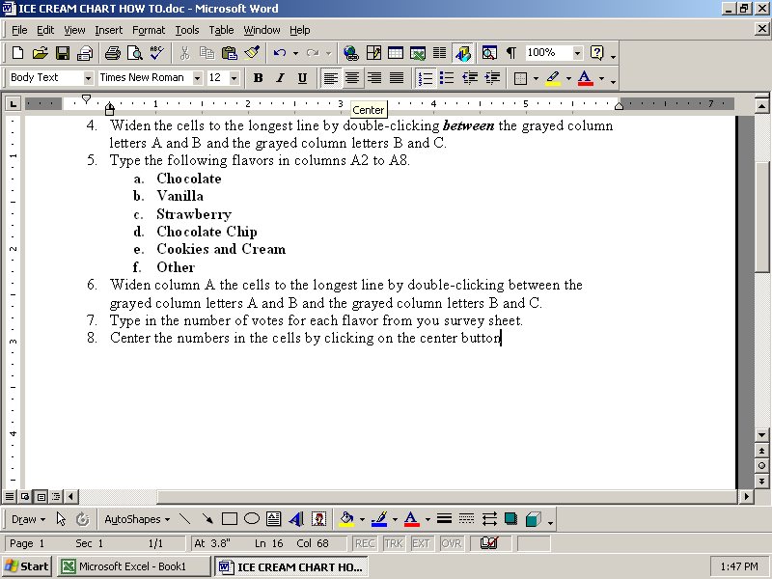Type the following formula cell B2: **=A2+2**
2. Click on the bottom right corner of cell B2 and drag formula through cell B9
3. Center the numbers in the cells by clicking on the center button.
4. Add border (ALL BORDERS) on the table of values (cells A1 through B9).
5. Add color fill for cells A1 and A2.

**Making the Chart:**

1. 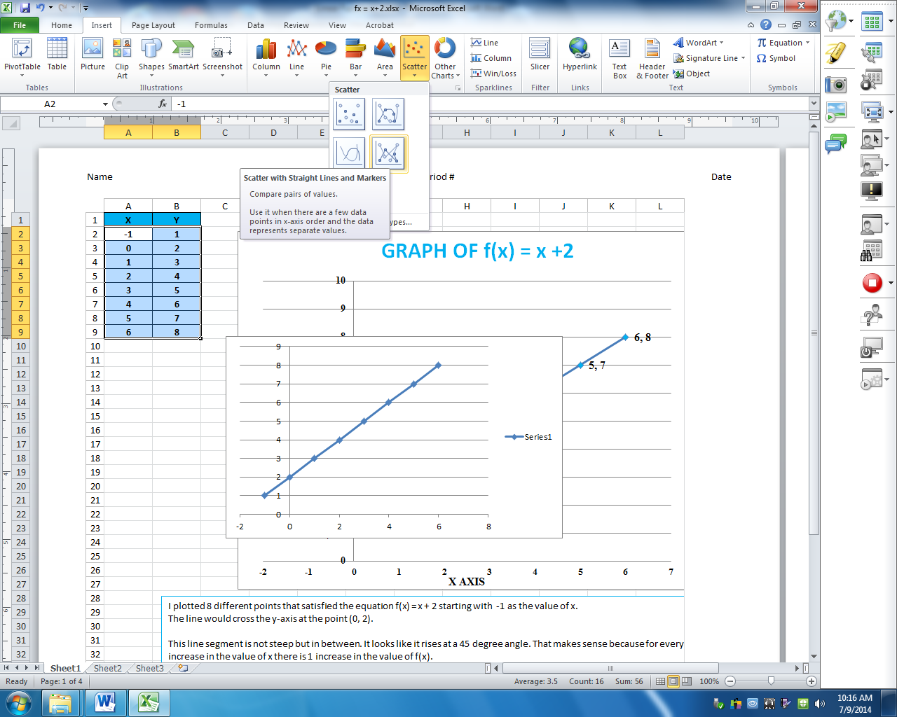Highlight the range: A2 through B9 (This tells the computer which data you want for your chart.)
2. Click on Insert/Scatter/**Scatter with Straight Lines and Markers**.
3. File/Page Layout – select Orientation/Landscape.
4. Click on bottom right-hand corner of chart and stretch it on the page.
5. Click on Chart Tools/Design/Layout 1
6. Add Chart Title **LINEAR FUNCTION - GRAPH OF f(x) = x + 2.**
7. Select larger font and color.
8. Label X Axis (horizontal) and Y Axis (vertical.)
9. Delete Series 1.
10. Click on lines of chart and right click to select Format Axis. Set the following parameters in the appropriate spaces:

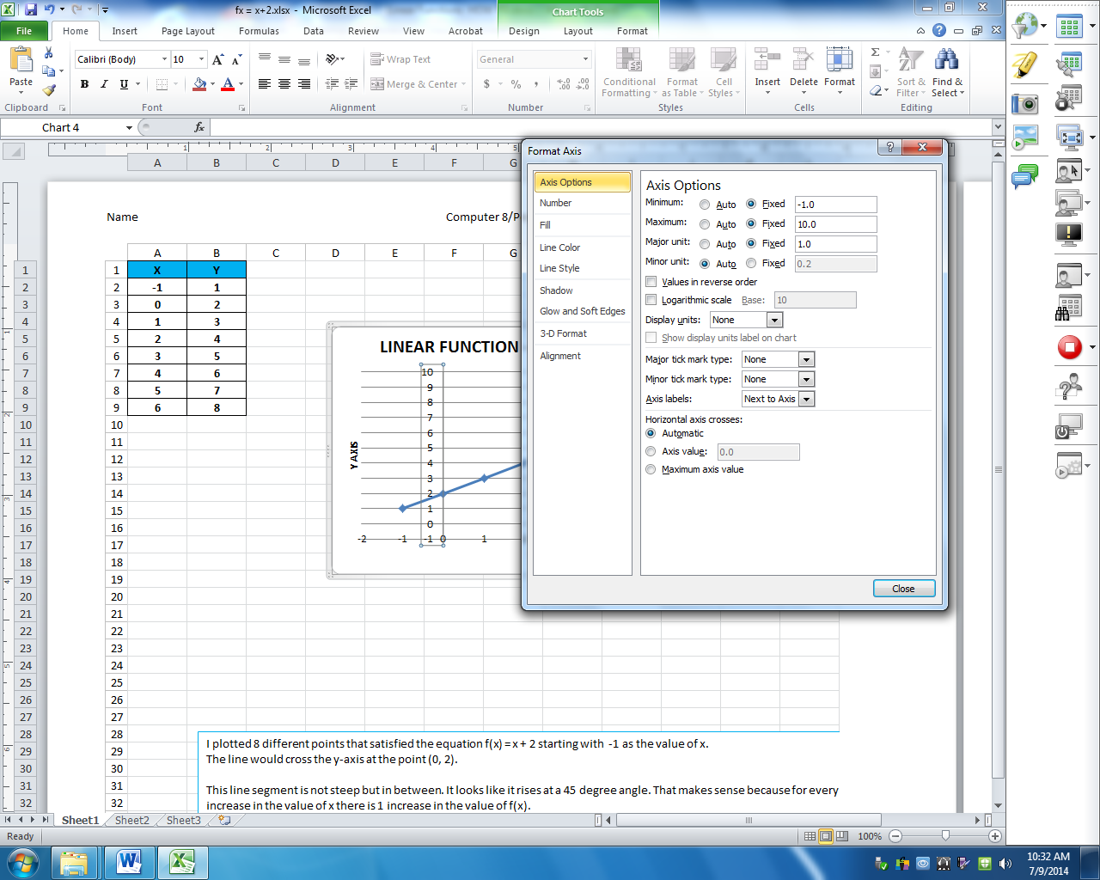

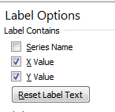

1. Right click on line and ADD DATA LABELS. Right click on line again and FORMAT DATA LABELS. Under Label Options/Label Contains - Select X and Y Values.
2. Right click on the data labels (make sure all are selected) of your chart and select **Format Data Series.** Click on **MARKER OPTIONS:** Choose **Built-in** to select size of marker**.** Click on **Marker** Fill to select color of marker, and click on **Line Color** to change the color of the line.
3. Insert/Header/Click on Custom Header. Type the following:

Name Computer 8/Period # Date

1. Insert text box and write a description of what you did and what the graph represents. Click on text box and select Drawing Tools/Shape Outline/Color.
2. Click on File/Print. Select Color Printer. IMPORTANT—Check your preview BEFORE you print to color printer. Make sure everything fits on one page.

Name \_\_\_\_\_\_\_\_\_\_\_\_\_\_\_\_\_\_\_\_\_\_\_\_\_\_\_\_\_\_\_\_\_\_\_\_ Period # \_\_\_\_\_\_\_\_\_\_\_\_\_\_

**EXIT OUTCOME**

Linear Function

Directions: Write the equations for f(x) as per the first example.

|  |  |  |
| --- | --- | --- |
| **X** | **f(x) = x+2** | **Y** |
| **-1** | **2 = -1+2** | **2** |
| **0** |  | **3** |
| **1** |  | **4** |
| **2** |  | **5** |
| **3** |  | **6** |
| **4** |  | **7** |
| **5** |  | **8** |
| **6** |  | **9** |

# GRAPHING EXPONENTIAL FUNCTIONS

**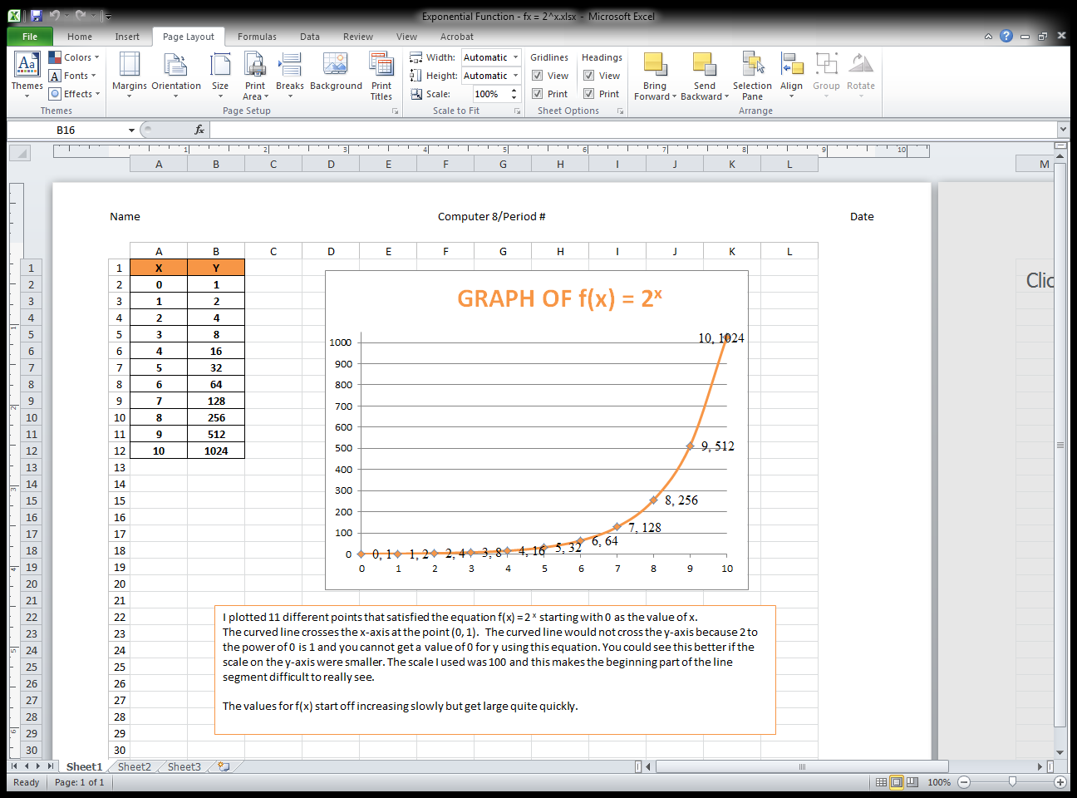Recording the Data:**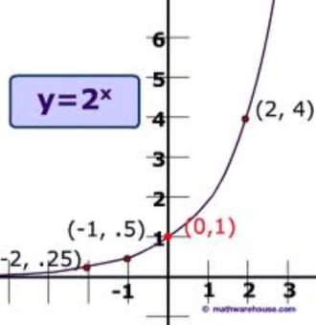

1. Double-Click on Microsoft Excel.
2. Type X in cell A1. (USE ALL CAPS)
3. Type Y in cell B1. (USE ALL CAPS)
4. Type the following numbers in columns A:



1. Type the following formula cell B2: **=2^A2 (^ is the shift of the number 6)**
2. Click on the bottom right corner of cell B2 and drag formula through cell B12.
3. Center the numbers in the cells by clicking on the center button.
4. Add border on the table of values (cells A1 through B12).
5. Add color fill for cells A1 and A2.
   1. **Making the Chart:**
6. Highlight the range: A2 through B12 (This tells the computer which data you want for your chart.)
7. Click on Insert/Scatter/**Scatter with Straight Lines and Markers**.
8. File/Page Layout – select Orientation/Landscape.
9. Click on bottom right-hand corner of chart and stretch it on the page.
10. Click on Chart Tools/Design/Layout 1
11. Add Chart Title **EXPONENTIAL FUNCTION - GRAPH OF f(x) = 2x**
    1. **(Type the x and select it then click on superscript button for exponent.)**
12. Select larger font and color.
13. Label X Axis (horizontal) and Y Axis (vertical.)
14. Delete Series 1.
15. 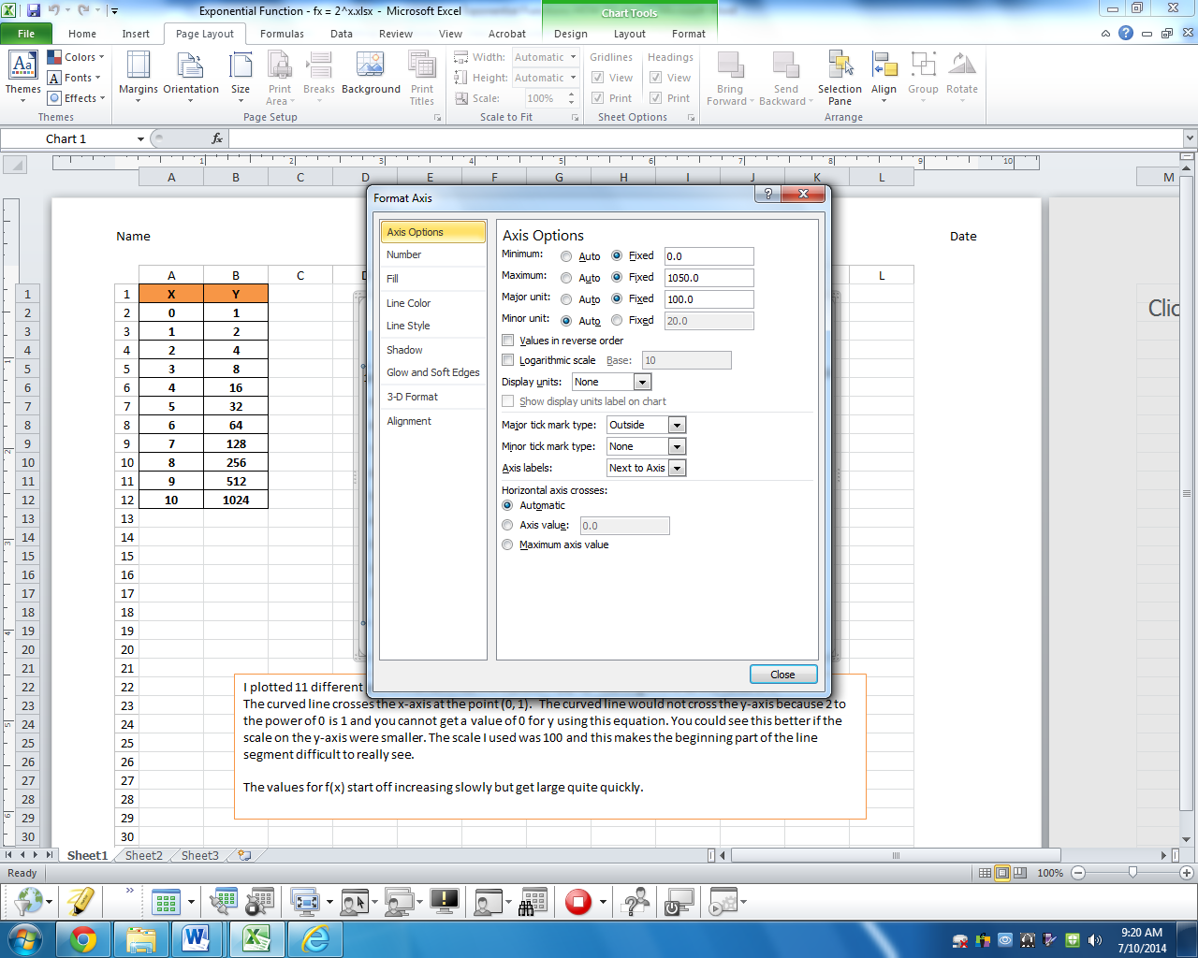Click on lines of chart and right click to select Format Axis. Set the following parameters in the appropriate spaces:



1. Right click on line and ADD DATA LABELS. Right click on line again and FORMAT DATALABELS. Under Label Options/Label Contains - Select X and Y Values.
2. Right click on the line markers of your chart and select **Format Data Series.** Click on **MARKER OPTIONS:** Choose **Built-in** to select size of marker**.** Click on **Marker** Fill to select color of marker, and click on **Line Color** to change the color of the line.
3. 14. Insert/Header/Click on Custom Header. Type the following:
   * 1. Name Computer 8/Period # Date
4. Insert text box and write a description of what you did and what the graph represents. Click on text box and select Drawing Tools/Shape Outline/Color.
5. Click on File/Print. Select Color Printer. IMPORTANT—Check your preview BEFORE you print to color printer. Make sure everything fits on one page.

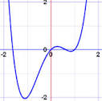**Recording the Data:**

# GRAPHING

# POLYNOMIAL

# FUNCTIONS

1. Double-Click on Microsoft Excel.
2. Type X in cell A1. (USE ALL CAPS)
3. 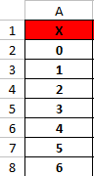Type Y in cell B1. (USE ALL CAPS)
4. Type the following numbers in columns A:



1. Type the following formula cell B2: **=A2^2 (^ is the shift of the number 6)**
2. Click on the bottom right corner of cell B2 and drag formula through cell B8.
3. Center the numbers in the cells by clicking on the center button.
4. Add border (ALL BORDERS) on the table of values (cells A1 through B8).
5. Add color fill for cells A1 and A2.
6. **Making the Chart:**
7. Highlight the range: A2 through B8 (This tells the computer which data you want for your chart.)
8. Click on Insert/Scatter/**Scatter with Straight Lines and Markers**.
9. File/Page Layout – select Orientation/Landscape.
10. Click on bottom right-hand corner of chart and stretch it on the page.
11. Click on Chart Tools/Design/Layout 1
12. Add Chart Title **POLYNOMIAL FUNCTION - GRAPH OF f(x) = x2 (Type the 2 and then select the 2 and click on Home/FONT/Superscript)**
13. Select larger font and color.
14. Label X Axis (horizontal) and Y Axis (vertical.)
15. Delete Series 1.
16. 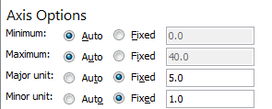Click on lines of chart and right click to select Format Axis. Set the following parameters in the appropriate spaces:



1. Right click on line and ADD DATA LABELS. Right click on line again and FORMAT DATALABELS. Under Label Options/Label Contains - Select X and Y Values.
2. Right click on the line markers of your chart and select **Format Data Series.** Click on **MARKER OPTIONS:** Choose **Built-in** to select size of marker**.** Click on **Marker** Fill to select color of marker, and click on **Line Color** to change the color of the line.
3. 14. Insert/Header/Click on Custom Header. Type the following:

Name Computer 8/Period # Date

1. Insert text box and write a description of what you did and what the graph represents. Click on text box and select Drawing Tools/Shape Outline/Color.
2. Click on File/Print. Select Color Printer. IMPORTANT—Check your preview BEFORE you print to color printer. Make sure everything fits on one page./

Works Cited

Alejandre, Suzanne. "Graphing Exponential Functions." *- Claris Works*. Web. 10 July 2014.

Alejandre, Suzane. "Graphing Linear Functions." *- Claris Works*. Web. 10 July 2014.

Alejandre, Suzanne. "Graphing Polynomial Functions." *- Claris Works*. Web. 10 July 2014.

Baetz, Quinn, and George Reese. "The Cereal Box Problem:." *The Cereal Box Problem:*. N.p., n.d. Web. 10 July 2014.

“Graphing Linear Equations." *BrainPOP*. N.p., n.d. Web. 10 July 2014.

"How Do You Graph a Linear Equation by Making a Table?" Virtual Nerd: Real Math Help for School and Home. Pearson Education, Inc., n.d. Web. 10 July 2014.

"Slope and Intercept." *BrainPOP*. N.p., n.d. Web. 10 July 2014.