**East Meadow School District**

Curriculum Area Project

**2014**

**Computer - Grade 6**

Superintendent:

Mr. Louis R. DeAngelo

**Woodland Middle School**

Principal:

Mr. James Lethbridge

Project Facilitator:

Marie Garcia

Writers:

Marie Garcia and Janice Seeley

Curriculum Area Project

**CAP SUMMER 2014**

**Computer – Grade 6**

**Table of Contents**

|  |  |
| --- | --- |
| Content | Page(s) |
| Abstract | 4 |
| Rationale | 5 |
| **UNIT - A FEW QUESTIONS** |  |
| A Few Questions – Part 1 (Lesson Plan) | 6 |
| A Few Questions Do Now | 7 |
| A Few Questions – Part 1 (Activity Sheet) | 8 |
| A Few Questions – Part 1 (Sample) | 9 |
| A Few Questions – Part 2 Transitional Words (Lesson Plan) | 10 |
| A Few Questions – Part 2 Transitional Words Activity Sheet | 11 |
| Transitional Words Table | 12 |
| A Few Questions Part 2 (Sample) | 13 |
| A Few Questions – Part 3 (Lesson Plan) | 14 |
| A Few Questions – Part 3 – Formatting Activity Sheet | 15-16 |
| A Few A Questions Part 2 (Sample) | 17 |
| A Few Questions Exit Card | 18 |
| **UNIT – CAUSE AND EFFECT** |  |
| Cause and Effect (Lesson Plan) | 19-21 |
| Cause and Effect Activity 1 How-to Sheet | 22 |
| Cause and Effect Activity 1 | 23 |
| Flashlight Cause and Effect | 24 |
| Flashlight Cause and Effect Answer Sheet | 25 |
| Hamster Cause and Effect How-to Sheet | 26 |
| Hamster Cause and Effect Activity Sheet | 27 |
| Hamster Cause and Effect Answer Sheet | 28 |
| Graphic Organizer – Cause and Effect | 29 |
| Cause and Effect Topics | 30 |
| Graphic Organizer Cause and Effect Activity Sheet | 31 |
| Formatting Your Graphic Organizer | 32 |
| Graphic Organizer – Cause and Effect RUBRIC | 33 |
| **UNIT – EATING AND OREO COOKIE – DRAG AND DROP** |  |
| Eating and Oreo Cookie – Drag and Drop (Lesson Plan) | 34-35 |
| How do YOU eat an Oreo cookie? - DO NOW | 36 |
| Eating an Oreo Cookie PowerPoint | 37-38 |
| How to Eat an Oreo Cookie Drag and Drop Activity Sheet | 39 |
| Oreo Sentences (Scrambled) | 40 |
| How to Eat an Oreo Cookie RUBRIC | 41 |
| Eating an Oreo Cookie Sample | 42 |
| Eating an Oreo Cookie Exit Outcome | 43 |

|  |  |
| --- | --- |
| **UNIT - FAVORITES – NUMBERING AND BULLETS IN WORD** |  |
| Favorites – Numbering And Bullets In Word (Lesson Plan) | 44 |
| My Favorites Do Now | 45 |
| Favorites – Numbering and Bullets in Word How-to Sheet | 46-49 |
| Favorites – Numbering and Bullets RUBRIC | 50 |
| Favorites – Numbering and Bullets Sample | 51-52 |
| Numbering and Bullets Exit Card | 53 |
| **UNIT – HEALTHY LUNCH MENU TABLE ACTIVITY** |  |
| Healthy Lunch Menu Table Activity (Lesson Plan) | 54-56 |
| Lunch Menu DO NOW | 57 |
| Healthy Lunch Menu Table How-to Sheet | 58-59 |
| Healthy Lunch Menu Sample | 60 |
| New Rules Double Up Fruits, Veggies for School Meals Questions Activity Sheet | 61 |
| New Rules Double Up Fruits, Veggies for School Meals Article | 62 |
| Rows and Columns DO NOW | 63 |
| Calorie King Fast-Food Freddy Table | 64 |
| Fast-Food Freddy Letter | 65 |
| Inserting Tables Columns/Rows DO NOW | 66 |
| Inserting Tables Number of Columns and Rows PowerPoint | 67 |
| Eat McDonald’s for 3 months, lose 37 pounds? Article | 68-69 |
| Eat McDonald’s for 3 Months, Lose 37 Pounds Questions | 70 |
| UNIT – GREEK MYTHOLOGY |  |
| Greek Mythology (Lesson Plan) | 71-73 |
| Brain Pop Paraphrasing QUIZ | 74 |
| Paraphrase Don’t Plagiarize Activity Sheet | 75 |
| Greek Gods/Goddesses Research How-to Sheet | 76 |
| Greek Gods/Goddesses Research Table | 77 |
| Greek Mythology Websites | 78 |
| Gods/Goddesses in Advertising Activity Sheet | 79 |
| Values of the Gods Activity Sheet | 80 |
| Create A God/Goddess Activity Sheet | 81 |
| Gods/Goddesses Poster | 82 |
| Poster Directions | 83 |
| **UNIT – SPICE ACTIVITY USING THE THESAURUS** |  |
| Spice Activity – Using the Thesaurus (Lesson Plan) | 84-85 |
| Spice Activity DO NOW #1 | 86 |
| Spice Activity – Using the Thesaurus Part 1 How-to Sheet | 87-88 |
| Spice Activity Part 1 Sample | 89 |
| Spice Activity DO NOW #2 | 90 |
| Spice Activity DO NOW #2 Key | 91 |
| Spice Activity – Using The Thesaurus Part 2  How-to Sheet | 92 |
| Sentence How-to Sheet | 93 |
| Spice Activity Part 2 Sample | 94 |
| Works Cited | 95 |

Curriculum Area Project

**Summer 2014**

**Computer – Grade 6**

Abstract

This Curriculum Area Project is geared towards students in Computer - Grade 6. It was designed to streamline the Computer – Grade 6 Curriculum and to incorporate Common Core Standards and English Language Arts into the lessons.

Lessons were designed to incorporate reading and writing skills. The Microsoft Word application is used as a writing tool and also as a means to design graphic organizers. Many of the activities involve the use of on-line resource, such as: thesaurus, synonyms, and dictionary. The Healthy Lunch Menu unit includes newspaper articles which supplement the curriculum topic. Students will read the articles to answer evidence-based questions. Additional critical thinking questions were designed to align with the Common Core Curriculum in each of the lesson units.

Curriculum Area Project

**Summer 2014**

**Computer – Grade 6**

Rationale

This Curriculum Area Project was created to provide students in Computer - Grade 6 with the opportunity to combine their computer application skills with the Grade 6 curriculum in line with the Common Core requirements.

Students are introduced to high-level computer and thinking skills incorporating the Grade 6 English Language Arts curriculum to create computer activity units. Several topics include; transitional words, on-line resources (thesaurus, synonyms, dictionary), paraphrasing/plagiarism, parts of speech, cause and effect, graphic organizers and tables, and Greek mythology. Students are given the opportunity to work in a cooperative learning environment through groups work and shared ideas. Projects use hands-on activities to teach computer skills and English Language Arts concepts. The students are responsible and accountable for their final projects. They will develop their communication and presentation skills by sharing their completed work with others.

**A Few Questions – Part 1**

**Objectives**: The students will be able to do the following:

* + Center a title
  + Left align their cursor
  + Using complete sentences type the answers to a series of questions (see attached)
  + Proofread their work
  + Follow written and oral directions

**Do Now**:

1. Log on
2. Complete “A Few Questions” Do Now Activity Sheet

**Procedure**:

1. Students will be asked the following questions:
   1. What do you like to do in your spare time?
   2. What is your favorite food?
2. Once answers are discussed students will be given the activity sheet “A Few Questions” will be handed out to all students.
3. Using the computer and Vision Software the teacher will model how to complete the activity.
4. Students will complete the activity.

**Assessment:** Students will turn in completed activity to show proficiency with writing and proofreading complete sentences.

**Instructional Materials**: Do Now and “A Few Questions” activity sheet

**Instructional Technology**: computer, Vision Software

**New York State Standards**

MST #2, #5

**Common Core Standards**

Reading Standards for Literacy in Science and Technical Subjects

Key Ideas and Details - #3

Craft and Structure - #4

Name: ____________________________

A Few Questions Do Now

Directions:

* Write your name at the top of the page.
* Write an answer to the following questions.
* Do not turn this sheet in; you will need it for today’s activity.

1. What do you like to do in your spare time?
2. What is your favorite fast food item?
3. What do you want to be when you grow up?
4. Do you prefer daytime or nighttime? Why?
5. Do you prefer M&M’s or Skittles? Why?
6. What is the sound you love the most? Why?
7. What is the last television show you watched?
8. What is the last movie you saw?
9. What is the last item you purchased (bought)?
10. What is the best gift you ever gave or received? Why?

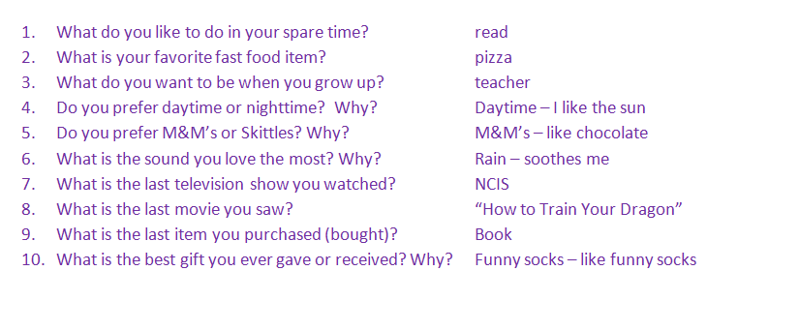

Sample

**A Few Questions - Part 1**

**Directions:**

1. Open Microsoft Word.
2. Insert a **HEADER (Insert Ribbon --- Header)**
3. Save in your **Word** Folder as **A Few Questions**
4. Type the title **A Few Questions**



1. Center the title.
2. Press the **Enter** key 2 times.
3. Align Left your cursor by pressing the “**Align Left**” button.
4. **Using your DO NOW type your answers to the following questions using** **complete sentences. Restate the question as part of your answer.**

**Example:**

What do you like to do in your spare time?

In my spare time I like to read.

1. Proofread your work and make sure your answers make sense.
2. Make sure you followed all directions.
3. Save, Print on the **laser printer** and attach your DO NOW and turn in.

Name

A Few Questions – Part 1 Sample

In my spare time I like to read a good book.

My favorite fast food item is pizza.

When I grow up I want to be a teacher.

I prefer the daytime because I like to go outside and enjoy the sunshine.

I prefer M&M’s because I love chocolate.

The sound I love the most is the rain on the roof when I am going to sleep. I love this sound because it soothes me.

The last television show I watched was “NCIS”.

The last movie I watched was “Zoo Keeper”.

The last item I purchased was a pair of shoes.

The best gift I ever received was a Christmas present made by my son. I loved this gift because he made it for me.

**A Few Questions – Part 2**

**Transitional Words**

**Objectives**: The students will be able to do the following:

* + Make corrections by editing their sentences
  + Use transitional words to enhance their complete sentences
  + Proofread their work
  + Follow written and oral directions

**Do Now**:

1. Log on
2. Make corrections to their **A Few Questions** as indicated by teacher on their Part 1 sheets

**Procedure**:

1. Students will be asked the following questions and answers will be discussed:
   1. What is the meaning of the word “transition”?
   2. What are “transitional words”?
   3. How do you think transitional words can enhance your writing?
2. Using the LiteWare projector the teacher will give an example of using transitional words to enhance a sentence.
3. As a class, the students will be asked to model the use of transitional words to enhance three example sentences.
4. Teacher will review A Few Questions – Part 2 (Transitional Words) activity sheet with the class.
5. Students will complete the activity.

**Assessment:** Students will turn in completed activity to showing the use of transitional words to enhance their sentences.

**Instructional Materials:** Corrected “A Few Questions - Part 1,” “A Few Questions – Part 2,” activity sheet, Transitional Words table

**Instructional Technology**: computer, Vision Software

**New York State Standards**

MST #2, #5

**Common Core Standards**

Reading Standards for Literacy in Science and Technical Subjects

Key Ideas and Details - #3

Craft and Structure - #4

**A Few Questions – Part 2**

**TRANSITIONAL WORDS**

**Directions:**

1. Open your document **A Few Question**s.
2. Make any corrections indicated on **A Few Questions** which has been returned to you.
3. Re-save.
4. Now take your sentences and use the attached list of **Transitional Words** to expand your responses by adding more information. This will make your sentences more interesting.

**For example:**

Part 1 = In my spare time I like to read.

Part 2 = In my spare time I like to read a good book **since** reading helps to build my vocabulary.

1. Proofread your work and make sure your responses make sense.
2. Make sure you followed all directions.
3. Save and print to the laser printer.
4. Turn in.

Transitional Words

|  |  |
| --- | --- |
| **Relationships** | **Transitional Words** |
| Time | first, next, suddenly, when, after, before, soon, at the same time, as soon as, the following, finally, as, then, meanwhile, afterward, immediately, later |
| Place | beside, here, near, there, above, below, on the left, on top of, around, opposite, next to |
| Importance | first, second, third, primarily, predominantly, largely, above all, chiefly, mainly, principally, for the most part, better, best, last, more important, most important, most of all, least, last but not least |
| Cause/Effect | therefore, for that reason, namely, because, due to, thus, as a result, consequently, so, since, for , as a result, then |
| Comparison | similarly, like, dearly, same as, in the same way, as, also, obviously, apparently, correspondingly, equally |
| Contrast | but, however, yet, although , dearly, even though , in n contrast, different from, unlike, on the other hand , nevertheless, but, conversely, in spite of , though, still |
| Examples | that is, for this reason, such as, for example, like, in other words, along with, as follows, for instance, as, namely, dearly, evidently, undoubtedly, without a doubt, plainly, unmistakably |
| Adding Information | again, also, additionally, in addition, furthermore, another, and, besides, for example, for instance,  moreover , next, likewise, finally, as well , along with, equally important,  in other words |

Name

A Few Questions Part 2 Sample

In my spare time I like to read a good book since reading helps to build my vocabulary.

My favorite fast food item is pizza even though I don’t eat it very often.

When I grow up I want to be a teacher in fact, I want to be an elementary teacher.

I prefer the daytime because I like to go outside and enjoy the sunshine whenever I get the chance.

I prefer M&M’s because I love chocolate especially creamy milk chocolate.

The sound I love the most is the rain on the roof when I am going to sleep because it soothes me and calms me down.

The last television show I watched was “NCIS” which I like to watch whenever I get the chance.

The last movie I watched was “Zoo Keeper” which was surprisingly a very funny movie.

The last item I purchased was a pair of shoes due to the fact that the heel on my old pair broke.

The best gift I ever received was a Christmas present made by my son. I loved this gift because he made it for me.

**A Few Questions – Part 3**

**Objectives**: The students will be able to do the following:

* Make corrections to their A Few Questions – Part 2 document
* Format text as directed on activity sheet:
  + Bold/Italicize/Underline text
  + Different Font styles
  + Underline text
  + Change the color/style of an underline
  + Center/right/left align text
  + Format color of text
  + Resize text
* Follow written and oral directions

**Do Now**: Log on

Open previously created document “A Few Questions”

**Question:** What does formatting mean?

**Procedure**:

1. Distribute corrected copies of the student’s work from the previous day.
2. Answers to Do Now question will be discussed.
3. Distribute copies of “A Few Questions - Part 3” activity sheet
4. Teacher will model the how to format text per the activity sheet using the Vision Software
5. Students will complete the activity

**Assessment:** Students will turn in completed activity which shows proficiency in following directions and formatting text

**Exit Card**: Upon completion of the activity the students will be given the “A Few Questions Exit Card”

**Instructional Materials**: Activity sheet “A Few Questions - Part 2”

**Instructional Technology**: computer, Vision Software

**New York State Standards**

MST #2, #5

**Common Core Standards**

Reading Standards for Literacy in Science and Technical Subjects

Key Ideas and Details - #3

Craft and Structure - #4

**A Few Questions – Part 3 -Formatting**

**Directions:**

1. Open your document **A Few Questions**.
2. Make any corrections indicated on **A Few Questions - Part 2 which has been returned to you.**
3. Re-Save
4. Format your answers as directed below:

|  |  |
| --- | --- |
| What do you like to do in your spare time? | * Bold the text * Change the font color |
| What is your favorite fast food item? | * Underline the text * Change the font type to “Baskerville Old Face” * Change the font color |
| What do you want to be when you grow up? | * Center align the text * Change the font type to “Comic Sans MS” * Change the font color |
| Do you prefer daytime or nighttime? Why? | * Right align the text * Change the font type to “Franklin Gothic Demi” * Change the font color to red |
| Do you prefer M&M’s or Skittles? Why? | * Change the font to size 16 * Change the font type to “Bauhaus 93” * Change the font color to orange |
| What is the sound you love the most? Why? | * Change the font color to green. * Underline the text * Change the underline color to red |
| What is the last television show you watched? | * Bold and center the text * Change the text color to purple * Underline the text with a double line * Change the underline color to green |
| What is the last movie you saw? | * *Italicize* your text * Right Align your text |
| What is the last item you purchased (bought)? | * Change the text size to 22 * Change the text color to red * Change the text to “Informal Roman” |
| What is the best gift you ever gave or received? Why? | * Underline the text using a “Wave underline” * Change the underline color to orange * Change the font size to 18 * Change the text style to “Tempus Sans ITC” |

1. Proofread your work and make sure you followed all directions.
2. Add a border to your page. (Page Layout/Page Borders)
3. Insert 1 graphic which goes with one of your questions.
   1. Border the graphic
   2. Use a picture effect
4. Make sure you followed all directions.
5. Save and print to the Color printer.
6. **Attach Part 2 and Part 3 together and turn in.**

Name

A Few Questions Part 2 Sample

**In my spare time I like to read a good book since reading helps to build my vocabulary.**

My favorite fast food item is pizza even though I don’t eat it very often.

When I grow up I want to be a teacher in fact, I want to be an elementary teacher.

I prefer the daytime because I like to go outside and enjoy the sunshine whenever I get the chance.

I prefer M&M’s because I love chocolate especially creamy milk chocolate.

The sound I love the most is the rain on the roof when I am going to sleep because it soothes me and calms me down.

**The last television show I watched was “NCIS” which I like to watch whenever I get the chance.**

*The last movie I watched was “Zoo Keeper” which was surprisingly a very funny movie.*

The last item I purchased was a pair of shoes due to the fact that the heel on my old pair broke.

The best gift I ever received was a Christmas present made by my son. I loved this gift because he made it for me.

Name: _______________________________

**A Few Questions Exit Card**

**Directions:**

1. Write your name at the top
2. Answer the following questions and turn in.
3. Which term describes text repeated at the ***top*** of each page of a document?
4. Banner
5. Footer
6. Header
7. Headline
8. Mr. Reynolds asks you to format your Word document. Which of the following is an example of formatting?
   1. Insert picture
   2. Change the color/style/size of your text
   3. Insert a page break
   4. Spell check

**Cause and Effect**

**Objectives**: The students will be able to do the following:

* Define cause and effect
* Identify cause and effect within sentences
* Read a story and identify cause and effect relationships
* Combine two sentences into one that shows both the cause and effect relationship
* Work cooperatively in groups to discuss a cause and effect relationship
* Create a graphic organize to show a cause and effect relationship
* Follow written and oral directions

**Day 1**

**Do Now**: What is the cause and effect relationship in the following sentence?

**I took out my umbrella because it started to rain.**

**Procedure**:

1. Answers to the DO NOW question will be discussed.
2. Students will be asked to define Cause and Effect based on the discussion.

**Definition**

A *cause* is something that makes something else happen. Out of two events, it is the event that happens first.

To determine the cause, ask the question "Why did it happen?"

An *effect* is what happens as a result of the cause. Of two related events, it’s the one that happens second or last. To determine the effect, ask the question "What happened?"

1. Using the LiteWare projector the following sentences will be displayed.
   1. The boy kicked the ball, and the ball rolled down the street.
   2. The cat growled when the little girl teased the cat.
   3. Mary earned an “**A”** on her test because she studied very hard for the test.
   4. Joe became really tired so he went to sleep early.
2. The class will be asked to identify the cause and effect relationship in each of the sentences.

1. Teacher will hand out Cause and Effect Activity 1 sheet.
2. Students will complete the activity per the directions.

**Assessment:**

Students will complete the Cause and Effect Activity 1 activity demonstrating their ability to identify cause and effect in sentences.

**Instructional Materials**: Cause and Effect Activity 1 Direction Sheet and Cause and Effect Activity sheet.

**Day 2**

**Do Now**: Log on and read the story Flashlight Cause & Effect which is displayed using the LiteWare projector

**Procedure**:

1. Students will read the story Flashlight Cause & Effect.
2. As a class students will be asked to complete the table by identifying the cause and effect relationships based on the story.
3. Teacher will distribute Hamster Cause and Effect direction sheet.
4. Students will open Hamster Cause and Effect Activity.
5. Students will complete the activity based as per the direction sheet.
6. Students will print and hand in their assignment.

**Assessment:**

Students will complete the Hamster Cause and Effect activity demonstrating their ability to identify cause and effect relationships based on the story.

**Instructional Materials**: Hamster Cause and Effect direction sheet and Hamster Cause and Effect activity

**Instructional Technology**: computer, Vision software

**Day 3**

**Do Now**: Give students the following scenario:

**Cause**: Hurricane Sandy

**Effects**: What were the effects to Long Island/Its people?

**Procedure**:

1. Students will think and discuss their answers to the scenario with the class.
2. Students will randomly be put into groups of 2-3 students
3. Teacher will distribute a list of topics for students to pick.
4. Each group will select a different topic.
5. Students will district Graphic Organizer – Cause and Effect Template
6. As a group the students will identify the effects for their selected cause.
7. Teacher will distribute the Graphic Organizer Cause and Effect direction sheet and grading rubric.
8. Teacher will model the steps to creating the graphic organizer using Microsoft Word.
9. Each student will complete the activity based on their groups’ findings and the direction sheet.
10. Each student will print and hand in their graphic organizer activity.

**Assessment:**

Students will complete the Graphic Organizer Cause and Effect activity using the computer and demonstrate their ability to identify effects of a specific cause.

**Instructional Materials**: Graphic Organizer - Cause and Effect direction sheet, Graphic Organizer template

**Instructional Technology**: computer, Vision software

**New York State Standards**

MST #2, #5

ELA #3, #4

**Common Core Standards**

Reading Standards for Literacy in Science and Technical Subjects RL 2.1-2.10, RI 2.1-2.10

**Supplemental Activities**

Cause and Effect Matching Game

<http://www.quia.com/mc/94601.html>

Cause & Effect

Activity 1

**Directions**

1. Click on **COMPUTER-- --- SCHOOL SHARE --- TEACHER NAME --- COMPUTER 6 - WORD –Cause Effect Activity 1**
2. Insert a Header
3. Save as **Cause Effect Activity 1** in your Word Folder
4. Read each sentence and do the following:
   1. Underline the cause in each sentence.
   2. **Bold** the **effect** in each sentence.

**Examples:**

I took out my umbrella because **it started to rain.**

**The little pig was very muddy**, so Fern gave him a bath.

1. Save
2. Print on the laser printer and turn in

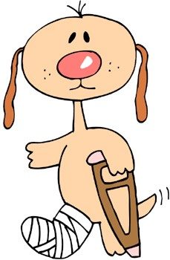

**Cause & Effect**

**Activity 1**

1. Katie ate all of her breakfast because she was hungry.
2. The stove temperature was set too high, so the cake burned.
3. I was late for school today because my alarm never went off.
4. Frank dropped his Batman toy because he didn’t hold it tightly.
5. Family was coming for dinner, so we helped clean the house.
6. Nana baked me a cake because it was my birthday.
7. There was a hole in the bag, and the candy spilled all over.
8. The movie was over, so mom said we had to go to bed.
9. We sold our car because we needed a bigger one.
10. Mom took Rover to the vet because he hurt his leg.

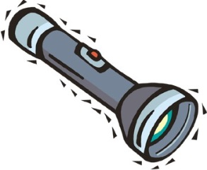

Flashlight Cause & Effect

Directions: Read the story.

Last weekend my friend Karen slept over. We stayed up very late playing with our dolls. My mom came into the room to tell us we had to go to sleep. It was dark, so, Karen and I took my dad’s flashlight and played under the covers. I’m not sure when we finally fell asleep, but we left the flashlight on. In the morning, it no longer worked. The batteries were dead. Yesterday, there was a big thunderstorm and we lost our electricity. Dad went to get his flashlight so we could see, but it didn’t work. He wasn’t very happy when he found out I had left it on all night and wasted the batteries. Now I have to rake up all of the leaves that blew around from the storm!

|  |  |
| --- | --- |
| **CAUSE** | **EFFECT** |
|  | Mom came in to tell us to go to bed. |
| It was dark. |  |
|  | Flashlight batteries died. |
| Dad tried to use the flashlight, but it didn’t work. |  |



Flashlight Cause & Effect

Answer Sheet

|  |  |
| --- | --- |
| **CAUSE** | **EFFECT** |
| *We stayed up late playing with our dolls.* | Mom came in to tell us to go to bed. |
| It was dark. | *We took my dad’s flashlight and played under the covers.* |
| *We left the flashlight on when we fell asleep.* | Flashlight batteries died. |
| Dad tried to use the flashlight, but it didn’t work. | *He wasn’t happy when he found out I left it on all night and now I have to rake the leaves.* |

Hamster Cause and Effect Activity

C:\Users\jseeley.INST\AppData\Local\Microsoft\Windows\Temporary Internet Files\Content.IE5\RPRLN9KN\MC900057214[1].wmf

Directions:

1. Open Click on **COMPUTER-- --- SCHOOL SHARE --- TEACHER NAME --- COMPUTER 6 - WORD –HAMSTER CAUSE EFFECT ACTIVITY**
2. Insert a Header
3. Save as **Hamster Cause Effect Activity** in your Word Folder
4. Read the story
5. Complete the table by identifying the cause and effect relationships based on the story.
6. Save
7. Print on the laser printer and turn in

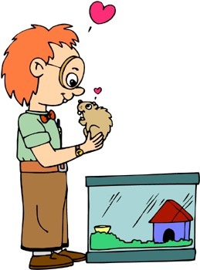

Hamster Cause & Effect

Yesterday, after playing with my hamster on the floor, I put him back into his cage. But, I didn’t close the lid tightly and he escaped. I didn’t know he was loose until I saw something run by my feet. I jumped up quickly and hit the lamp on the table next to me. The lamp fell and crashed to the ground, making a loud noise. Soon, my dad was in the room upset that he was awoken from his nap. I walked over to apologize when I stopped just in time. My hamster was sitting in front of me, looking up, and smiling. I reached down to grab him, and he took off under the couch and into the kitchen. When I heard the scream, I knew my mom had seen my pet. She scooped him into a colander and popped him back into his cage. I tightly secured the top, and he was back in his home. I watched him play, and thought for sure I saw him give me a little wink.

|  |  |
| --- | --- |
| CAUSE | EFFECT |
| I did not close the lid tightly. |  |
|  | I jumped up and hit the lamp. |
| The lamp crashed to the floor and made a loud noise. |  |
| Walked to apologize, stopped, and tried to grab my hamster. |  |
|  | My mom screamed. |
|  | I watched my pet play and thought I saw him wink at me. |

Hamster Cause & Effect Answer Sheet

|  |  |
| --- | --- |
| **CAUSE** | **EFFECT** |
| I did not close the lid tightly. | *My hamster escaped.* |
| *Hamster ran by me and startled me.* | I jumped up and hit the lamp. |
| The lamp crashed to the floor and made a loud noise. | *The noise woke my dad.* |
| Walked to apologize, stopped, and tried to grab my hamster. | *Hamster ran into kitchen.* |
| *Hamster startled mom.* | My mom screamed. |
| *Mom scooped up hamster and put him in his cage.* | I watched my pet play and thought  I saw him wink at me. |

**Graphic Organizer - Cause and Effect**

C:\Users\mgarcia.INST\AppData\Local\Microsoft\Windows\Temporary Internet Files\Content.IE5\LG1Y3NE2\MC900437789[1].wmf

**Effect**

**The effect your group has determined.**

**Effect**

**The effect your group has determined.**

**Effect**

**The effect your group has determined.**

**Effect**

**The effect your group has determined.**

**Effect**

**The effect your group has determined.**

**Cause  
Pollution**

**Effect**

**The effect your group has determined.**

C:\Users\mgarcia.INST\AppData\Local\Microsoft\Windows\Temporary Internet Files\Content.IE5\XXHDNFYA\MC900132639[1].wmf**Cause and Effect Topics**

**Graphic Organizer Activity**

* Texting while driving
* Smoking
* Eating too many sweets
* Cheating on a test
* Misbehaving in class
* Playing sports
* Always doing homework
* Behaving in class
* Eating healthy
* Getting involved with a club
* Exercising
* Playing video games
* Littering
* Pollution

Graphic Organizer Cause and Effect Activity Sheet

Directions:

1. Microsoft Word
2. Change the Page Layout to Landscape (Page Layout – Orientation – Landscape)
3. Insert a Header

Your Topic

1. Save as _____________**Graphic Organizer** in your Word Folder
2. Type and center a title as follows (see sample on back):

Graphic Organizer - Cause and Effect

1. Insert a rounded rectangle in the center of your page
2. Type the following in your rounded rectangle shape:

Cause

You’re Topic

1. For each effect insert a rectangle and place the shapes around your center topic shape.
2. Insert a line from the center topic shape to each effect shape.
3. In each of the rectangles type the following (press Enter :

Effect

The effect your group has determined

1. Save

Formatting your Graphic Organizer

1. For each shape do the following in the order listed:
   1. Format the size/color/style of the text.
   2. Center all text
   3. Select Shape Fill – White
   4. Format the shape outline (color/weight/style)
2. Format the color/weight/style of the lines.
3. Insert an appropriate graphic
4. Proofread and spell check your work.
5. Print on the laser printer and proof your organizer to make sure you have followed all directions.
6. Print a final laser copy
7. Print a color copy
8. 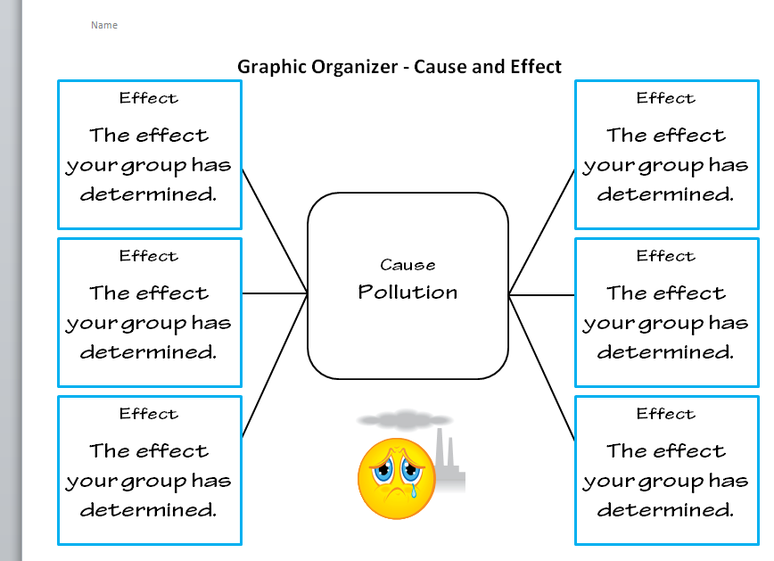Attach laser and color copies to the grading rubric and turn in.

**Name: ___________________ Project Grade: _________**

|  |  |
| --- | --- |
| **ITEM** | **DID YOU?** |
|  | * Change the page layout to landscape * Type and Center the title * Insert a rounded rectangle for your Cause * Insert a rectangle for each of your Effects * Insert a line from the Cause shape to each Effect shape * Type an effect for each shape * Format the size/color/style of all text * Center all text * Select shape fill (white) for all shapes * Format the shape outline (color/weight/style) for each shape * Format the color/weight/style for each line * Insert an appropriate graphic * Spell check and proofread your work * Print a corrected copy on the laser * Print a corrected copy on the color printer * Attach color copy and laser copy to the grading rubric and turn in   **Note**: Grading Rubric goes on top. |

**Graphic Organizer – Cause and Effect RUBRIC**

Eating an Oreo Cookie – Drag and Drop Lesson Plan

Aim of Lesson:

* Each student will be able to use Drag and Drop to sequence a story into proper order
* Each student will be able use the formatting tools to produce a print ready copy of their document

New York State Standards

2.1-2.6, 3.3-3.6, 4.1-4.4 MST 5.3/ELA 1.2/6.2

Common Core Standards

Reading Standards for Literacy in Science and Technical Subjects

3, 4, 6

Writing Standards – Literacy in History/Social Studies, Science, And Technical Subjects 6-12

1c-1e, 2a-2f, 4, 5, 6

Motivation:

DO NOW: Students will write down how they eat an Oreo cookie using steps. Have several students share with class.

Procedure

1. Introduce the topic of sequencing. Talk about what words the students used to tell how they ate their Oreo cookie (First, then, second, lastly, etc.)
2. Show PowerPoint – How to Eat An Oreo Cookie
3. Introduce the Drop and Drag activity to the students. Demonstrate how to get document from Share folder
4. Insert a HEADER
5. Rearrange the story into the correct order (sequencing) using drag and drop
6. Follow the How-To-Sheet for formatting skills: Centering text, double spacing, balancing page, format font colors, format page border, inserting pictures
7. Spell Check and Proofread. Print Preview to make sure nothing is cutting off.
8. Save, Print to color and put in completed work folder. Attach rubric.
9. Have students complete the Exit Outcome questions and hand in at the end of class.

Instructional Materials

* LiteWare Projector for demonstrating and modeling

Instructional Technology

* Computers
* Internet
* LiteWare Projector
* Microsoft Word
* Microsoft PowerPoint for Oreo Presentation

Assessment Questions

Were you able to access the share folder and save “Oreo” activity to your directory?

Were you able to sequence the “Oreo” story in proper order?

Were you able to follow instructions to complete assignment and print a hard copy?

Did you complete the Exit Outcome questions?

Summary

* Students are to submit their completed Drop & Drag “Oreo” activity to the completed work folder.
* Students are to hand in their completed Exit Outcome.

Name ______________________________________________________ Period # ___________

**How do YOU eat an Oreo cookie?**

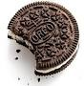

**List your steps:**

**___________________________________________________________________________________________________________________________________________________________________________________________________________________________________________________________________________________________________________________________________________________________________________________________________________________________________**

Eating an Oreo Cookie PowerPoint

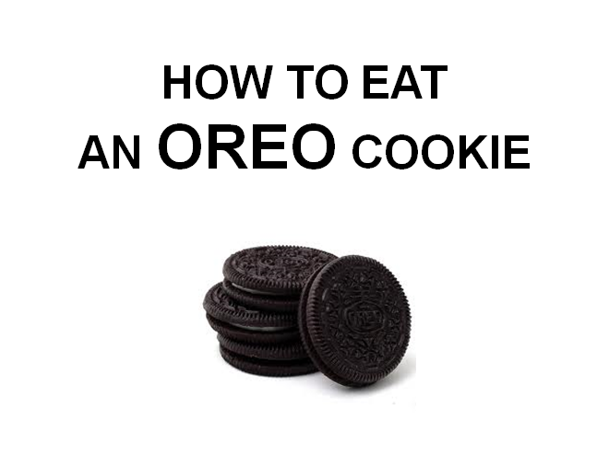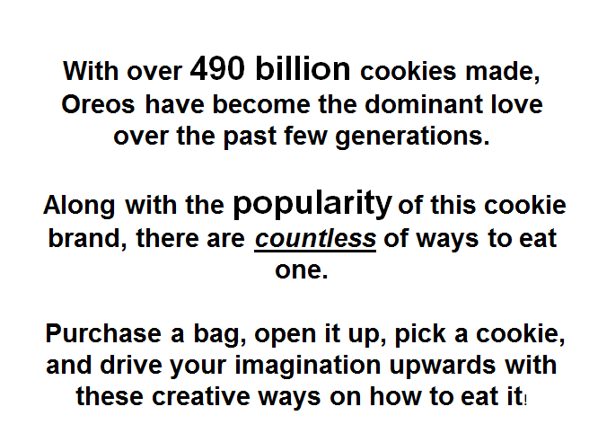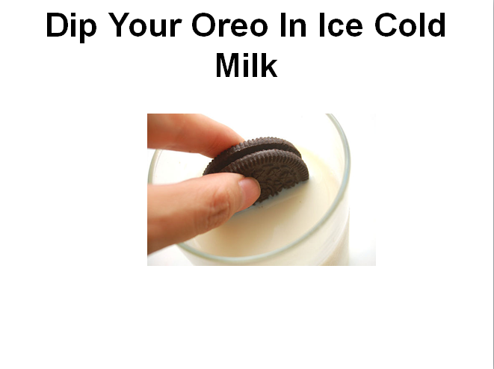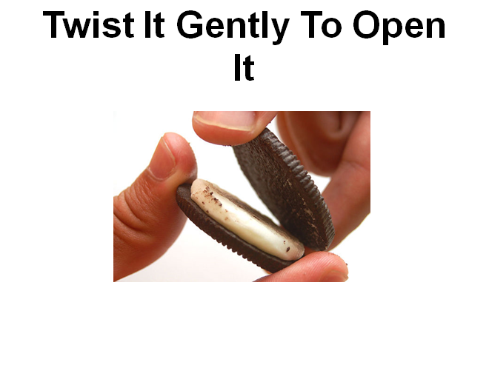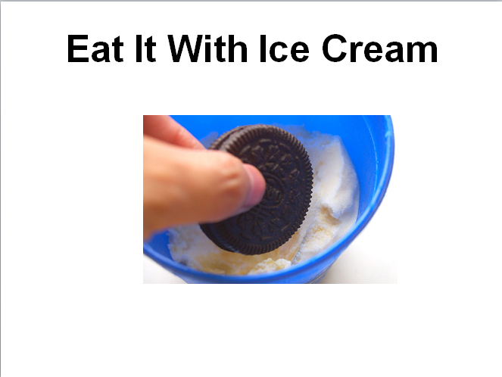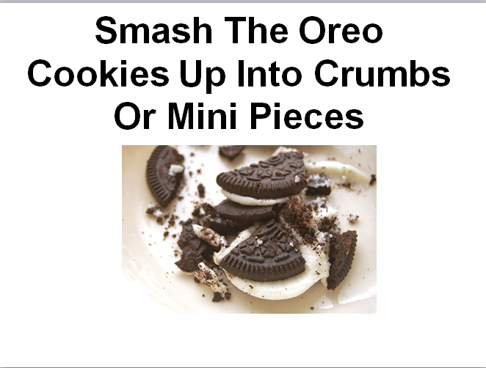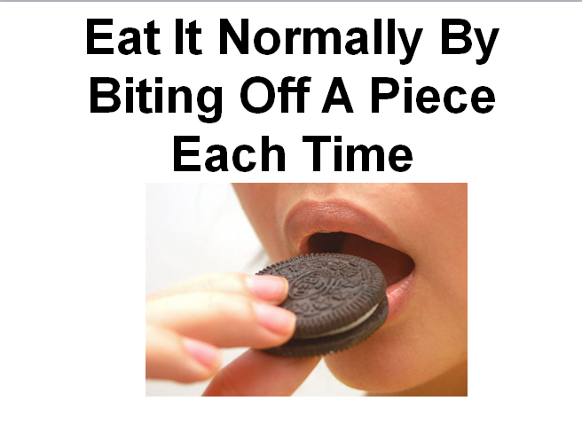

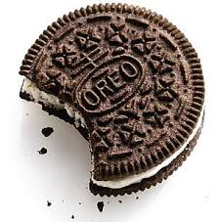How to Eat an Oreo Cookie

Drag and Drop (Cut and Paste) Activity

Directions:

1. Open Microsoft Word
2. Open “Oreo” from Share directory in Teacher Name/Computer 6/Word

1. Save in your Word Folder as “Oreo”
2. Insert a HEADER
3. Rearrange the story into the correct order. *(Using Drag and Drop)*

* *Don’t forget the title*

1. 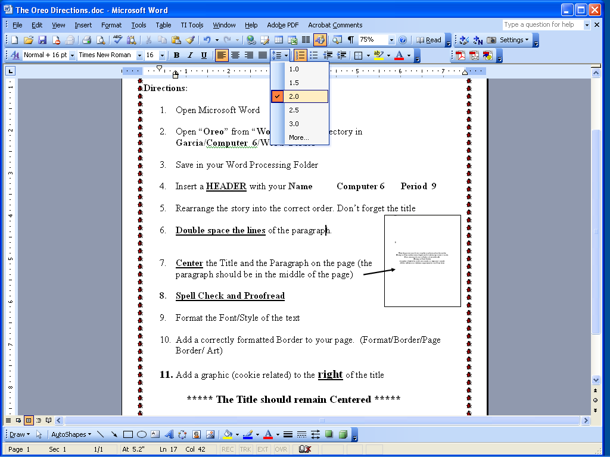CENTER the Title. (No Word Art)

1. Enter 2x after the title.
2. Keep Title on one line
3. Double space (2.0) the lines of the story.
4. BALANCE the lines on the whole page by using larger font sizes and different fonts --OK if lines of story *wrap around* to more than one line)
5. Format font style/color/size. Everything should be easy to read.
6. Add a correctly formatted Border to your page by selecting Page Layout/Page Borders
7. Add a graphic (cookie related) AND put it to the right of the title (Picture/Layout/IN FRONT OF TEXT)

* The Title should remain Centered.

1. *You may add additional pictures to balance your page.*
2. Spell Check and Proofread. Print Preview to make sure nothing is cutting off.
3. Save, Print to color, attach grading rubric and turn in.

# Then the person must have a napkin or plate to place the cookie.

Eating an Oreo cookie cannot begin until careful preparation is made.

First, one must have a tall glass of ice cold milk.

Eating an Oreo Cookie

A napkin is helpful to catch any crumbs or wipe one’s mouth.

All this will ensure a delicious experience for any Oreo lover.

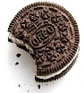Name: ___________________ Project Grade: _________

**How to Eat an Oreo Cookie Rubric**

|  |  |
| --- | --- |
| **Item** | **DID YOU?** |
|  | * Insert a Header * Correctly rearrange the story into the correct order (sequencing) using drag and drop * Centered the title * Skip a line after the title * Double space the lines of the paragraph. * Format the Font/Style of the text. * Balance the paragraph on the page. * Format the font style/color/size * Insert a correctly formatted border. * Included a cookie related. * Proofread and spell check your work. * Print on the color printer, attach grading rubric and turn in. |

**Eating an Oreo Cookie Sample**

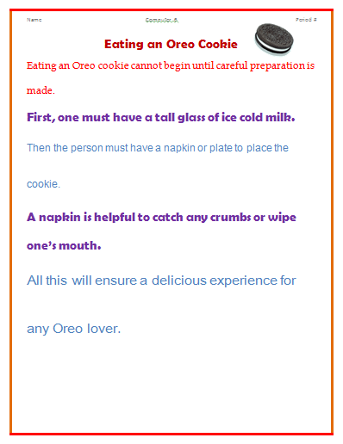

[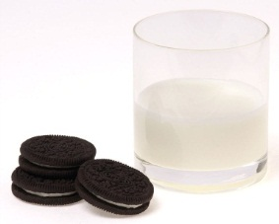](http://upload.wikimedia.org/wikipedia/commons/7/74/Oreos-&-Milk.jpg)**Eating an Oreo Cookie**

**Exit Outcome**

1. What is another phrase for “Drag and Drop?”
2. What happens to the text when you Drag and Drop? Explain.
3. What are some words to look for when you are SEQUENCING events?

**Favorites – Numbering and Bullets in Word**

**Objectives**: The students will be able to do the following:

* Type a list of 5 of their favorite and least favorite things
* Use the Sort function
* Copy and paste their sorted lists
* Number and bullet their lists as directed
* Insert a page border
* Follow written and oral directions

**Do Now**: Log on

Complete My Favorites Do Now

**Procedure**:

1. Teacher will display a list of 5 of her favorite and least favorite things using the Vision software.
2. Teacher will demonstrate the following to the students:
   1. Sorting the list
   2. Copy and Paste the list
   3. Formatting the numberings
   4. Inserting a page break
3. Teacher will review the How to Sheet “Favorites – Numbering and Bullets in Word”
4. Students will complete the activity cooperatively.

**Assessment:**

Students will complete the Numbering and Bullets Exit Card.

Students will turn in the completed activity and attach the grading rubric.

**Instructional Materials**: “Numbering and Bullets Do Now” and Activity sheet/Grading Rubric/Exit Card

**Instructional Technology**: computer, Vision software

**New York State Standards**

MST #2, #5

ELA #3, #4

**Common Core Standards**

Reading Standards for Literacy in Science and Technical Subjects

Key Ideas and Details - #3

Craft and Structure - #4

Name: ________________________________

My Favorites Do Now

Directions:

* List your favorites and least favorites on the lines below
* Do not turn this sheet in. You will need it for today’s activity

Favorite snack food _________________________________________________

Favorite movie _________________________________________________

Favorite hobby/sport _________________________________________________

Favorite TV show _________________________________________________

Favorite place _________________________________________________

Least favorite snack food _________________________________________________

Least favorite movie _________________________________________________

Least favorite hobby/sport _________________________________________________

Least favorite TV show _________________________________________________

Least favorite place _________________________________________________

**FAVORITES - NUMBERING AND BULLETS IN WORD**

**Directions:**

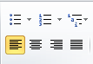

Left Center Right

Align Align

Bullets Numbering

1. Open Microsoft Word and Insert a header
2. Type and Center the title **My Favorites**
3. Press **Enter** 3 times and left align your cursor.
4. Click on the **NUMBERING** button on the Home Ribbon
5. Type the five favorites from your DO NOW sheet pressing enter after each one.



1. Press **Enter** 3 times after the last item.
2. Highlight the list and using the “**Sort**” function sort your list A to Z (Ascending)
3. Highlight and copy your list.

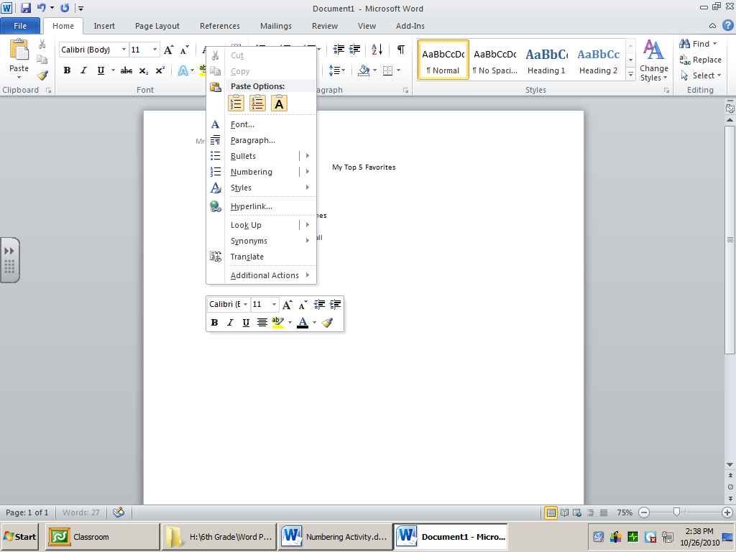

1. Click under your list and use the ***second option*** under Paste Options:

(Make sure there is space between your lists.)

1. Press **Enter** 3 times
2. Paste again using the second option
3. Save as **Favorites** in your Computer 6/Word Folder

**Format the first 3 lists using NUMBERING as follows:**

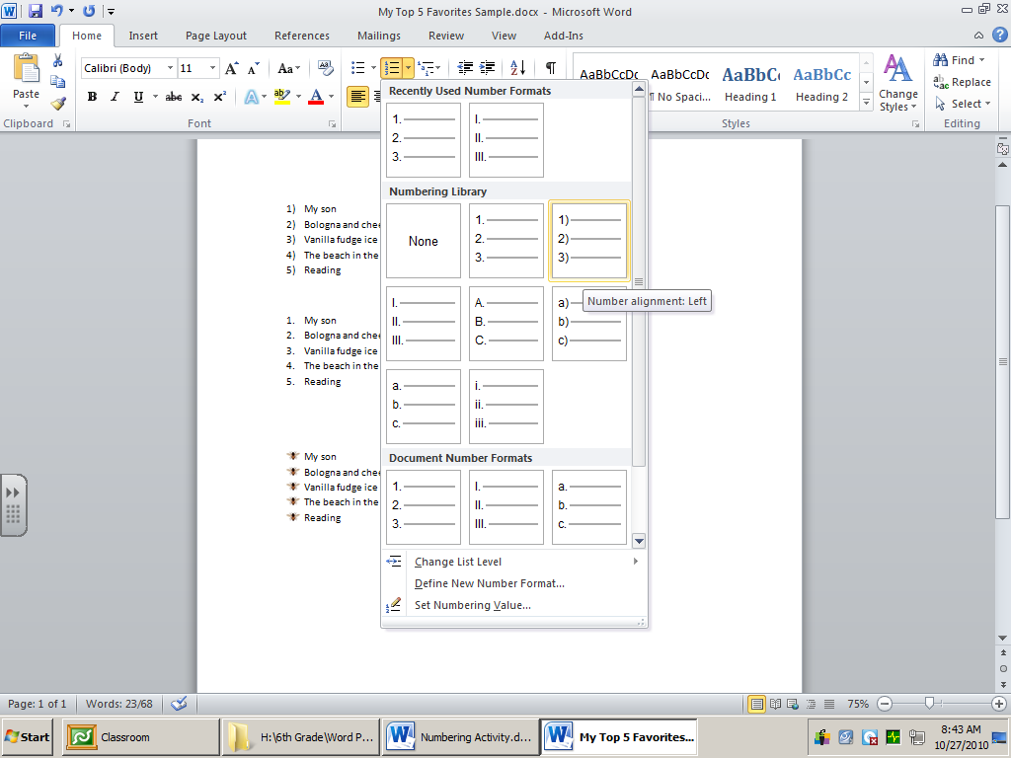

**1st List -** Format the numbers to



1. Highlight the text
2. Click the arrow next to the numbering bullet and select
3. Select a different font style/color

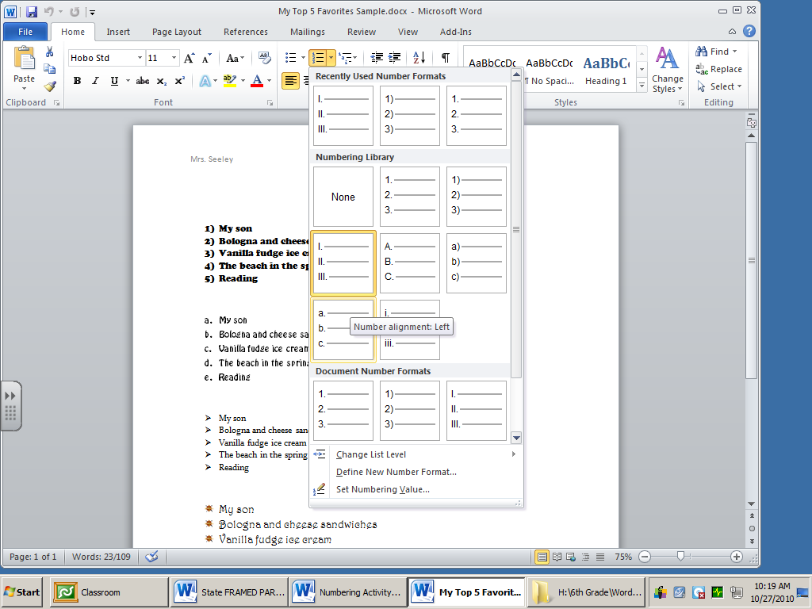**2nd List -** Format the numbers to **Roman Numerals**

1. Highlight the text
2. Click the arrow next to the numbering bullet and select Roman Numerals
3. Select a different font style/color

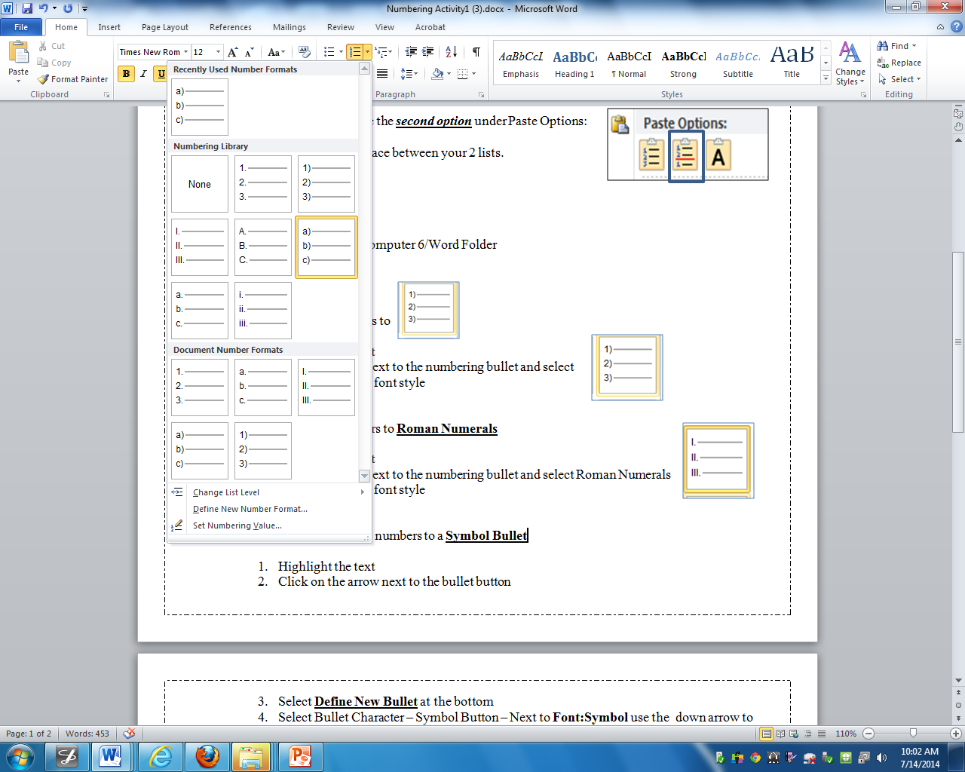

**3rd List -** Format the numbers to



1. Highlight the text
2. Click on the arrow next to the numbering bullet and select
3. Select a different font style/color

**Click under the 3rd List and click on Insert/Page Break**

1. Type and Center the title **My Least Favorites**
2. Press **Enter** 3 times and left align your cursor.
3. Click on the **BULLET** button on the Home Ribbon
4. Type the five least favorites from your DO NOW sheet pressing enter after each one.
5. Press **Enter** 3 times after the last item.
6. Highlight the list and using the “**Sort**” function sort your list Z to A (Descending)
7. Highlight and copy your list.



1. Click under your list and use the ***first option*** under Paste Options
2. Press **Enter** 1 time
3. Paste again using the ***first option***
4. Save

**Format the last 3 lists using BULLETS as follows:**

**4th List -** Format the bullets to a **Symbol Bullet**

1. Highlight the text
2. Click the arrow next to the bullet button
3. Select **Define New Bullet** at the bottom
4. Click the **Symbol Button** and select a symbol from the list
5. Click OK --- OK
6. Select a different font style/color

**5th List -** Format the bullets to a **Font Bullet (Webdings)**

* Highlight the text
* Click the arrow next to the bullet button
* Select **Define New Bullet** at the bottom
* Click the **Symbol Button** and select Webdings from the drop down menu using the arrow to the right
* Click OK --- OK
* Select a different font style/color

**6th List -** Format the bullets using a picture of your choice **(IMPORT PICTURE)**

* + - 1. **Save a picture in your “My Pictures” Folder first**

1. Find a picture on the Internet
2. Right Mouse Click on the picture – Save picture as
3. Give the picture a name and save
4. Highlight the text
5. Click the arrow next to the bullet button
6. Select on **Define New Bullet**
7. Click the *Picture Button*
8. Click on **Import** at the bottom left
9. Select your picture from your **Pictures Library**
10. Click Add – Make sure to select your picture
11. Press OK and OK again
12. Select a different font style/color

**Formatting your Page and Printing**

1. Format the font /style/color of both titles (My Favorites and My Least Favorites)
2. Put a page border on the page (Page Layout Ribbon – Page Borders)

1. 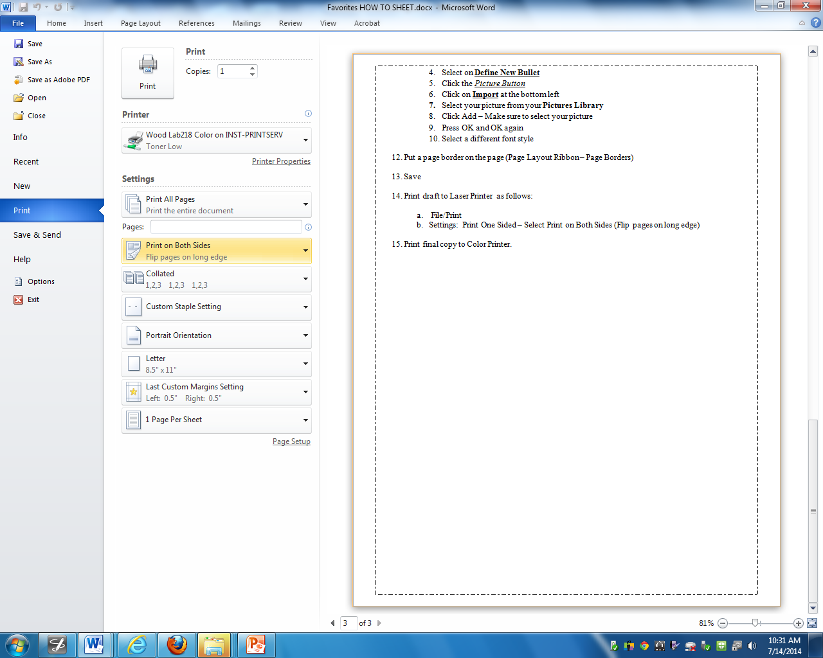Save
2. Print a draft to the Laser Printer as follows: (Back-to-Back)
   1. File/Print
   2. Click on **Settings**. Click on Print One Sided and use the drop down arrow on the right to **Select Print on Both Sides (Flip pages on long edge)**
3. Proofread your work using the grading rubric and make any corrections.
4. Print a corrected laser copy as directed above. (Back-to-Back)
5. Print a final copy to the color printer as directed above. (Back-to-Back)
6. Attach and submit the following:
   1. Grading rubric (on top)
   2. Laser copy
   3. Color copy

**Name: ___________________ Project Grade: _________**

|  |  |
| --- | --- |
| **ITEM** | **DID YOU?** |
|  | * Insert a Header * Type and Center the title My Favorites * Type your five favorites * Sort your five favorites A-Z * Copy and paste your favorites (3 lists total) * Type your five least favorites * Sort your five least favorites Z-A * Copy and paste your least favorites (3 lists total) * Insert a page break as directed * Format your Numbering Lists as directed * Format your Bulleting Lists as directed * Insert a page border * Spell check and proofread your work * Print a corrected copy on the laser (back to back) * Print a corrected copy on the color printer (back to back) * Attach color copy and laser copy to the grading rubric and turn in   **Note**: Grading Rubric goes on top. |

**Favorites - Numbering and Bullets RUBRIC**

Favorites – Numbering and Bullets Sample

Name

My Favorites

1. Backyard
2. Baseball
3. Dolphin Tales
4. Hollywood Game Night
5. Potato chips
6. Backyard
7. Baseball
8. Dolphin Tales
9. Hollywood Game Night
10. Potato chips
11. Backyard
12. Baseball
13. Dolphin Tales
14. Hollywood Game Night
15. Potato chips

My Least Favorites

* The Goonies
* Scooby Doo
* Reading
* Library
* Cheese
* The Goonies
* Scooby Doo
* Reading
* Library
* Cheese
* The Goonies
* Scooby Doo
* Reading
* Library
* Cheese

Name: __________________________

**Numbering and Bullets Exit Card**

**Directions:**

1. Write your name at the top of this page.
2. Answer the question at the bottom of the page.
3. Turn in.

D

A

F

B

C

E



1. Mary is typing a list of items she needs to buy at the store. Which of the above would she use to create a bulleted list?

Answer: ______________________

1. Now Mary wants to change her bulleted list to a list using A, B, C. Which of the above would she use?

Answer: ______________________

1. Mary has decided that she wants to sort her list in ABC order. Which of the above would she use?

Answer: _______________________

1. Mary wants to use a picture of a “shopping bag” as her bullet, which of the following would be the procedure she would follow? (circle the correct answer)
   * Click on the Bullet icon and select the shopping bag.
   * Save a picture of a shopping bag, click on the Bullet icon, and select the picture
   * Save a picture of a shopping bag, click on the Bullet icon, select “Define New Bullet”, click on “Picture”, click on “Import” and select the picture of the shopping bag.
   * Save a picture of a shopping bag, click on the Bullet icon, select “Define New Bullet”, click on “Picture” and select the picture of the shopping bag.

Healthy Lunch Menu Table Activity

Aim of Lesson:

* Each student will use Microsoft Word to organize a healthy lunch menu which includes fruits and veggies.
* Students will read about the regulations with school lunches, explore fast food restaurants calorie counts, and write a letter persuading their “cousin” Fast-Food Freddie to make changes in his poor eating habits.

DO NOW:

DAY 1

* Hand Out sheets to have students come up with the five different meals they would like the cafeteria to serve for lunch for one week.

DAY 2

* Students will read article “New Rules Double Up Fruits, Veggies for School Meals” and answer the seven questions using supporting detail from the article.

DAY 4

* Hand out ditto – have students write down the number of columns and rows used for each of the tables

DAY 5

* Hand out index cards to the groups of students – show presentation on Rows/Columns – Have students in group write down their answers to the number of columns and rows

New York State Standards

2.1-2.6, 3.3-3.6, 4.1-4.4

Common Core Standards

READING STANDARDS FOR LITERACY IN SCIENCE AND TECHNICAL SUBJECTS

3, 4, 6

WRITING STANDARDS – LITERACY IN HISTORY/SOCIAL STUDIES, SCIENCE, AND TECHNICAL SUBJECTS 6-12

1c-1e, 2a-2f, 4, 5, 6

Motivation/Behavioral Objectives:

Students will monitor their lunch eating habits for one week. They will create a “healthy” lunch menu of their dreams! They will also learn about making good choices with healthy food choices. They will use websites to find Fast Food Restaurant calorie counts and convince others to eat healthy.

Procedure

DAY 1

* Students will complete the Do Now
* Students will open a blank document in Word and Create title/subtitle for Lunch Menu
* Students will create a 5 x 2 table (Adjustments for Special Needs Students can be made)
* Students will use Column Headings for the table
* Students will provide the lunch information in the cells from their Do Now sheets.
* Homework: Hand Out Ditto “What’s For Lunch” and have students fill out what they ate for one week and whether they packed lunch or bought lunch.

DAY 2/3

* Students will complete the Do Now. After collecting DO NOW review answers with class
* Have students add at least one fruit and one vegetable to their lunch menu items for each day
* Hand Out Grading Rubric for Lunch Menu
* Have students add at least one picture to each day of the lunch menu
* Print draft to laser printer
* Print final copy to color printer – Attach Rubric

DAY 4

* Do Now: Rows & Columns Ditto – Collect
* Handout Fast-Food Freddy – Students will use the [www.calorieking.com](http://www.calorieking.com) website and compare the calories, fat, and carbs in at least two fast-food meal choices.
* Once students find the information on the fast-food items they will write a letter to their cousin, Fast-Food Freddy persuading him to change his eating habits
* HW: Finish letters

DAY 5

* Have students form groups and show presentation of Rows/Columns to review setting up tables. Students will write answers on index cards.
* Students will read article “Eat McDonald’s for 3 months, lose 37 pounds?” and answer the six questions using supporting detail from the article.
* Collect HW – What’s for Lunch?

Instructional Materials

* Hand out instruction How-to-Sheet and Grading Rubric
* LiteWare Projector for demonstrating and modeling
* Overhead Projector for Rubric
* Newspaper Article/Questions Handout
* Website [www.calorieking.com](http://www.calorieking.com)

Instructional Technology

* Computers
* Internet – online resources and Woodland website
* LiteWare Projector
* Overhead project – sample table

Assessment Questions

When is it beneficial to use a table? In regard to the school lunch information, what did we learn from the article? What did we learn about our own eating habits? What did we learn about fast foods? What can we continue to do or do differently in regard to improve our eating habits?

Summary/Evaluation

* Students are to submit their completed Lunch Menu Tables and hand in Rubric
* Students are to submit their DO NOW – Lunch Article Questions
* Students are to submit their Group Index Card Answers to the ROW/COLUMN review
* Students are to submit their Fast-Food tables with calorie information
* Students are to submit their letters to Fast-Food Freddy
* Students are to submit HW – What’s for Lunch?

Supplemental Activities:

1. Discuss the ways fast-food restaurants target kids and teens. Do you think they are successful?

2. Fast food often has a lot of trans fats, as do many packaged snack foods. Research why trans fats are so

dangerous and how to spot them on an ingredient list.

**________________’S LUNCH MENU**

**Week of ____________________**

|  |  |  |  |  |
| --- | --- | --- | --- | --- |
| Monday | Tuesday | Wednesday | Thursday | Friday |
|  |  |  |  |  |

**Healthy Lunch Menu Table**

1. Open Microsoft Word
2. Type and center the title of your table ( ___________________’s Lunch Menu)

**Ex: Robert Johnson’s Lunch Menu**

1. Press ENTER 2 times
2. Type and center the subtitle of your table (Week of ______________)

**Ex: Week of April 7, 2014**

1. Press **ENTER** **3** times.
2. Click on **Insert Ribbon – Table** – **5 X 2 Table**
3. Type the following in the first row of your table pressing **TAB** after each word:

|  |  |  |  |  |
| --- | --- | --- | --- | --- |
| Monday | Tuesday | Wednesday | Thursday | Friday |

1. Highlight the column headings and center days of the week (if they were not already centered)
2. Click in the second row under **Monday** and press **ENTER** **8** times to make the cell larger.
3. Save in your Word Folder as **Healthy Lunch Menu**
4. Click in the cell under Monday near the top and type the lunch information from your Do Now
5. Repeat for each day of the week.
6. Press **ENTER 2** times after each menu item
7. Save
8. Insert a graphic from the Internet to correspond with your lunch items.

Be sure to select Format/Picture/Layout/In Front of Text

1. Save frequently
2. Highlight the first **ROW** and fill with color (use a light color. Paint bucket located on Home Ribbon.
3. Format the font ***style/color/size*** of the information in your table.
4. Format the **border** of the table (color/style/size).
5. Make sure your menu is neat and attractive.
6. Make sure your menu is on 1 page.
7. Make sure all of your information is **centered**.
8. Spell check and proof your menu.
9. Save
10. Print on the laser and using the **Grading Rubric** proof your work. Make any corrections needed.
11. Print a corrected copy of the menu on the laser and the color printer.
12. Attach the laser copy and the color copy to the **Grading Rubric (Rubric on top)** and turn in.

Healthy Lunch Menu Sample

**MARIE GARCIA’S LUNCH MENU**

**Week of April 7, 2014**

|  |  |  |  |  |
| --- | --- | --- | --- | --- |
| **Monday** | **Tuesday** | **Wednesday** | **Thursday** | **Friday** |
| **Chicken Caesar Salad**  **Grapes**  **And Lemonade**  Description: http://3.bp.blogspot.com/-XjVQEEgFhmI/TayKQYIPrEI/AAAAAAAAAaM/1YgnA1Jm8qY/s1600/ceasar-salad-health-benefits.jpg  MC900411884[1] | **Checkers**  **Hamburgers With Tomato And Lettuce And Pepsi**  **And Grapefruit**  **http://www.foodfranchise.com/franchise/141934/webpages/checker-logo.jpg**  [http://t1.gstatic.com/images?q=tbn:ANd9GcT_p8fzMYPIz-5CJpTATwWQ-r5OBen-3Dubupy10w7V6qRDYlss](http://www.google.com/imgres?q=juicy+grapefruit&hl=en&safe=active&sa=X&biw=1280&bih=902&tbm=isch&tbnid=psdx5j8Si0NicM:&imgrefurl=http://purefragranceoils.com/index.php?main_page=product_info&products_id=106&docid=g8BvN1jFzQZ4NM&imgurl=http://purefragranceoils.com/images/pink_grapefruit.jpg&w=400&h=300&ei=3QpjUaDULMTD4APUxYH4CQ&zoom=1&ved=1t:3588,r:22,s:0,i:159&iact=rc&dur=599&page=2&tbnh=194&tbnw=248&start=20&ndsp=26&tx=114&ty=134) | **Pizza And Water**  Description: http://images.paraorkut.com/img/pics/images/p/pizza-13994.jpg**Sliced Carrots And Kiwi** | **Hot Dog,**  **Fries, And**  **Cola**  **Apple And**  **http://www.graphicsbydezign.com/food-clip-art.htmlCelery Sticks** | **Peanut Butter And Jelly Sandwich**  http://cache.boston.com/resize/bonzai-fba/Globe_Photo/2007/09/03/1188864954_0653/410w.jpg**Carrots And Oranges And Milk** |

DO NOW Computer 6 Literacy Article/Questions

NAME ____________________________________________ PERIOD#___

**Directions:**

Please answer the following questions based on the article “New Rules Double Up Fruits, Veggies for School Meals”

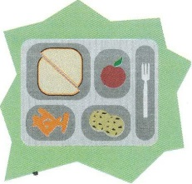By Dina Elboghdady

1. What are the new guidelines to make school cafeteria meals more nutritious?
2. What are the two foods that Congress did not eliminate from the school meals?

_____________________________ and __________________________

1. What type of milks must they offer?

_____________________________ and __________________________

1. How did administration cut the cost for these new guidelines?
2. What was the original price?
3. What was the new price?

New Rules Double Up Fruits, Veggies for School Meals – Dina Elboghdady –

# New rules call for more nutritious school lunches

Dina Elboghdady / The Washington Post   
Published Jan 26, 2012 at 04:00AM / Updated Nov 19, 2013 at 12:31AM

WASHINGTON — School cafeterias will be serving more-nutritious meals with twice as many fruits and vegetables, more whole grains and less sodium and fat under new guidelines that will revamp the federally backed school meals program for the first time in 15 years.

The meals will continue to include pizza and french fries because Congress, after heavy lobbying from the food industry, derailed the Obama administration’s original plan to limit tomato paste and starchy vegetables such as potatoes.

Even so, consumer groups hailed the changes as a major improvement over the current standards.

“When we send our kids to school, we expect that they won’t be eating the kind of fatty, salty, sugary foods that we try to keep them from eating at home,” said Obama, who has championed efforts to combat childhood obesity.

Under the guidelines, which cover both breakfast and lunch, participating schools must offer a mix of fruits and vegetables daily and offer double as much as currently required. Schools also must offer only fat-free and low-fat milk varieties; limit calories based on the age group served and lower the amount of trans fats and sodium in meals.

As the Agriculture Department was crafting the final guidelines, opponents often cited as problematic the program’s estimated $6.8 billion price tag over the next five years and the financial burdens it would place on school districts.

In response, the administration slashed the cost to $3.2 billion. It did so by abandoning the push to have schools offer meat or meat alternatives for breakfast. The administration also decided to phase in the standards over three years for the breakfast program. The rules will kick in for school lunches next school year.

Name: _____________________

**DO NOW:**

How many rows and columns do you need to insert for the following tables?

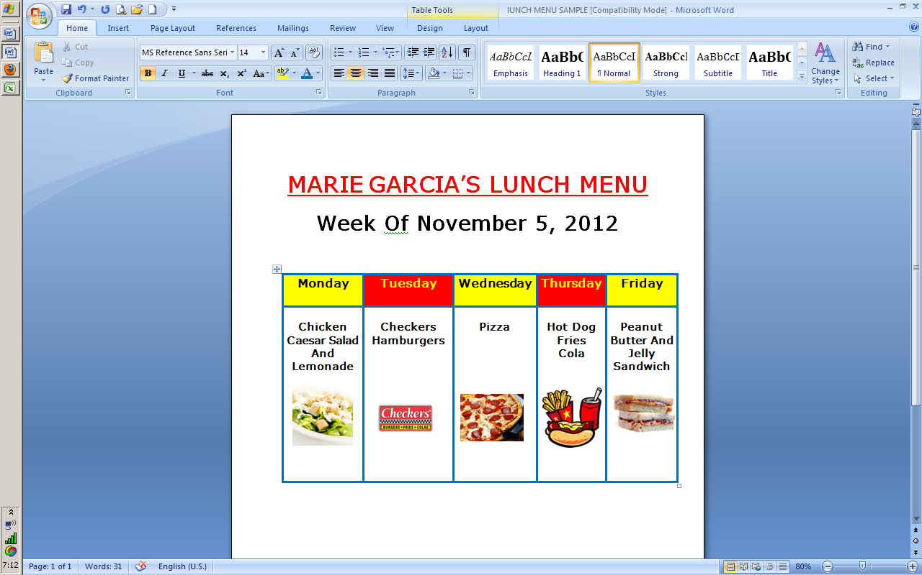

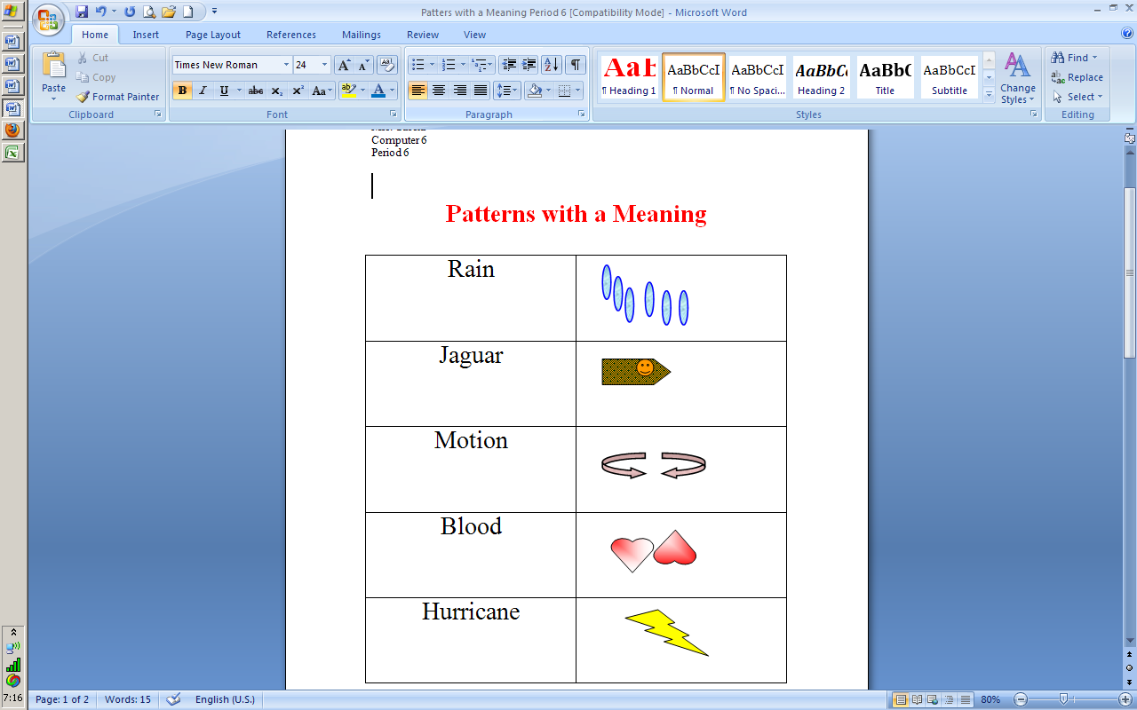

Columns = _____

Rows = _____

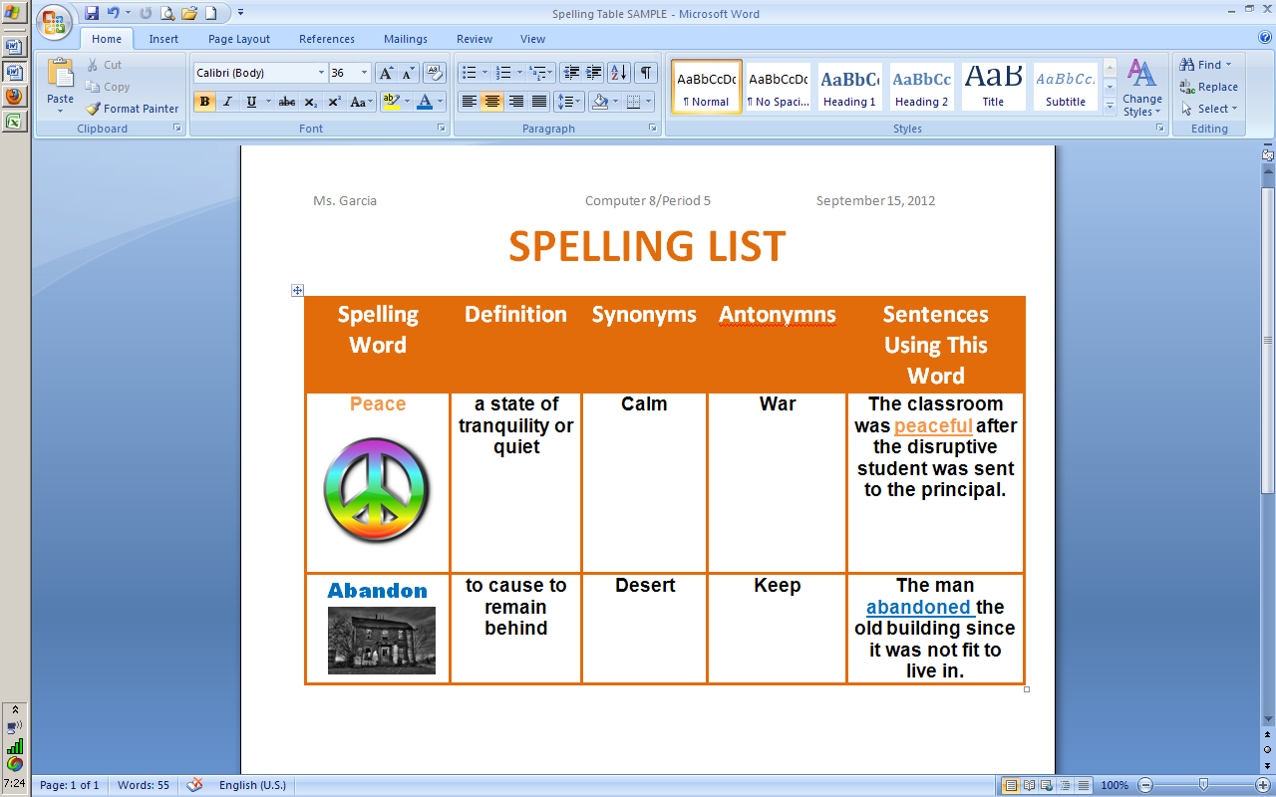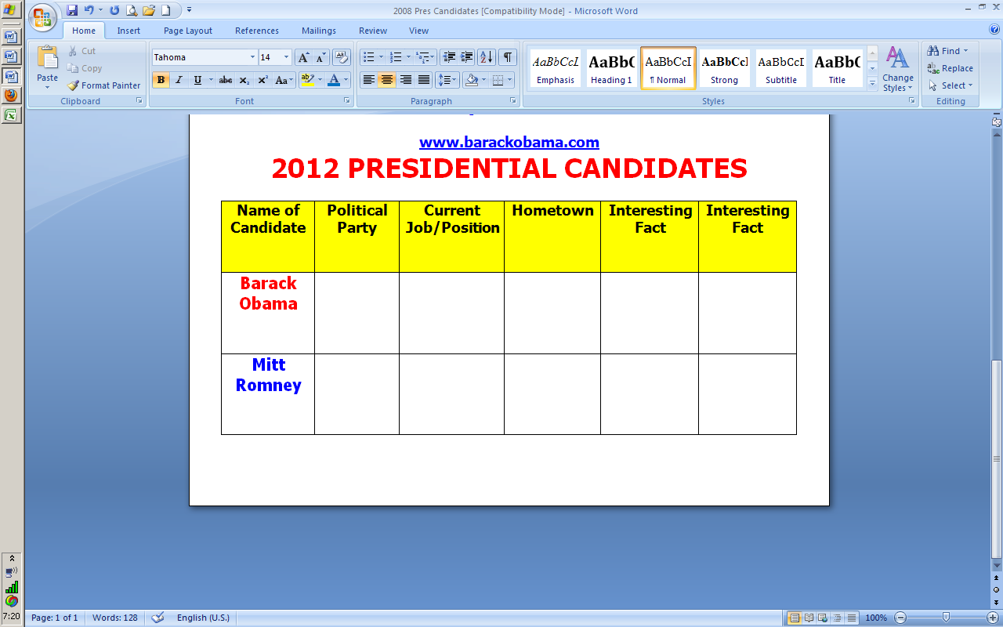

Columns = _____

Rows = _____

Columns = _____

Rows = _____

Columns = _____

Rows = _____

Name: __________________________________________

**C:\Users\mgarcia\AppData\Local\Microsoft\Windows\Temporary Internet Files\Content.IE5\T25ARGKF\MC900264260[1].wmf**

**Calorie King**

**Fast-Food Freddy**

1. **Using the website below compare the calories, fat, and carbs in *at least two* of Fast-Food Freddy’s meal choices.**

[www.calorieking.com](http://www.calorieking.com)

|  |  |  |  |  |
| --- | --- | --- | --- | --- |
| **Fast Food Restaurant** | **Food Item** | **Calories** | **Fat (g)** | **Carbs** |
| **Burger King** |  |  |  |  |
| **McDonald’s** |  |  |  |  |
|  |  |  |  |  |
|  |  |  |  |  |
|  |  |  |  |  |
|  |  |  |  |  |

1. **Add additional Fast Food Restaurant Items as needed.**



Name: __________________________________________

**Fast-Food Freddy**

**Instructions**: You are Fresh-Food Frankie, writing a letter to your cousin Fast-Food Freddy, who eats nothing but fast food. Explain why eating so much fast food is not healthy. Be sure to:



* compare the calories, fat, and carbs in at least two of his meal choices
* discuss fast-food portion sizes
* explain how Freddy’s eating habits might hurt his health and energy levels
* suggest ways Freddy can improve his diet

*Dear Freddy:*

© 2012 The Nemours Foundation/KidsHealth. Reproduction permitted for individual classroom use.

Your cousin,

Frankie

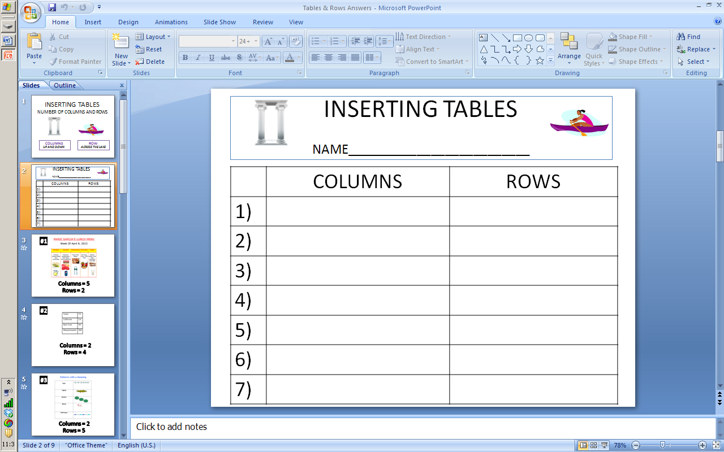

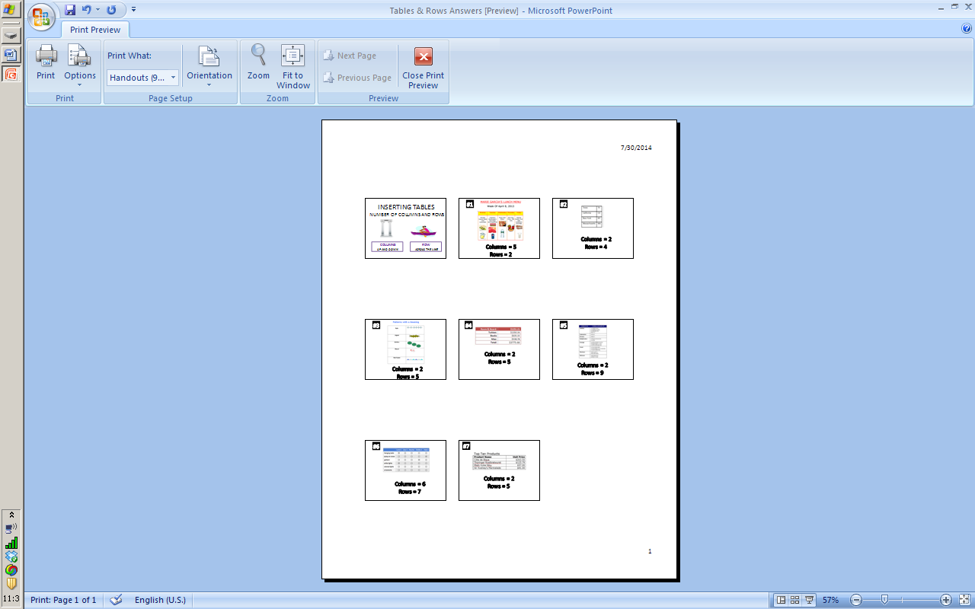

**Eat McDonald's for 3 months, lose 37 pounds?**

[Bruce Horovitz, USA TODAY](http://www.usatoday.com/staff/688/bruce-horovitz) 6:45 p.m. EST January 6, 2014

**Science teacher goes on McDonald's-only diet to prove it's not where you eat, but what you eat (and how much you exercise) that matters.**

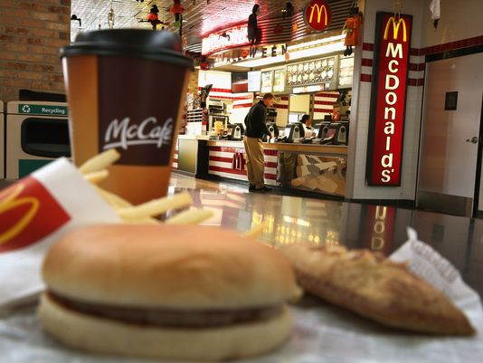

(Photo: Scott Olson, Getty Images)

**Story Highlights**

* Teacher says McDonald's doesn't make folks fat, but food and lifestyle choices do
* He stuck to about 2,000 calories per day, but ate much more than McDonald's salads

McDonald's executives aren't just loving it — they're eating it up.

Roughly one decade after the film *Super Size Me* skewered McDonald's for selling food that the hit documentary film claimed was not healthy and lacking in key nutritional elements when consumed regularly, there's a new, unexpected twist to the experiment that had director Morgan Spurlock gaining weight and getting sick after chowing-down on McDonald's food for only 90 days.

The new twist: A high school science teacher in the Colo-Nesco School District in Colo, Iowa, says he lost 37 pounds in 90 days also by eating only McDonald's food — but he followed strict nutritional limits laid out by his students. That included limits of 2,000 calories a day and attempts to stick with daily recommended allowances for protein, carbohydrates, cholesterol and several other nutritional restrictions.

"I'm the perfect example of a slob," says the teacher, John Cisna, in a phone interview on Monday. He insists that he ate a variety of stuff on the McDonald's menu — including Big Macs, Quarter Pounders and even desserts, including sundaes and ice cream cones. His mission: to demonstrate to his students that it's how and what you eat — not where you eat — that matters most. During the three months, he says, his cholesterol dropped from 249 to 170.

He had two Egg White Delight McMuffins, a bowl of McDonald's Fruit & Maple Oatmeal and 1% milk for breakfast and, typically, a salad for lunch. Then, at dinner, he'd often have a more traditional Value Meal. He also adopted a new exercise regimen of walking 45 minutes daily.

**MORE:** [Five things you didn't know about McDonald's](http://www.usatoday.com/story/money/markets/2013/11/19/five-things-about-mcdonalds/3643557/)

"McDonald's had absolutely nothing to do with this," he says, although he did coax a local McDonald's franchisee into giving him the three-month meal supply for free. "If you had a McDonald's senior executive serve me a Quarter Pounder in person, I wouldn't know him."

For McDonald's, which has been repeatedly baffooned — if not lambasted — in the news media for selling junk food, the experiment is both an eyebrow raiser and an I-told-you-so moment that is surely gloat-worthy.

"We congratulate John Cisna on his weight loss and improved overall health, and we are pleased he was able to accomplish his goals by making balanced choices, which included many of his favorite McDonald's menu items," says Cindy Goody, senior director of nutrition at McDonald's USA, in a statement.

Spurlock, who had a very different experience eating only at McDonald's 10 years ago, was filming the CNN show *Inside Man* on Monday and unavailable for comment.

Jo Ann Hattner, a nutritional consultant at Stanford University School of Medicine, says McDonald's has much improved its menu. "You have to give them some credit," she says.

But, she notes, "I don't advise a McDonald's diet," she says. "You need more fresh vegetables and fresh fruits."

Name __________________________________________________ Period _________

EAT MCDONALD’S FOR 3 MONTHS, LOSE 37 POUNDS?

Directions: Answer the following questions based on the above article.

1. What fast-food restaurant did the science teacher eat all his meals? _______________________________________________________
2. How many calories did the Science teacher eat per day? ____________
3. How much weight did the science teacher lose in 90 days? ____________
4. What was his “mission?” ________________________________________________________________________________________________________________________________________________________________________________________________________________________
5. What did he do for exercise? _____________________________________
6. What did he usually eat for lunch? ________________________________
7. What did the nutritional consultant say about this “experiment?” ________________________________________________________________________________________________________________________________________________________________________________________________________________________________________________________________________________________________

**Greek Mythology**

**Objectives**: The students will be able to do the following:

* Paraphrase information from the Internet
* Using websites provided research a list of Greek Gods and provide at least one interesting detail about the each god using their own words (paraphrasing)
* Identify the use of Greek Gods in modern advertising campaigns
* Identify some values, ideas, skill, traced or aspects of nature that people value today
* Identify 5 –10 things they value
* Create a modern day god/goddess based upon a something they value
* Create a poster (informative or wanted) which depicts their god/goddess

**Day 1**

**Do Now**: What do the following 2 words mean?

Paraphrasing Plagiarism

**Procedure**:

1. Answers to the DO NOW question will be discussed
2. Using the Vision software the teacher will play BrainPop – Paraphrasing video
3. The BrainPop – Paraphrasing Quiz will be taken as a class and answers reviewed
4. Teacher will hand out the Paraphrase Don’t Plagiarize Activity Sheet
5. Students will complete the activity per the directions with a partner

**Assessment:**

Students will complete the Paraphrase Don’t Plagiarize Activity Sheet demonstrating their ability to paraphrase information.

**Instructional Materials**: BrainPop – Paraphrasing video, Paraphrasing Quiz and Paraphrase Don’t Plagiarize Activity Sheet.

**Day 2**

**Do Now**: Identify 1 interesting fact about a Greek god/goddess

**Procedure**:

1. Answers to the DO NOW question will be discussed.
2. Teacher will hand out the Greek Gods/Goddesses Research Activity Sheet
3. Using the website list provided in the share folder the students will complete the activity per the directions.
4. Students will print and hand in their assignment.

**Assessment:**

Students will complete the Greek Gods/Goddesses Research demonstrating their ability to use websites provided to research information about Greek gods/goddess and paraphrase the information.

**Instructional Materials**: Greek Gods/Goddesses Research Sheet and Greek Mythology Websites

**Instructional Technology**: computer, Vision software

**Day 3**

**Do Now**: Can you think of any companies that use a Greek god/goddess as part of their advertising?

**Procedure**:

1. Students will think and discuss their answers to the Do Now question
2. Teacher will display the website: <http://greekmythologytoday.com/biz02.html>
3. Class will be shown a number of companies which use a Greek god/goddess as part of their advertising campaign.
4. Teacher will hand out the God/Goddess in Advertising Activity Sheet
5. Teacher will model procedure for completing the activity
6. Students will complete the activity per the directions.

**Assessment:**

Students will complete the Gods/Goddess in Advertising activity using the computer and demonstrate their ability to link a god/goddess to a company and explain the mythological connection.

**Instructional Materials**: Gods/Goddess in Advertising activity sheet and the website <http://greekmythologytoday.com/biz02.html>

**Day 4**

**Do Now**: Values of the Gods activity sheet - Using your knowledge of Ancient Greece what are some of the things the Greeks valued?

**Procedure**:

1. Students will complete Values of the Gods activity sheet in groups
2. Teacher will discuss their answers to the Do Now question and activity
3. Teacher will distribute Create a God/Goddess Activity
4. Teacher will model the procedures for completing the activity using the Vision software
5. Students will complete the activity per the instruction sheet

**Assessment:**

Students will complete the Create a God/Goddess activity using the computer and demonstrate their ability to link a god/goddess to a current day value

**Instructional Materials**: Value of the Gods activity sheet and create a Greek God/Goddess activity sheet

**Instructional Technology**: computer, Vision software

**Day 5**

**Do Now**: What is the difference between an informative poster and a wanted poster?

**Procedure**:

1. Class will discuss their answers to the DO NOW question
2. Previous day’s activity will be handed back to students and students will share their ideas with the class
3. Students will be given the instruction sheet for the Gods/Goddess Poster
4. As a class, Page 1 of the activity sheet will be discussed and ideas shared
5. Using the Vision software and Part 2 of the activity sheet, the teacher will model the procedure for creating a poster using Microsoft Publisher
6. Students will complete the activity per the instruction sheet

**Assessment:**

Students will complete the God/Goddess Poster activity using the computer and demonstrate their ability to create an informative or wanted poster

**Instructional Materials**: Gods/Goddess Poster activity sheet

**Instructional Technology**: computer, Vision software

**New York State Standards**

MST #2, #5

ELA #3, #4

**Common Core Standards**

Reading Standards for Literacy in Science and Technical Subjects RL 2.1-2.10, RI 2.1-2.10

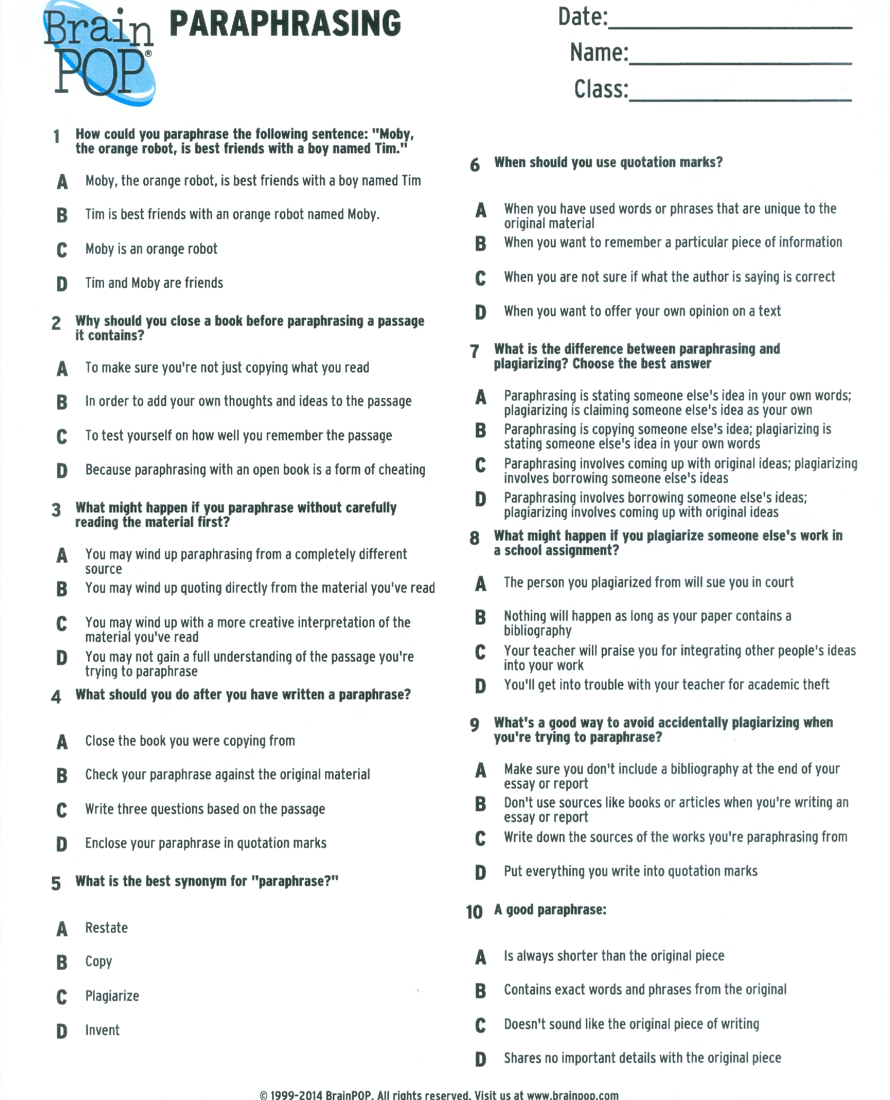

PARAPHRASE DON’T PLAGIARIZE

1. When **depicted** in art, Demeter is often shown carrying a **sheaf** of grain. What do the bolded words mean?

|  |  |
| --- | --- |
| **BOLDED WORD** | **MEANING** |
| **Depicted** |  |
| **Sheaf** |  |

**Paraphrase below:**

______________________________________________________________________________

1. This was Helen of Sparta, who became **infamous** as Helen of Troy when Paris **subsequently** **eloped** with her. What do the bolded words mean?

|  |  |
| --- | --- |
| **BOLDED WORD** | **MEANING** |
| **Infamous** |  |
| **Subsequently** |  |
| **Eloped** |  |

**Paraphrase below:**

______________________________________________________________________________

1. The Goddess Hera took many forms, among them that of a bird.

**Paraphrase below:**

______________________________________________________________________________

**NAME(S) ____________________________________________________________________**

C:\Users\jseeley.INST\AppData\Local\Microsoft\Windows\Temporary Internet Files\Content.IE5\Y6H1AZZ4\MC900414940[1].wmfGreek Gods/Goddesses Research

Directions:

1. Open the following documents from the share folder:

* Greek Gods/Goddesses Research
* Greek Mythology Websites

1. Insert a header on the Greek Gods/Goddesses Research document
2. Save this document in your Word Folder as Greek Gods Goddesses Research
3. Using the Greek Mythology Websites complete the chart
   * Remember to paraphrase not plagiarize!!
4. Save
5. Proofread and spell check your work.
6. Print on the laser printer and turn in.

C:\Users\jseeley.INST\AppData\Local\Microsoft\Windows\Temporary Internet Files\Content.IE5\Y6H1AZZ4\MC900414940[1].wmf

Greek Gods/Goddesses Research

|  |  |  |
| --- | --- | --- |
| **Name of god/goddess** | **God/Goddess of……** | **Interesting detail(s)** |
| Aphrodite |  |  |
| Apollo |  |  |
| Ares |  |  |
| Artemis |  |  |
| Athena |  |  |
| Demeter |  |  |
| Dionysus |  |  |
| Hades |  |  |
| Hephaestus |  |  |
| Hera |  |  |
| Hermes |  |  |
| Poseidon |  |  |
| Zeus |  |  |

C:\Users\margarci.EM-INSTRUCT\AppData\Local\Microsoft\Windows\Temporary Internet Files\Content.IE5\IQ8R6RGK\MC900037382[1].wmf

<http://www.greekmythology.com/Olympians/olympians.html>

<http://www.infoplease.com/ipa/A0881990.html>

<http://www.mythweb.com/>

<http://www.greekmythology.com/>

<http://www.crystalinks.com/greekgods.html>

<http://dir.yahoo.com/Society_and_Culture/Mythology_and_Folklore/Mythology/Greek/Gods_and_Goddesses/>

[www.boolify.org](http://www.boolify.org)

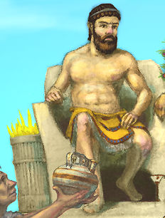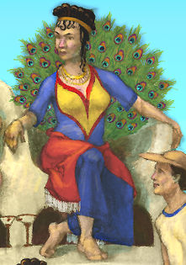

**Gods/Goddesses in Advertising**

**Many advertising campaigns use references to Greek mythology.**

**Directions:**

1. Insert a header
2. Save in your Word Folder as **Gods/Goddesses in Advertising**
3. Complete the chart using the Greek Mythology and Advertising link below. **Remember to paraphrase not plagiarize!!**

[**http://greekmythologytoday.com/biz02.html**](http://greekmythologytoday.com/biz02.html)

1. Delete the directions
2. Save
3. Print on the laser printer and turn in

|  |  |  |
| --- | --- | --- |
| **Name of god/goddess** | **Company Name** | **Explanation of mythological connection** |
| Hercules |  |  |
| Midas |  |  |
| Minerva |  |  |
| Pandora |  |  |
| Poseidon |  |  |
| Venus |  |  |

**C:\Users\jseeley.INST\AppData\Local\Microsoft\Windows\Temporary Internet Files\Content.IE5\I7GWK035\MC900237373[1].wmf**Name: ____________________________

**Values of the Gods**

As you read Greek myths, you realize that great emphasis was placed on certain skills and talents. The immortals also had power over many aspects of the natural world. The following is a short list of things the ancient Greeks valued:

**clouds rain fire sun soil light  
marriage purity        reason         wisdom        fire         water  
battle archery hunting       speed artisans war**

* What are some values, ideas, skills, trades (occupations), or aspects of nature that people value today?
* Come up with at least 5 things (but challenge yourself to come up with 10) that represent the world we live in.

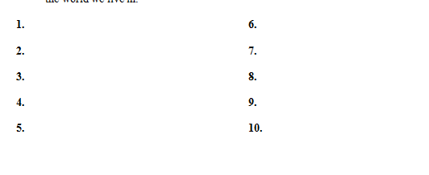

**Create a God/Goddess Activity Sheet**

**Introduction:**

* From your list of modern day values, choose one idea to expand upon.
* You are going to use that word to help you create a modern day god or goddess.
* Your immortal could represent a positive aspect of our society or a negative.
  + For instance, if your word was air, you might come up with the god of satellites or the goddess of greenhouse gases.
  + For money, it could be the goddess of charity or the god of greed.

**Directions:**

1. Open Word
2. Insert a header in a blank document
3. Save as **Values of the Gods** in your Word folder
4. Once you have selected a word from your list complete the following:

* Value chosen:
* Name of god/goddess:
* I chose to create this god or goddess because…
* This god or goddess is significant to our society today because…

1. Save
2. Print on the laser printer and turn in.

Gods/Goddesses Poster

You are going to design and present a poster starring your Greek God or Goddess based on the **Values of the Gods** Activity

You may select on the following two options:

|  |  |
| --- | --- |
| **Option 1** | **Option 2** |
| Make an informative poster. | Make a “Wanted” poster. (easier if you have a god/goddess who did bad things.) |

Your poster must include at least the following information:

* Name of god or goddess
* Your Name
* Symbol of the god/goddess
* Include their role (what they were god or goddess of)
* Significance to our society today
* 5 facts about your god or goddess.
* A drawing of your god or goddess.
  + You may use any of the following options:
    - Drawing to be scanned into you poster
    - The Paint Program
    - Shapes to create your god/goddess

**Poster Directions:**

1. Open Microsoft Publisher – Blank 8.5 x 11” or Blank 11 x 8.5”
2. Save as **God/Goddess Poster** in your Computer 6 Folder
3. Poster must include the following:
   1. Name of god/goddess using WordArt
   2. **Insert – Advertisements – Free Offer** ribbon and type one of the following depending on type of poster you are creating:

Wanted

* Introducing
* Presenting
* Starring
* Wanted
  1. Textbox with your name – format font style/color/size.
  2. Picture of your god/goddess (scanned drawing/Paint/shapes)
  3. Use shapes for emphasis of information – format shape borders and text within shapes (Do not fill shape with color).
     1. Use contrasting colors
     2. Text should be large enough to read easily.
  4. Graphics (Internet or Clip Art) should be added to enhance poster.
  5. At least 1 Borders & Accents must be used.

1. Keep your page balanced and make sure layout is attractive.
2. Save
3. Proofread and spell check your work
4. Print on the laser printer and show to teacher
5. Make any necessary corrections
6. Print a corrected color copy and turn in.

**Spice Activity – Using the Thesaurus**

**Objectives**: The students will be able to do the following:

* Adjust margins in a Word document
* Set tab stops
* Use on-line thesaurus to identify synonyms for a given list of words
* Label the parts of speech in sentences (noun, verb, adjective, adverb)
* “Spice” up sentences using synonyms from the thesaurus
* Follow written and oral directions

**Day 1**

**Do Now**: Spice Activity – DO NOW #1

**Procedure**:

1. Answers to the DO NOW question will be discussed.
2. Using Vision Software the teacher will model how to adjust margins and set tab stops.
3. Teacher will handout Spice Activity – Using the Thesaurus – Part 1 sheet to students.
4. Teacher will model how to complete Spice Activity – Using the Thesaurus – Part 1
5. Students will complete the activity per the directions.

**Assessment:**

Students will save the completed activity in their Word folder for a follow-up activity the next day.

**Instructional Materials**: Spice Activity - DO NOW #1 and Spice Activity – Using the Thesaurus – Part 1

Day 2

**Do Now**: Spice Activity – DO NOW #2

**Procedure**:

1. Students will answer the DO NOW question in groups and answers will be discussed.
2. Teacher will handout Spice Activity – Using the Thesaurus – Part 2 sheet to students.
3. Using Vision Software the teacher will model how to adjust use the thesaurus to select synonyms for given words.
4. Teacher will model the procedure for “spicing up” the sentence in the activity per the instruction sheet
5. Students will complete the activity per the directions.

**Assessment:**

Students will complete the Spice Activity – Using the Thesaurus – Part 2 activity and print to hand in for a grade

**Instructional Materials**: Spice Activity - DO NOW #2 and Spice Activity – Using the Thesaurus – Part 2

**Instructional Technology**: computer, Vision software

**New York State Standards**

MST #2, #5

ELA #3, #4

**Common Core Standards**

Reading Standards for Literacy in Science and Technical Subjects RL 2.1-2.10, RI 2.1-2.10

Name: ____________________________

Spice Activity

DO NOW #1

Team 1 Team 2 Team 3

Mary Paul Jane

Tim Janice Marie

Brian Olivia Amanda

Patty Jen Dave

Your teachers created the above team lists in Microsoft Word.

How do you think these lists were created?

________________________________________________________________________________________________________________________________________________________________________________________________________________________________________________________________________________________________________________________________________________________________________________________________________

**C:\Users\mgarcia.INST\AppData\Local\Microsoft\Windows\Temporary Internet Files\Content.IE5\173Y3095\MC900038648[1].wmfC:\Users\mgarcia.INST\AppData\Local\Microsoft\Windows\Temporary Internet Files\Content.IE5\LH39PCSE\MC900298949[1].wmf**

**Spice Activity – Using The Thesaurus**

**Part 1**

Directions:

1. Open Word and set **Margins** to **Narrow** (Page Layout/Margins/Narrow)
2. 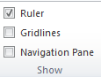Insert a header
3. Select **View – Show Ruler** (make sure there is a check mark next to ruler)
4. Set Tab Stops to 2”, 4”, and 6” by clicking on the numbers on the ruler.



1. Center the Title **Spice Activity**
2. Press Enter 2 times
3. Left align your cursor
4. Type the word **House**
5. Double click on **House** to select the word
6. Copy the word **House**
7. Click at the end of the word **House**
8. Press the **Tab** button

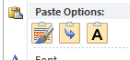

1. At the 2” Tab Stop paste the word and use Paste Options - **A** (Keep Text Only)
2. Press Tab again and at the 4” Tab Stop paste the word using Paste Options – **A**
3. Press **Tab** again and at the 6” Tab Stop paste the word using Paste Options – **A**
4. Press **Enter**
5. Repeat steps 8 – 16 using the following words:

Pretty

Walked

Quickly

1. Press Enter 3 times
2. Type the following sentence.

**The man ran to the store.**

1. Copy and paste the sentence below the first sentence.

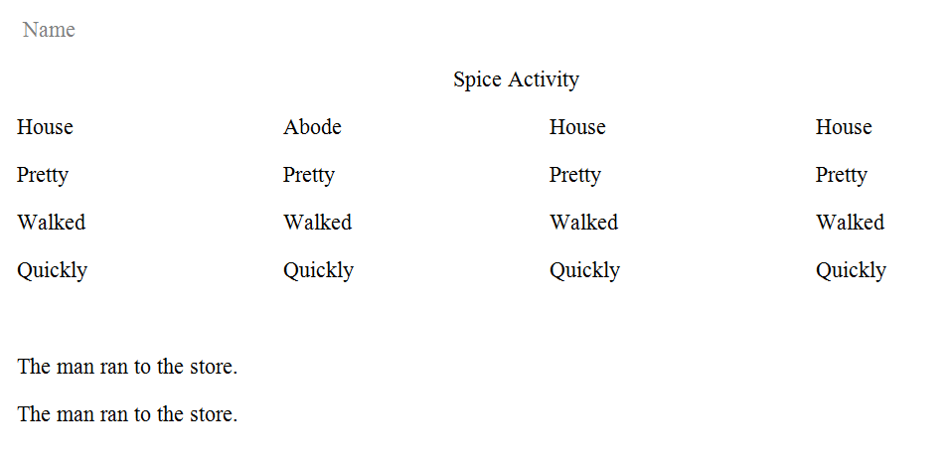

1. Save in your Word Folder as Spice Activity
2. **DO NOT PRINT**

Spice Activity Part 1 Sample

Name

Spice Activity

House House House House

Pretty Pretty Pretty Pretty

Walked Walked Walked Walked

Quickly Quickly Quickly Quickly

The man ran to the store.

The man ran to the store.

Name ___________________________________________

**Spice Activity**

**DO NOW#2:**

Directions: Label the **parts of speech** listed below in each sentence.

**Noun (N) Verb (V) Adjective (Adj) Adverb (Adv)**

Example:

The brown dog jumped swiftly over the lazy fox.

**Adv**

**Adj**

**Adj**

**N**

**V**

**N**

1. The tall ship sailed smoothly into the quiet harbor.
2. The young child was skipping quickly.

Spice Activity Do Now #2 Key

Name ___________________________________________

**Spice Activity**

**DO NOW#2:**

Directions: Label the **parts of speech** listed below in each sentence.

**Noun (N) Verb (V) Adjective (Adj) Adverb (Adv)**

Example:

The brown dog jumped swiftly over the lazy fox.

**Adv**

**Adj**

**Adj**

**N**

**V**

**N**

1. The tall ship sailed smoothly into the quiet harbor.

**Adj**

**Adj**

**Adv**

**V**

**N**

**N**

1. The young child was skipping quickly.

**Adj**

**Adv**

**V**

**N**

**C:\Users\mgarcia.INST\AppData\Local\Microsoft\Windows\Temporary Internet Files\Content.IE5\173Y3095\MC900038648[1].wmfC:\Users\mgarcia.INST\AppData\Local\Microsoft\Windows\Temporary Internet Files\Content.IE5\LH39PCSE\MC900298949[1].wmf**

**Spice Activity – Using The Thesaurus**

**Part 2**

**Directions**:

Open your Spice Activity from your Word Folder.

**Words**

1. Select the word House at the 2” Tab Stop

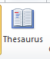

1. On the **Review Ribbon** at the top click on **Thesaurus**
2. To the right select a **synonym** for the word House

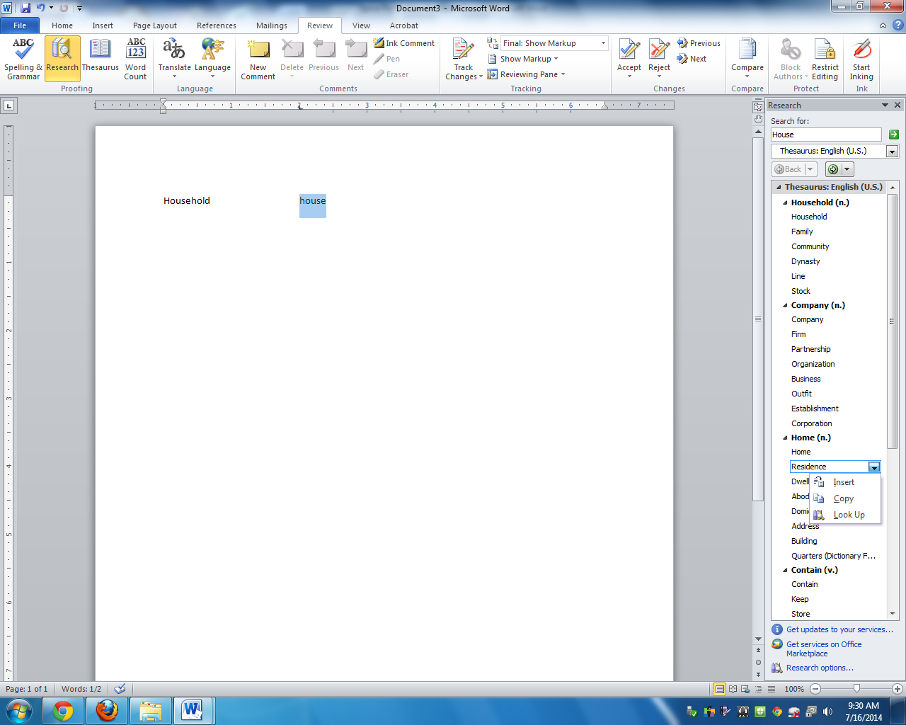

1. Click on the down arrow to the right of the synonym that you want to use and click on **Insert**.
2. Click on the word House at the 4” Tab Stop, select a **synonym** for the word and click on the down arrow to the right of the synonym to select the word.
3. Click on the word House at the 6” Tab Stop, select a **synonym** for the word and click on the down arrow to the right of the synonym to select the word.
4. Repeat Steps 1-6 for the remaining three words.
5. Save

**Sentence**

1. Leave the first sentence as is.
2. For each **noun** in the second sentence select an appropriate synonym.
3. For the **verb** in the second sentence select an appropriate synonym.
4. Insert two **adjectives** and select appropriate synonyms for each adjective.
5. Insert one **adverb** and select an appropriate synonym for the adverb.
6. Proofread your work and make sure you followed all directions.
7. Save
8. Print on the laser printer and turn in.

Spice Activity Part 2 Sample

Name

Spice Activity

House Dwelling Lodge Residence

Pretty Beautiful Lovely Sweet

Walked Strolled Marched Sauntered

Quickly Swiftly Promptly Hastily

The man ran to the store.

The pleasant gentleman dashed briskly to the exclusive retailer.

Works Cited

"Activities." *Interactivate:*. Web. 30 July 2014.

"CalorieKing - Diet and Weight Loss. Calorie Counter and More." *CalorieKing - Diet and Weight Loss. Calorie Counter and More*. Web. 28 July 2014.

"Cause / Effect." *Quia -*. Web. 30 July 2014.

Elboghdady, Dina. "New Rules Double Up Fruits, Veggies for School Meals." Print.

"Greek Mythology Today Business Page Two." *Greek Mythology Today Business Page Two*. Web. 30 July 2014.

Horovitz, Bruce. "Eat McDonald's for 3 Months, Lose 37 Pounds?" n.d.: n. pag. Print.

"Paraphrasing." *BrainPOP*. N.p., n.d. Web. 31 July 2014.

Series, Personal Health. *Handout: Food Labels (Grades 6 to 8)* (n.d.): n. pag. Web.